Which Office 365 plans include Microsoft Forms?
Forms is available to Office 365 businesses that have any of the following commercial Office 365 plans: Office 365 Business Essentials, Office 365 Business Premium, and Office 365 Enterprise E1, E3, and E5 plans.
Where to find Forms?
To find the app, open your Office 365 Home Page and look at your list of apps. If Forms isn’t showing, click Explore all your apps and you’ll find it listed in there. (This is different depending on organisational rollout and whether enabled). 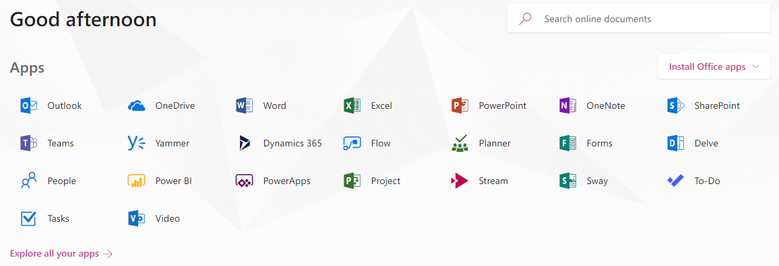

Creating a Form:
The basics of creating a form. Inside the app, you’ll be presented with the Forms home page.
You can choose to create a new form or quiz. 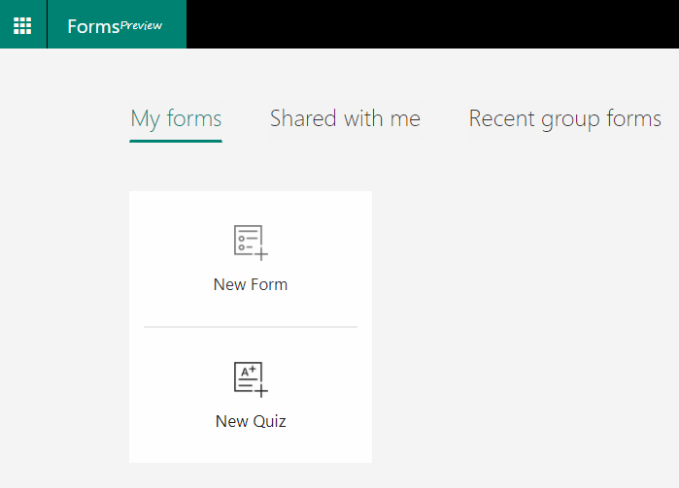
When you select a new form, you can simply input the form details and add an image if required. (details: what the form is about, add an image to show for the form when shared)
You can easily add questions with multiple different types to your survey/Quiz.
Choice: Add multiple-choice questions and as many potential answers as you wish to include. You can also determine whether the responder can provide multiple answers and whether completing the question is mandatory by toggling the ‘multiple answers’ and ‘required’ functions on/off. You can also add an image if it gives context to the question if required
Text: Your respondents can answer your question with a free-text response - they can write whatever they like in the text box.
Date: This allows the option to select a date from a calendar in response to a question.
Rating: Questions allow you to rate something using a scale of numbers or stars.
After adding your questions, you can easily change the appearance of your form by adding a theme. You can simply pick from the different colours and graphics options, before using the preview button to see what the final survey will look like to your respondents.

Sharing your Form:
Sharing your survey is simple. You can choose whether the survey is only shareable to people within your organisation or for anyone who has access to the URL link. You can also share survey templates if you have saved them.
Copy Link: Copy the link, you can paste it anywhere. In an email, on a webpage or social media. 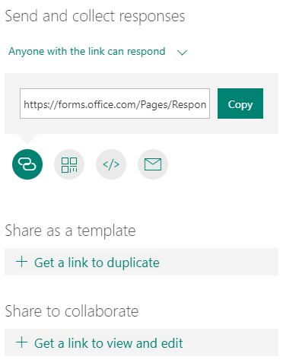
QR code: This requires someone to scan the code using their mobile device to access the form. 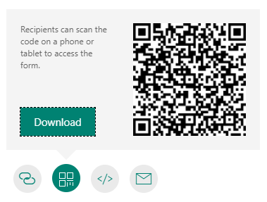
Embed: The embed option provides some HTML code which you can paste in a webpage.
Email: You can email the link to one or more recipients.
Responses and Results:
Once you’ve shared your new survey, you will want to review the responses. In your survey responses tab, you will find a dashboard with analytics of the data submitted by your survey respondents. 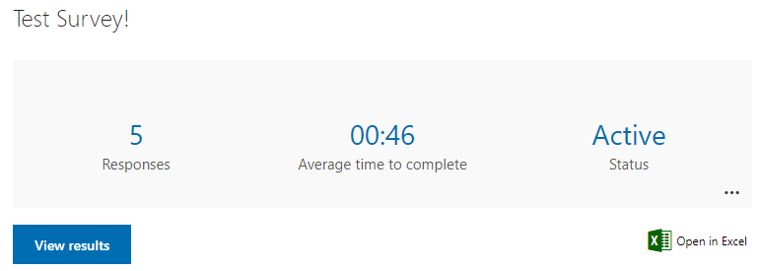
You can quickly find out how many people have submitted responses, the average time it takes a respondent to complete the form, and the status of the form. Following this, you can see an overview of the answers for each of your survey’s questions. For a multiple-choice question, you will see the number of responses for each option and a pie chart.
For any question type, you can see a full breakdown of all the different answers. Note how each respondent is provided with an ID. This allows you to cross-compare answers between different questions. If you share your survey with people inside your organisation, you can select the option to capture their names – otherwise the data is anonymised.
With ‘rating’ questions, the overview shows you the average rating from all of the responses. 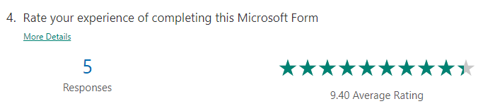
You can open the data in an Excel spreadsheet in case you want to do more detailed statistical analysis – or you could even add the data into Power BI (if you have access to Power BI and use it).
…………………………………………………………………………………………………………………………………………………………….
Creating a Quiz:
- Click New Quiz.
- A new blank quiz will be displayed.
- Set up a few basics including the title, description and an image for our quiz.
- Click the Untitled Quiz text to change the title.
- Enter a description to give the end-user an idea of what the form is about or some instructions if needed.
- Set an image to use for our quiz, this could be a logo, header image or just an image associated with the topic of your quiz.
- Click the Insert Image button.
- You have the option of searching for an image using the internet, accessing images you have stored in your OneDrive account, or uploading an image from your computer.
- Select the Upload option:
- Locate the image you wish to use, select it and click Open (The image will be added to your quiz header area)

Apply a Theme to your quiz:
One way to improve the look of your quiz form is to apply a theme. The theme allows you to customise the background area of your form either with a solid colour or with a background image. Forms will allow you to use their built-in Theme Ideas or upload your own image.
- Click the Theme button.
- The Theme Ideas pane will appear. In this section the theme ideas will customise depending on the title of your quiz. Experiment if you like by changing the topic of your quiz to something completely different, then see the different theme ideas it provides you.
- Choose a Theme you like for your quiz (if required).
- If you would like to use a solid colour or even upload your own image to use as the background, click the Hide link in the top right corner of the Theme Ideas pane.
- There will be options for solid colours along with some additional themes. You will also have the option to click the + button and upload your own image.
- You should now see the theme applied to your quiz.

Add a text-based question:
Now to add the questions to our quiz.
If you are using the quiz for colleagues who are part of your main organisation’s Office 365 unit, then the members details will automatically be displayed on their responses. If, however, you are planning to quiz a mixture of people within your organisation and external users, it is recommended to add fields to collect their name and/or email address. If you do not then each response will be labelled Responder 1, Responder 2 etc with no names associated.
- Click the Add New button to add the first text-based question.
- From the options select Text (link to each question detail).
- A blank text question will appear.
- Type the first question into the Question field e.g. Your Name.
- Repeat this and add a text question for Your Email.
- You have the option to make both of these fields required, meaning that your responder’s MUST enter their details.
- Click on a text question to open the editing options, click the Required button to enable it.
- Click outside the question area to close the editing screen.
A text-based question allows you to assign an image to the question or add a list of correct answers.
You can set the question to allow a long answer or make the question a required field.
For more options, click the ellipses (…) button in the bottom right corner and enable additional settings such as Subtitle (add additional instructions or a prompt for the question), Restrictions (specify restrictions such as only allow a number between certain values), and Maths (allows you to enter a Maths equation).

Add a multiple-choice question:
We are going to use the Choice question type which will allow responders to select from multiple-choice questions. If you would like to automatically let responders know their results, we can also assign points to each question and specify which question is the correct one so that the form can automatically let the responder know their result.
- Click the Add New button.
- Select the Choice question type (Link to different question types).
- A blank Choice question is displayed.
- Type the next question into the question field. (If your choice question requires a visual prompt, you need to add the image into the question).
To do this click the Insert media button.
From the Insert media pane select Image;
Select the source of your image, you can use internet search, select an image from your OneDrive, or Upload from a computer.
Select the image and click Open, the image will now be added to the question.
- Now add the answers into the fields provided.

- To add more answer options, simply press Enter at the end of the last answer or click the + Add Option button.
Assign points for each question:
So that your quiz can be automatically marked, you need to indicate how many points each question is worth.
- From the question area, click into the Points field and enter the value for this particular question.
- You can allocate points to each of the questions in the quiz (however many you would like).
Assign which answer is correct:
Our final step for this choice question is to indicate which answer is the correct one so that the automatic marking process can function.
- From the question area, hover over the correct answer from the list.
- Individual options for that particular answer will be displayed.
- Here you can delete an answer, enter a message to be displayed if a respondent chooses that particular answer, or mark it as the correct answer.
- Click the tick icon for the correct answer for your question.
- It will now display “Correct answer” next to the answer (this is not visible when respondents are completing the quiz).
- Repeat this process to create any additional multiple-choice based questions in your quiz.
…………………………………………………………………………………………………………………………………………………………….
Adding Forms Tab in MS Teams:
- In Teams, go to the channel you want and click Add a tab +.
- Under Tabs for your team, click Forms.
- In the Forms tab configuration page that opens, choose create a shared form that your team can edit, then provide a name for your new form.
- Post to the channel about this tab is automatically checked so you can immediately share your new form with your team. If you don't want to share it right away, deselect this option.
- Click Save.
You are now ready to work with your team to create this form.
Note: Each form tab will have an action status in front of the form title. In the following example, this survey is in the process of being created, so edit is in front of the form title.

Add an existing form to collect responses, show survey results, or collaborate with your team:
- In Teams go to the channel you want and click Add a tab +.
- Under Tabs for your team, click Forms.
- In the Forms tab configuration page that opens, choose Add an existing form.
- In the Search field, type in the name of the form you want to add or select from the list below the field.
- In the dropdown list below Add an existing form, choose whether to Collect responses, show results, or Collaborate.
(If you select Collect responses, the form will be in "Fill" mode, so you'll see fill in front of the title to let you know you're in the process of collecting responses from your team.
If you select Show Results, you are sharing the results of a form with your team, and the form will be in "Results" mode. You'll see Results in front of the title to let you know responses have been collected and you're now sharing those results with your team.
If you select Collaborate, you and your team can edit an existing form. You'll see Edit in front of the title to let you know the form is open for edit.)

- Post to the channel about this tab is automatically checked so you can immediately share your new form with your team. If you don't want to share it right away, deselect this option.
- Click Save.

Start a conversation with your team about a form:
Now that you've created a new form or added an existing one, anyone on your team can contribute to your form. It's easy to get a conversation going about it by clicking on the conversation icon in the upper right corner of Teams.
A conversation window will open to the right of your form tab.
Set up notifications about your form:
The Microsoft Forms connector can help you keep your team up-to-date on the responses for your forms. Just tell the connector which forms you want to subscribe to, and the channel will be notified with a summary of responses each day.
- Next to the channel for which you want to set up a notification about your form, click More options (ellipsis) then Connectors.
- If enabled with Forms, To the right of the Forms icon, click the Configure button.
- Under Choose the form you want to receive notifications for, click the drop down menu and select a form. You'll receive a daily update of responses to your selected form.

Conduct a poll within your team:
With Microsoft Forms, you can create an instant, real time poll in seconds within your Microsoft Teams app.
- Go to the Teams channel or chat window in which you want to include a quick poll. At the bottom of your Teams app (where format button, gifs, stickers etc are located), click Forms.
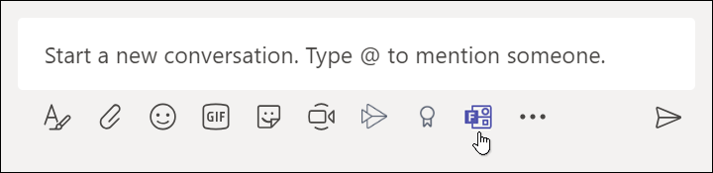
Note: If you don't see the Forms icon, click Messaging extensions ellipsis, and then select Forms.
- Add your question and options, and then click Next.
- Preview your poll, and then click Edit if you want to make changes or click Send if you're ready to post it.
As people in your group take the poll, you'll see real time results in your group conversation.
…………………………………………………………………………………………………………………………………………………………

MS Forms NWIS Policy –
(Please refer to your organisation’s IG Officer for the direct policy pertaining to your organisation)

Microsoft Forms not intended as a mechanism through which patients are engaged; proposals for patient questionnaires or engagement should be submitted through the normal channels.
For security, compliance, and maintenance purposes, authorised personnel may monitor, and audit surveys, quizzes and polls created and circulated in Microsoft Forms.
When creating or responding to surveys, quizzes or polls in Microsoft Forms:
- YOU MUST protect the privacy and confidentiality of colleagues and/or other NWIS information, as required by NWIS Information Governance policies.
- YOU MUST NOT request personal data (information that identifies individuals) unless it is required, and this should be limited in its nature. For example, names and contact details of respondents should only be requested if they needed for a specific purpose.
- YOU MUST NOT request or collect information about the health of patients or colleagues or other sensitive information, such as information about racial or ethnic origin,
- Surveys, even when they may otherwise contain “de-identified” PHI, may never be used to collect and store respondents’ personal information or usernames and passwords.
- All survey data is the property of NWIS.
- YOU MUST: You are responsible for the content and integrity of your survey data and must ensure that you have all the rights and permissions needed to use that content.
- You may not transmit any viruses, malware, or other types of malicious software, or links to such software, through Microsoft Forms.
- You may not use Microsoft Forms to infringe the intellectual property rights of others.
- You may not use Microsoft Forms to engage in or promote illegal, abusive or irresponsible behaviour, including: in any way that breaches any applicable national or international law, code or regulation, including data protection and laws relating to unsolicited commercial electronic messages.

