Welsh IG Toolkit
New User Features
Achievement Status Checker Page
The Achievement Status Checker page is available in the public domain. This page can be found on the login page of the WIGTK, under the ‘Register’ button.
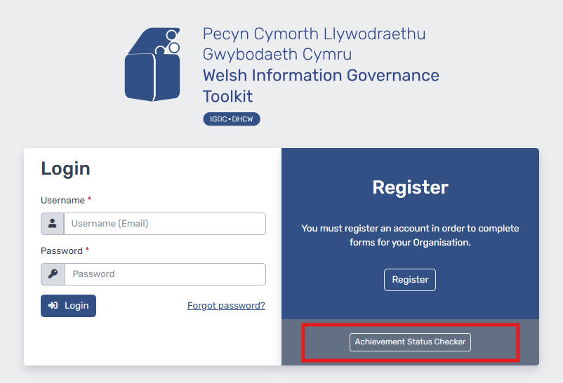
This tool provides the ability for anyone to search for an organisation and check their latest submission status and date. This will inform users whether a particular organisation has met a compliant or non-compliant position and in what submission period. Users of this page can either utilise the search bar to find an organisation by using the organisation’s name or code or operate the navigation at the bottom of the page, as highlighted in the image below:
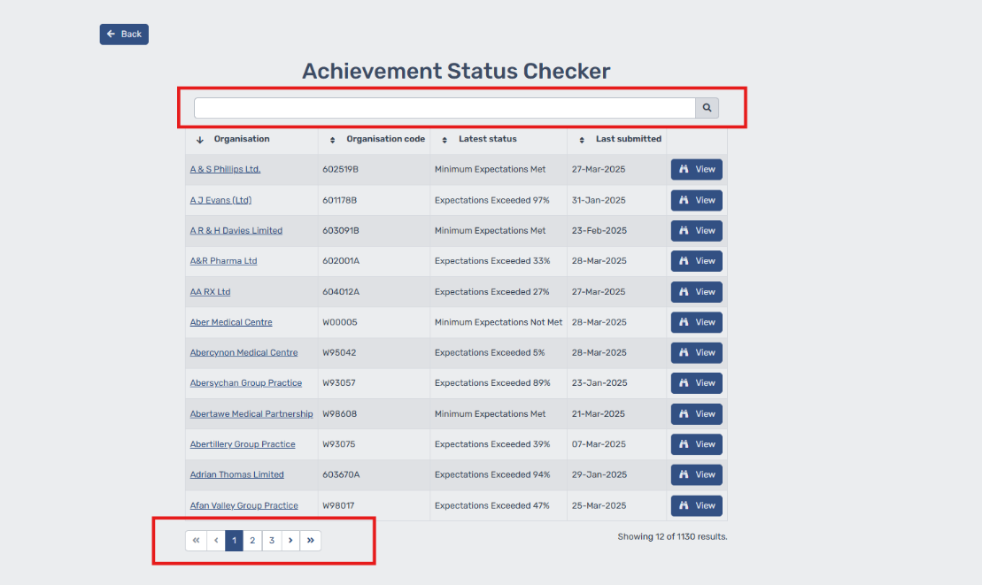
You can also view organisation’s submission outcomes from previous years by simply clicking “View”. This will display a history of their past submission outcomes.
Please note: The WIGTK will automatically generate an achievement status on the basis of the organisation’s self-assessment, these are:
- Minimum expectations not met (non-compliant position)
- Minimum expectations met (compliant position)
- Expectations exceeded X% (compliant position)
Currently, Child organisations are appearing as N/A on the Achievement Status Checker page due to the previous way Parent and Child Organisations were set up on Caforb. Should you wish to know the achievement outcome of a Child Organisation prior to the 2025/2026 submission period, this would be the same outcome as the Parent Organisation.
The Software Development Team are currently working on a solution which will be released shortly to combat this issue.

Copy Down Feature
Copy down functionality has been made available within the Caforb platform for organisations who are set up in the Parent (Host) and Child relationship. The Parent and Child relationship refers to a Host organisation, where organisations sit underneath, these organisations are referred to as Child organisations.

The Parent organisation typically provides strategic direction, policies and overall governance. While Child organisations may have its own operational autonomy and local deviations, they generally follow the overall direction set by the Parent organisation. However, each dynamic may be different.
The copy down feature enables the Parent organisation to copy down elements of their WIGTK form to their Child organisations. There is a choice of copying down the entirety of the form or only certain sections or even specific question down to the children. Where only certain sections or questions are copied down, this allows Child organisation to make local deviations to their own forms.
There is also an option for a post copy down action, in which the Parent organisation has the option to either do nothing, submit their own form, submit their own and their Child organisations form or only submit for their Child organisations. Therefore, when using copy down, you will need to select one of the following four options under the post copy down action section:
• Nothing
• Try to submit Host form
• Try to submit all Child forms
• Try to submit Host and all Child forms

You will also have the option to select which controls to be copied down. You will need to select from the below options:
• All Controls (this copies down the entirety of the form)
• Specific Controls (All controls will be selected by default, but users will have functionality to de-select what sections or certain questions you do not wish to be copied down)
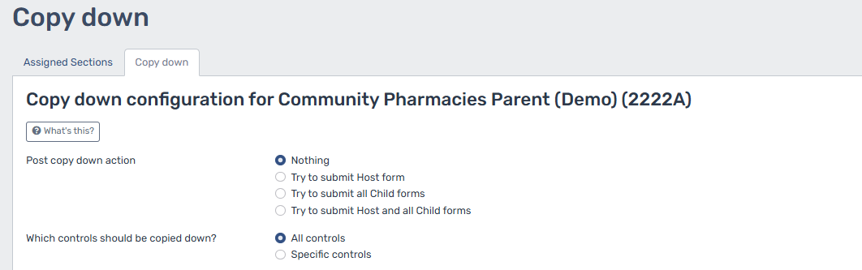

The copy down feature has a number of rules around its functionality which should be carefully considered, these can be found below:
- Copy down can only be used by Organisation Administrators of a Parent Organisation that have Child Organisation set up.
- If the Parent’s question is irrelevant to the Child, the answer will not be copied down.
- If the Parent’s question is unanswered, the question is ignored and will therefore not clear the Child's answer.
- If a Parent’s File upload control is answered with file upload(s), a copy of the file(s) will be created for the Child.
- Chosen answers from the Parent’s form will overwrite the Child's answer.
- The Child will be unable to make changes to their form until the copy down process is complete.
- Copy down can be used as many times as required.

Please note: Initiating a copy down will form part of an enqueue process, meaning that requests will be handled sequentially. Therefore, a copy down will not be actioned until the previous copy down task has been completed. Subsequently, organisations should plan accordingly as deadlines approach, ensuring that work is carried out well in advance of the submission period deadline. Organisations should also be mindful that multiple organisations will be accessing this feature concurrently, which may impact processing times and cause longer delays.
For further information on these features, please visit our User Guide which is available on the Support and Resources page. For any queries regarding the WIGTK or any of these features, please contact the team via email: WelshIGToolkit@wales.nhs.uk.

