Welsh Information Governance Toolkit
Caforb User Guide
Table of Contents
Introduction 2
Users 2
Organisation Administrator 2
User 2
Read Only 2
Registration 3
Creating Users and Read Only Users 4
Updating Organisation Profile 5
Resetting or Changing Passwords 6
Welsh Information Governance Toolkit Form 6
Copy Down 7
Accessing the Form 9
Form Legend 9
Dashboard 9
Closing your Form 10
Submitting your Form 10
Alerts 10
Current Progress Report 11
Action Plan Report 11
Sections and Assessment 11
Minimum Expectations 12
Expectations Exceeded 13
IG Action Plan and Notepad 13
Form Controls 14
Tooltips 14
Declaration Controls 14
From Progress 15
Completing the Form 15
Radio Buttons 15
Checkbox 16
Single line text 16
Paragraph 16
Date 16
File Upload and Alternative Descriptions 16
Submission 17
Accessing Previous Submissions and Action Plans 18

Introduction
Welcome to the Welsh Information Governance Toolkit (WIGTK) User Guide.

The WIGTK is a self-assessment that enables organisations to measure their level of compliance against national Information Governance standards and legislation to ascertain whether information is handled and protected appropriately within the organisation.

The assessment aims to help identify those areas which require improvement and assists in informing the organisation’s IG Action Plan. It will also provide reassurance to staff, patients, and other healthcare organisations that their information is processed securely and appropriately.

The WIGTK can be accessed using the Caforb Platform.

Users
There are three user types that can be assigned on the WIGTK. These are Organisation Administrator, Users and Read-Only Users. Further information on these roles can be found below.

Organisation Administrator
The Organisation Administrator is the ‘superuser’ for the organisation. It is expected that the Organisation Administrator will hold a senior role within the Organisation, for example Head of Information Governance.

The Organisation Administrator has the ability to complete and submit the WIGTK and is responsible for maintaining the Organisation Profile, Creating Users and controlling access to the Organisation’s WIGTK Form.

Only one Organisation Administrator can be set up for each organisation. If changes need to be made to the Organisation Administrator for your organisation, please contact the WIGTK Team.

The Organisation Administrator can set up Users and Read Only Users using the process described within the ‘Creating Users and Read Only Users’ section of this guidance.

User
Users have the ability to populate and submit the WIGTK form for their organisation. There is no limit to the number of users that can be created per organisation.

Read Only
Read Only users can review the organisation’s WIGTK Form, including answers and any uploaded evidence. Read Only users cannot make any changes to or submit the WIGTK form.

Auditor
Auditors have the ability to audit an organisations submission. When assigned an auditor role a ‘Auditing’ tab will appear on the lefthand side in the portal. This functionality enables the auditor to create an audit report and provide comments on each section of the organisations WIGKT form.

Registration
To register for an account as an Organisation Administrator visit the Caforb Platform site and select ‘Register’.
Complete the fields within the ‘Your account’ section of the registration form with the required information.

Please note, the email address you enter during the registration process will become your ‘Username' when accessing the platform, so it is essential that this is entered correctly as it cannot be changed.
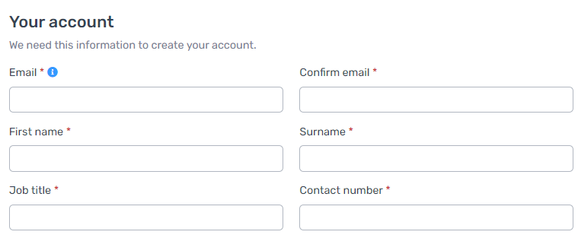

Continue through to the ‘Organisation details’ section and search for your organisation using either your organisation name or code. You will need to enter at least two characters to activate the search function.

Select your organisation from the list that appears. This will auto populate the organisation details on the righthand side of the form.

If you are unable to find your organisation, please contact the WIGTK Team.

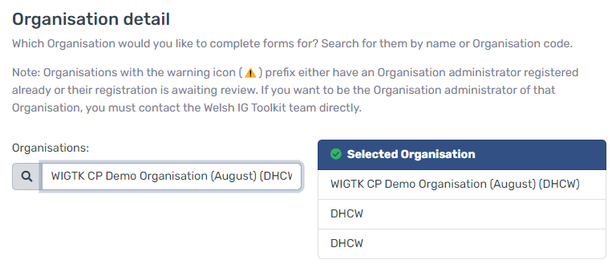
Only one Organisation Administrator can be set up for each organisation. If an Organisation Administrator has already registered for your organisation, a yellow triangle will appear next to the organisation name in the search results, and you will not be able to register in this way.

Please contact the WIGTK Team if you need to set up a replacement Organisation Administrator.

Continue through the form to complete the ‘Organisation profile’ section. These fields are not mandatory to complete at this stage, however we do encourage you to complete these during the registration process.

Once all fields have been completed, select the ‘Submit’ button.

A member of the WIGTK Team will review all account requests promptly. Once your account has been approved you will receive an email from Caforb Manager providing a link for you to set a password for your new account. Passwords must be at least 11 characters in length and weak passwords will not be accepted.

Please note, if you already have an account set up on the Caforb platform for a different team, such as Community Pharmacy Clinical Governance Toolkit (CGTK) or Clinical Governance Practice Self-Assessment Toolkit (CGPSAT), then you will be required to register for the WIGTK in a slightly different way. The steps on how to do this are listed below:
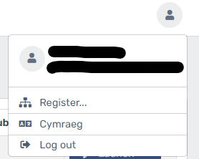
- Once logged into the Caforb platform, click the ‘User’ icon on the top right corner of the screen
- Select ‘Register’
- From the list of teams, select ‘Welsh IG Toolkit’

You will then be taken to a copy of the registration form. The ‘Your account’ details will already be populated with your current user account details. You will just be required to complete the ‘Organisation details’ and the ‘Organisation profile’ section, should you wish.

Once this has been completed, select the ‘Submit’ button. This will then send a notification to the WIGTK Team who will review the account request.

Creating Users and Read Only Users
Organisation Administrators have the ability to create users and read only users for their organisation. There is no limit to the number of additional users which can be added to an organisation.

Should you wish to add a user to your organisation on the WIGTK platform, the Organisation Administrator will firstly need to navigate to the ‘Organisation Management’ tab (which can be found on the left side of the screen once logged in) and then within this, select the ‘Users’ tab, followed by the ‘Create Portal User’ option.

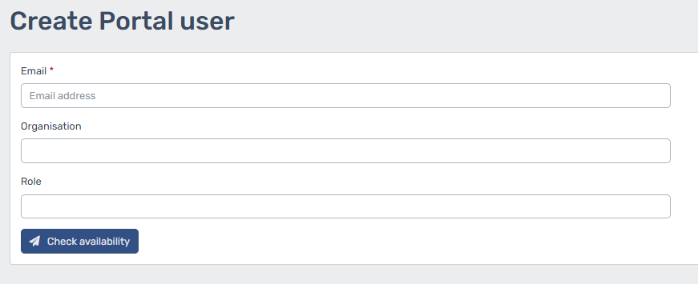
Please note, organisation management is only available to Organisation Administrators.
You should complete the required fields ensuring you select the correct organisation in the drop down if you are the administrator for more than one organisation.

You will need to select the correct role for the user from the dropdown options, which will be a ‘User’ or ‘Read only’.

Once all fields have been completed, review the details and then click ‘Check Availability’. If there is availability, you will be prompted to fill out extra fields. After all fields have been successfully completed, the new user will receive an email to set their password. Please note that this may appear in your junk folder.

Only new users can be created in this way. If you require a user to be added to your organisation who already has an account associated with their email address, please contact the WIGTK Team for further support.

Parent and Child Relationship
The Parent and Child relationship refers to a host organisation, where organisations sit underneath, these organisations are referred to as Child organisations.
The Parent organisation typically provides strategic direction, policies and overall governance. While child organisations may have its own operational autonomy and local deviations, they generally follow the overall direction set by the Parent organisation. However, each set up can vary and not all of them are the same.

If your organisation wishes to use the parent and child functionality, please contact the WIGTK Team directly.

Please note, this functionality has changed with the introduction to Copy Down for the 2025/2026 submission period. Please refer to page 7 for further information on Copy Down.

Updating Organisation Profile
If the organisation profile was not completed at the registration stage by the Organisation Administrator, you can input this information within the portal.

To do this, the Organisation Administrator will need to navigate to the ‘Organisation Management’ tab (which can be found on the left side of the screen once logged in) and then within this select the ‘Profiles’ tab.

Please note, organisation management is only available to Organisation Administrators.

Complete the required fields on the page, ensuring you select the correct organisation in the drop down if you are the administrator for more than one organisation.

Once all fields have been updated, click ‘Save’.

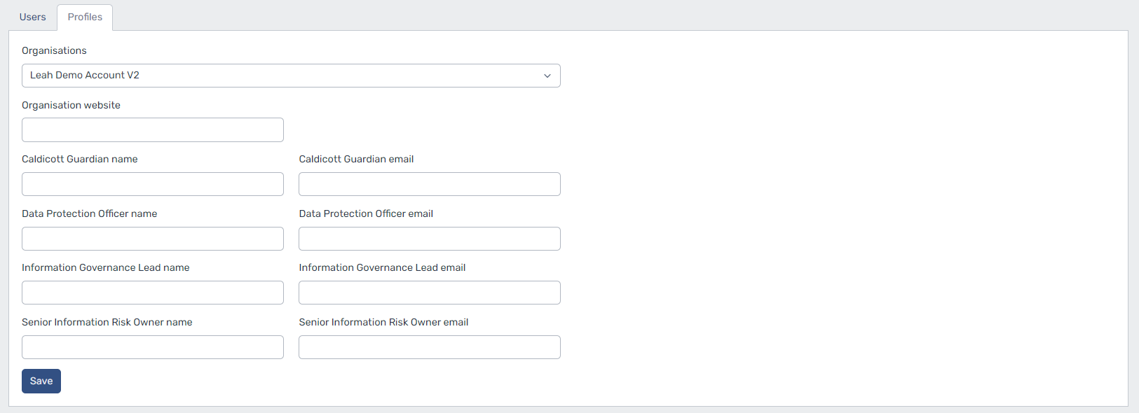
Should any amendments need to be made to the information within the organisation profile in the future, you can revisit this page and update the details accordingly.

Resetting or Changing Passwords
If you have forgotten your password, you can reset this yourself by navigating to the Caforb login page and clicking the ’Forgot password?’ link underneath the username and password box.

After following the instructions, you will then receive an email asking you to reset your password.

The Organisation Administrator can also issue an email to users for them to reset their password. To do this, the Organisation Administrator will need to click on ‘Organisation Management’ on the left-hand side toolbar and select the ‘Users’ tab. Once you have found the correct user, click the drop-down arrow on the right side of the 'Edit’ button and select reset password. This will then send an email to the user asking them to reset their password.

Please note, you can only reset your password once in 24 hours.

Welsh Information Governance Toolkit Form
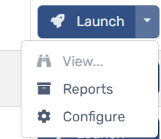
Assigned Sections
The WIGTK now includes functionality that allows Organisation Administrators to assign specific sections to Portal users.
To access this feature, click the arrow next to Launch, then select Configure. This will open the Assigned Sections tab.
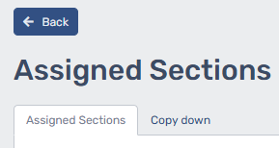
By default, all sections of the WIGTK form are editable by Organisation Administrators and Portal users—except for Read-only users. However, you can control access by toggling sections on or off for individual users.
- If an Organisation Administrator toggles off a section of the WIGKT form for a Portal user, the Portal user will not be able to amend or make changes to that specific section. They will only be able to view it in read-only mode.
- When a toggle is turned on for a Portal user their access will remain allowing them to amend and submit the WIGTK form. If all toggles are on, the Portal user will be able to access the entirety of the form.

- The Organisation Administrators read-only users will appear greyed out in the Assigned Sections page. As their user functionality is read-only, there is no requirement to amend their access.
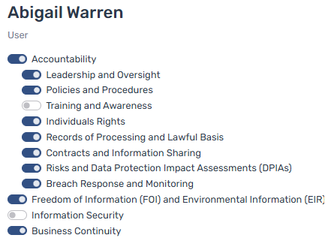

User access (amend and submit form)

Read-only Mode

Copy Down
The Copy Down functionality is particularly useful for Organisation who utilise the Parent and Child setup. To access this feature, click the arrow next to Launch, then select Configure.

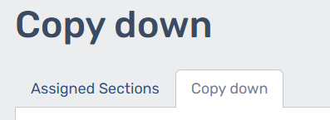
Once the Configure page has opened, click the Copy Down tab to launch this. This tab sits next to the ‘Assigned Sections’ page.

The copy down feature enables Parent organisation to be able to copy down elements of their WIGTK form to their Child organisations. There is a choice of copying down the entirety of the form or only certain sections or even specific question down to the children. Where only certain sections or questions are copied down, this allows Child organisation to make local deviations to their own forms. Therefore, when using Copy down, you will need to select one of the following four options for post copy down action:
- Nothing
- Try to submit Host form
- Try to submit all Child forms
- Try to submit Host and all Child forms
You will also have the option to select which controls to be copied down. You will need to select from the below options:
- All Controls (this copies down the entirety of the form)
- Specific Controls (this option provides the functionality to choose what sections or certain questions you wish to copy down)
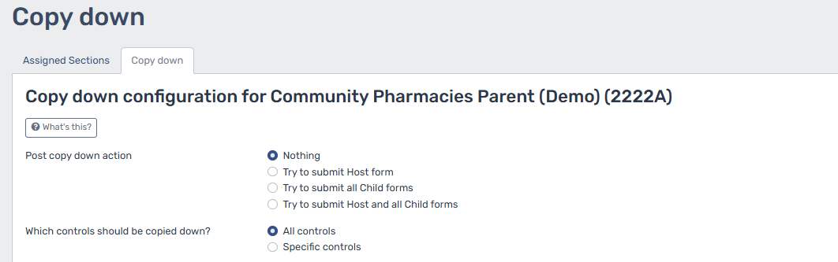

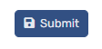
After selecting your copy down option, click “Submit” to initiate the Copy Down process. The Organisation Administrator will receive an email containing the “Post Copy Down Summary” along with a separate “Copy Down Complete” email for each child organisation. Additionally, each child organisation will receive its own email detailing the updates made to their form.
Important Note:
Initiating a copy down will form part of an enqueue process, meaning that requests will be handled sequentially. Therefore, a copy down will not be actioned until the previous copy down task has been completed. Therefore, large organisations especially, should plan accordingly as deadlines approach, ensuring that work is carried out well in advance of the submission period deadline. Organisations should also be mindful that multiple organisations will be accessing this feature concurrently, which may impact processing times and cause longer delays.

Accessing the Form
When you first log in to the platform, you will be presented with the forms that are available for you to complete.

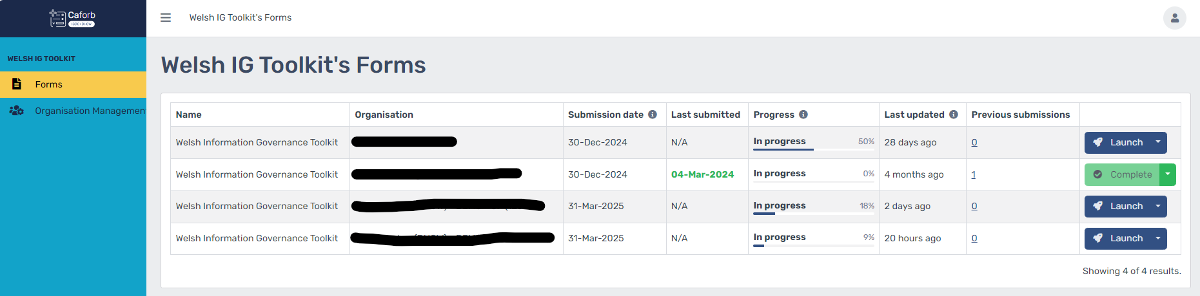
Navigate to the form titled ‘Welsh Information Governance Toolkit’ and select the ‘Launch’ button.

Most users will only have access to one form for one organisation, however this may vary if more than one organisation is affiliated to a user’s account or if another assessment applies.

Form Legend
When the form is launched, you will be presented with the Dashboard page, and you will see the form legend at the top.

Dashboard
When you launch the WIGTK form, you will automatically be taken to the dashboard page.

This provides you with an overview of the assessment sections within the WIGTK, including where the organisation has achieved minimum expectations, and any expectations exceeded. It will also highlight any identified gaps. These graphs are driven by the live data within your form, so they will update automatically as you progress through the sections.
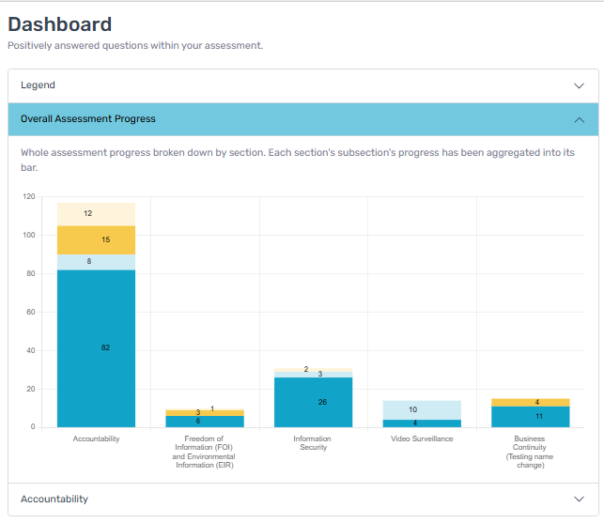
The numbers available on the graph indicate the number of questions where the minimum expectations are met, not met, or expectations are exceeded.

Expand the ‘Accountability’ section to view the progress of each subsection. Again, the numbers will provide clarity on what questions are minimum expectations met, not met, or expectations are exceeded.

If you want to return to the dashboard at any time, you can click the ‘Dashboard’ option from within the form menu.

Closing your Form
Click the ‘Close From’ button when you wish to exit the form and return to the main ‘Forms’ page.


Submitting your Form
This option opens a pop-up modal that details the conditions that must be met before you can submit your WIGTK form. See the Submission section below for further information on these conditions.

To confirm, you will need to be on the dashboard page in order to submit your WIGTK form.


Alerts
The Alerts section displays notifications, as appropriate, for all users.

Each time an alert has been sent to the platform it will be displayed above the Dashboard area when the user logs in. The alerts will be displayed in either red, amber, green, or blue depending on the topic and urgency. Examples of alerts you will see may include warnings of planned downtime for maintenance, training sessions, latest updates, or submission date reminders. You can dismiss the alert by clicking on the X.

If a red circle is highlighted on the Alerts tab, it is notifying you of alerts that you may have missed.

Click into the Alerts tab to view them. Once the alerts have been read, the red circle will disappear.


Current Progress Report
Should you wish to save a copy of your current progress on the WIGTK form, you can download a copy of this. There is no limit to the amount of current progress reports that you can generate, so you can do this as frequently as required.

There are two ways this can be accessed.
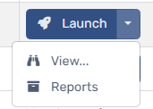
Option 1:
From the forms page, click the drop-down button next to the launch button and select view. A window will pop up which will present the report on screen, along with the option to download as a PDF.

Option 2:
When you launch the WIGTK form, click the ‘Current Progress Report’ tab within the form legend and the report will be downloaded as a PDF.


Action Plan Report
Should you wish to save a copy of your current IG Action Plan from the WIGTK form, you can download a copy of this by using the ‘Action Plan Report’ button. There is no limit to the number of reports that you can generate, so you can do this as frequently as required.

This report will also display any notes that you have made using the notepad feature.

Further information about using the IG Action Plan can be found under the IG Action Plan heading below.


Sections and Assessment
The WIGTK is broken down into five sections, these sections are indicated by the turquoise tabs on the from legend and contain the assessment questions to be completed.

The first section, ‘Accountability’, can be expanded to display several subsections. To expand this, click the arrow in the turquoise box. The other four sections do not contain sub-sections.

Please note, the Video Surveillance section is not relevant to Third Party Organisations.

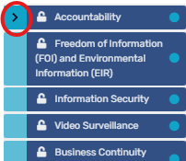

When a section or subsection is entered, it automatically becomes locked for that user, and no other user will be able to access it until they come out of it. A padlock symbol on the legend will identify which section(s) are locked for you and informs you who is currently accessing the section.

Once the declaration control is checked for a section, a green tick is displayed on the relevant section in the legend. Further information about declaration controls can be found below.

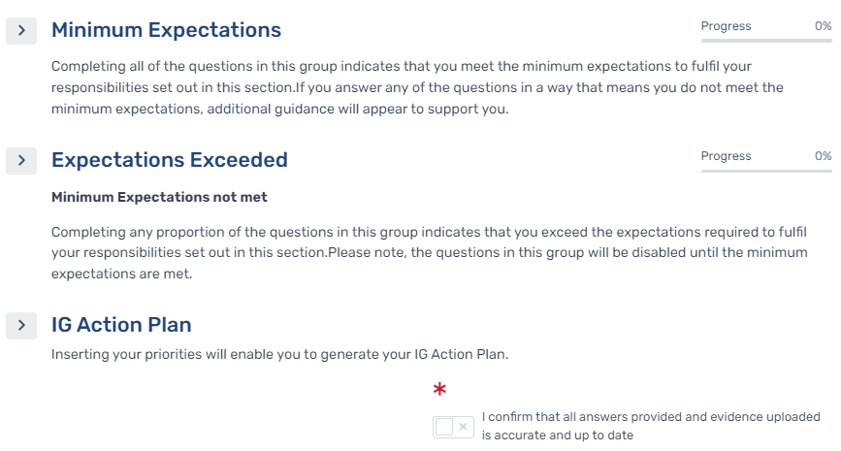
The assessments are set out in row groups; these break the form down into smaller segments and allow the user to expand and collapse the row groups so that they are only viewing the information required.

You will need to select the arrow to expand the row group to view the questions.

The key sections of the assessment are described below.

Minimum Expectations
The minimum expectations row group contains the first set of questions.

To meet the minimum expectations within the WIGTK, organisations will need to answer all questions within the minimum expectations positively. Some questions will require you to upload evidence in support of your answer. If this is required, a file upload control will appear below the question once it has been answered positively for you to upload your evidence.

If you answer any of the questions in a way which means that you do not meet the requirement, a statement explaining that the organisation has not met the minimum expectations will appear. This statement is for your information only and will not prevent you from submitting your Toolkit.

The questions which appear on the form will differ depending on your organisation type.

You can monitor your progress in meeting the expectations by referring to the progress bar at the top of the row group. This progress bar will only update once a question is answered positively.

Expectations Exceeded
The expectations exceeded row group contains an additional question set, which is available to organisations once the minimum expectations have been achieved for that assessment. Expectations exceeded allows organisations to demonstrate that they are working above the minimum in that topic area.

The controls within the expectations exceeded row group will be ‘read only’ until the minimum expectations have been achieved.

Please note, that depending on your organisation type, there may be sections that do not contain any expectations exceeded questions.

It is not envisioned that organisations will answer all the expectations exceeded questions, especially during the first couple of years, it will however enable organisations to demonstrate progress and allow for year-on-year improvement.

IG Action Plan and Notepad
The IG Action Plan, which is located towards the bottom of each assessment section, is designed for any identified priorities to be recorded. To confirm, the IG Action Plan does not form part of the WIGTK assessment and does not have to be utilised.

You can return to the Action Plan at any time while working through your form to enter subsequent updates, enabling this function to be used as your improvement or action plan.

It is broken down into three priority rows with four quarters in each row.

There is also a notepad available underneath the action plan to record any further comments relating to the organisation’s priorities and plans.

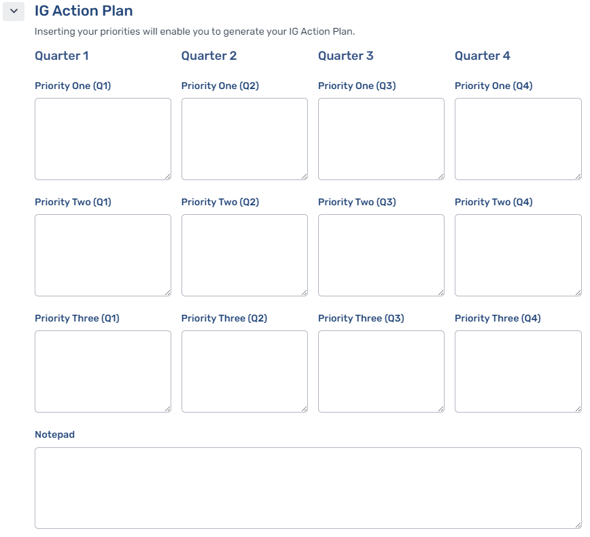

Form Controls

Tooltips
There are multiple tooltips available throughout the assessment. These are designed to provide additional information to support users in completing their WIGTK. There are three types of tooltips, which are available when hovered over or clicked on.
The Navy Tooltip provides example evidence.

The Yellow Tooltip provides supporting information, including links to guidance and templates to provide support in answering the question.

The Turquoise Tooltip provides a link to the legislation, best practice guidance, or ICO’s accountability framework to provide an explanation on where the question has come from and why it is being asked.

Declaration Controls
At the bottom of each assessment section is the declaration control.

The declaration control requires you to confirm that all information provided within that assessment section has been reviewed and is accurate and up to date. The declaration control will need to be selected on each assessment section for you to submit the WIGTK form. Even if you have chosen to not answer a section, the declaration control must be checked to enable submission.

As assessment answers and evidence remain on the form year on year, the declaration control will become unticked at the start of each submission period and is the organisations method of confirming that all existing answers and evidence have been thoroughly reviewed and remain valid.

The declaration control is what determines the form’s overall progress. Once a declaration is selected, the form progress will update on the main ‘Forms’ page.
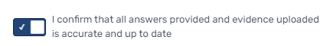

Form Progress
When you first complete your WIGTK form or at the start of a new submission period, the information on the ‘Forms’ page will appear as ‘Not started 0%’. As soon as the form is entered, the progress will update to show ‘In progress 0%’.

Progress is derived from the declaration controls within an assessment being selected. It is important to remember that it is not reflective of the number of questions that have been answered throughout the form.
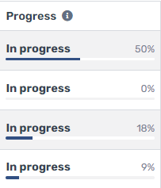
As each declaration control is checked, the progress % will increase. Once all declaration controls throughout the form have been selected, the form progress will update to ‘In progress 100%’.

Once you submit your form, the date of the submission will appear in green text within the ‘Last submitted’ column, indicating that the form has been successfully submitted for the current submission period.

The ‘Last updated’ field displays the last time the form was saved by any user accessing the form for the organisation.

Completing the Form
The platform has a range of formats that the questions are asked in. A breakdown of these is detailed below. There are some questions that are mandatory within the form, and these are marked with a red asterisk. Mandatory questions must be answered to submit the Toolkit.
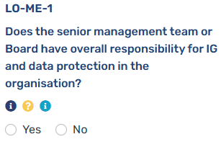
The WIGTK Team have implemented reference numbers to each question of the WIGTK. On the Caforb platform, you will now be able to visually see each reference number above all questions.
For example, “LO-ME-1” LO stands for Leadership and Oversight; ME stands for Minimum Expectations and the 1 stands for the first question of that section.

However, it is important to note, that the WIGTK form accommodates all organisations and questions in a single structure. As a result, certain questions may not be relevant to
your organisation type and will be automatically excluded, which
will lead to omissions in consecutive question numbering.

Radio Buttons
Most of the questions contained within the form are ‘Yes’ or ‘No’ radio buttons. Only one of the response options can be selected.

Checkbox
Checkbox controls require multiple checks as part of one question for it to be confirmed. All answers within the checkbox control must be selected for the control to be considered a positive answer.

Single line text
Single line text controls require a short text response.

An answer should only be inputted in a single line text box where it meets the requirement of the question. Please DO NOT input false positive answers, for example “Not in place, plans to develop”

Paragraph
Paragraph controls require a text response.

An answer should only be inputted in a paragraph box where it meets the requirement of the question. Please DO NOT input false positive answers, for example “Not in place, plans to develop”.

The control can be expanded by dragging the left-hand bottom corner down.

Date
Date controls require you to select a date from the calendar.

Please note that validation controls may be in place which will restrict the date range you are able to select.

Clear All Controls
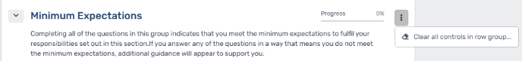
To clear all answered controls within a row group, click the grey dots on the right side of the section's progress bar, then select “Clear all Controls in Row Group.”

File Upload and Alternative Descriptions
Some questions require evidence to be provided in support of a positive answer, the requirement to provide evidence is then mandatory.

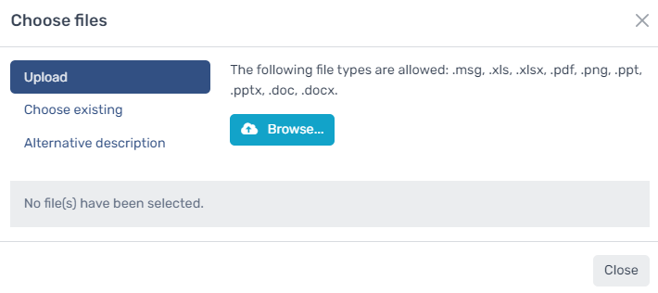
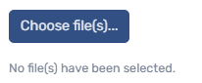
The ‘Choose File(s)’ option will be displayed on the row beneath the question. You will then have the option to select ‘Upload’, ‘Choose Existing’ or ‘Alternative description’ within the modal that appears.

Upload
Click on the Upload option then select the ‘Browse…’ button. This will allow you to select the file you require. The selected file will then be displayed.

If you have chosen an incorrect file, simply click ‘Deselect’ button and re-load the correct file.

Choose existing
If you select the ‘Choose existing’ option, the previous five files that you have uploaded on the platform will be displayed.

You can select one of these or start typing key words in the ‘Search for files…’ box and select the required file using the ‘+ Select’ button.

Alternative description
If you are unable to upload evidence, prefer not to or want to provide further detail about the uploaded evidence, you can click on the ‘Alternative description’ option and start typing in the text box. You can expand the box by dragging down from the bottom right-hand corner of the box.

An answer should only be inputted in the alternative description where it meets the requirement of the question. Please DO NOT input false positive answers, for example “Not in place, plans to develop”.

Submission

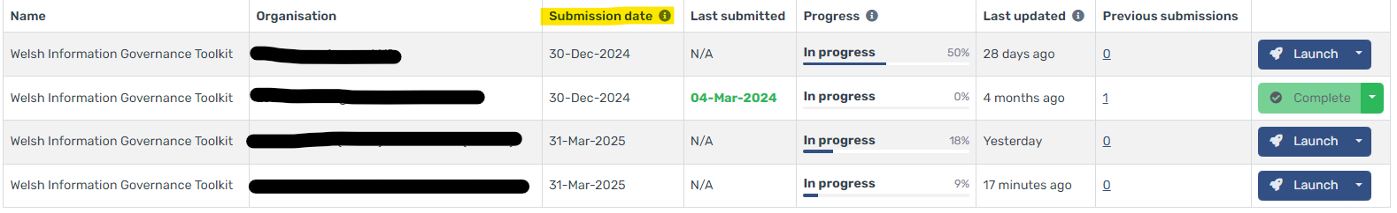
Each organisation is required to submit the WIGTK once per submission period. The submission period and deadline date are determined by your organisation type and can be viewed in the ‘Submission date’ column in the Forms table.

To submit the form, the following conditions must be met:
• There are no validation errors
• You are an Organisation Administrator or User
• You have answered all required questions across all Sections
• You have checked all of the declaration controls
• You have not exceeded your maximum submissions for the current submission period
• No other user is currently accessing the form and that you are on the Dashboard page

To monitor your progress in meeting the conditions, select the ‘Submit’ button within the form legend and the status of each of the above conditions will be shown. Any conditions that have not been met will be highlighted in amber. All conditions must be highlighted green before you can submit your form.

Once all the conditions have been met, the ‘Submit’ button within the modal will enable and you can click the ‘Submit’ button.

Please note that organisations will only be able to submit their WIGTK form once per submission period. Once the form has been submitted for the submission period, it will then be locked and marked as ‘Complete’ until the start of the next submission period.
Once the Submission period closes, the WIGTK will re-open the following day and the form ‘Progress’ will revert to ‘Not started’. All answers, including uploaded documentation, will remain on the form until users choose to update, replace, or delete them, unless there is a change to the question.

During the 12-month submission period, organisations will need to thoroughly review the carried over answers and evidence, and once updated as appropriate, the respective declaration controls will need to be re-checked to confirm all answers are accurate and up to date for that submission period.

Accessing Previous Submissions and Action Plans
Once you have submitted your organisation’s WIGTK form, you will be able to access a copy of the full submission report within the Caforb platform.

There are two ways that you can access this report, which are listed below. Please note that the most recent submission will be listed at the top of the page, however you can filter the ‘Submitted’ column should you wish.
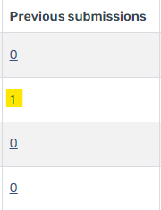
Option 1:
- Within your forms page, click the number within the ‘Previous submissions’ column
- This will direct you to the reports page where you can find all previous submission that have been made.

Option 2:
- Within the forms page, click the arrow next to the ‘Launch’ button
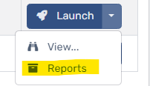
- From the two options, select ‘Reports’
- This will direct you to the reports page where you can find all previous submission that have been made.

Once on the reports page, you will need to click the ‘Full submission report’ button. This will download a PDF copy of your chosen report which you can save.

Should you wish to download a copy of the IG Action Plan and any notes you input within the notepad for that submission, you will need to click the arrow next to the ‘Full submission report’ button and then select the ‘Action plan report’ option that appears. Again, this will then download a PDF for you to save.

Once you have downloaded a copy of your full submission report, you can find your achievement status for that submission period by opening the PDF and referring to the top lefthand corner of the report.

Here you will find your achievement status, confirmation of the date you submitted the form and the date you generated the full submission report.
The WIGTK will automatically generate an achievement status on the basis of the organisation’s self-assessment, the possible outcomes are:
- Minimum Expectations Not Met (non-compliant position)
- Minimum Expectations Met (compliant position)
- Expectations Exceeded X% (compliant position)

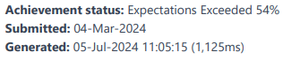

Achievement Status Checker Page

The Achievement Status Checker page is available in the public domain. This page can be found on the login page of the WIGTK, under the ‘Register’ button. This tool provides the ability for anyone to search for an organisation and check their latest submission status and date. This will inform users whether a particular organisation has met a compliant or non-compliant position and in what submission period.
Users of this page can either utilise the search bar to find an organisation by using the organisation’s name or code or navigate through the page navigation as highlighted in the image below.
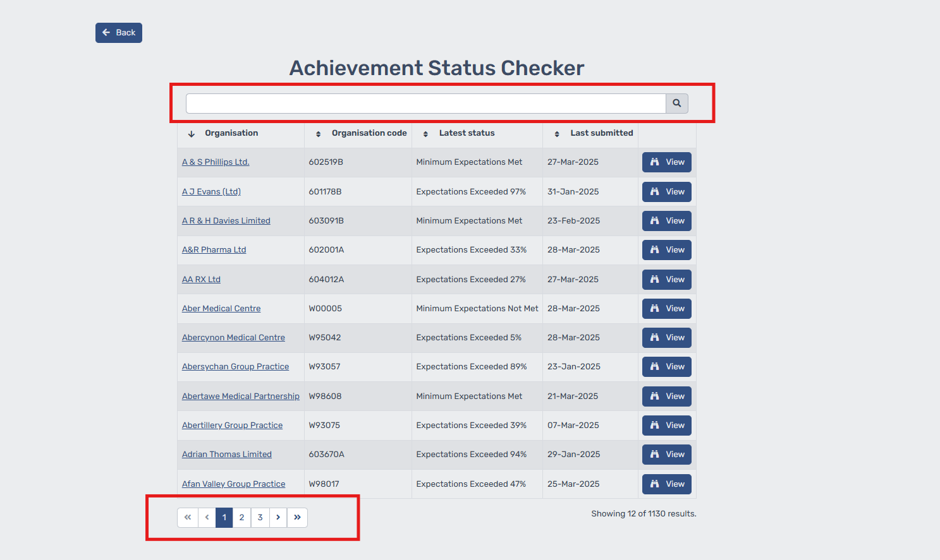

You can also view organisation’s submission outcomes from previous years by simply clicking “View”. This will display a history of their past submission outcomes.
