<ID Reference>

Strategy

DHCW – Cloud Strategy

Document Version | 1.0

Status | Draft

 | Document author: | Matt Palmer  Cloud Strategy Team
 | Approved by | Claire Osmundsen-Little  Executive Director of Finance
 | Date approved: | 21/02/2022
 | Review date: | 21/02/2022

TŶ GLAN-YR-AFON 21 Heol Ddwyreiniol Y Bont-Faen, Caerdydd CF11 9AD

Reading time: Approximately 45 minutes

TŶ GLAN-YR-AFON 21 Cowbridge Road East, Cardiff CF11 9AD

STRATEGIC OBJECTIVE | Mobilising digital transformation and ensuring high quality health and care data

WELL-BEING OF FUTURE GENERATIONS ACT | A healthier Wales

DHCW QUALITY STANDARDS | ISO 20000
N/A

HEALTH CARE STANDARD | Governance, leadership and acccountability

EQUALITY IMPACT ASSESSMENT STATEMENT | Date of submission: N/A
No, (detail included below as to reasoning) |  | Outcome: N/A
Statement: N/A

APPROVAL/SCRUTINY ROUTE: Person/Committee/Group who have received or considered this
COMMITTEE OR GROUP | DATE | OUTCOME
DHCW Cloud Strategy Team | February 2022 | Approved
DHCW Management Board | March 2022 | Approved

IMPACT ASSESSMENT
QUALITY AND SAFETY IMPLICATIONS/IMPACT | No, there are no specific quality and safety implications related to the activity outlined in this report.
LEGAL  IMPLICATIONS/IMPACT | No, there are no specific legal implications related to the activity outlined in this report.
FINANCIAL  IMPLICATION/IMPACT | Yes, please see detail below
FINANCIAL  IMPLICATION/IMPACT | Adjustments and shift to revenue will be required to allow progressive uptake of cloud service, whilst reducing reliance on future capital funding
WORKFORCE IMPLICATION/IMPACT | Yes, please see detail below
WORKFORCE IMPLICATION/IMPACT | Cloud strategy will require skills analysis and provision of training facilities to some individuals allowing better delivery of this strategy
SOCIO ECONOMIC IMPLICATION/IMPACT | No. there are no specific socio-economic implications related to the activity outlined in this report

TABLE OF CONTENTS

1 DOCUMENT HISTORY 6
1.1 REVISION HISTORY 6
1.2 REVIEWERS 7
1.3 AUTHORISATION 8
1.4 DOCUMENT LOCATION 8
2 Executive Summary 9
2.1 BACKGROUND 10
3 Strategic Context 11
3.1 What do we mean by the cloud? 11
3.2 Scope 12
4 Strategic Vision 13
4.1 Organisational benefits 13
4.2 Measuring Success 15
5 Cloud Strategic Principles 16
6 Risks associated with this strategy 18
7 Organisational Impact of Cloud Adoption 18
7.1 Cloud Architect approach 18
7.2 Teams and Skillsets 20
7.3 Cloud Centre of Excellence - CCOE 20
7.4 Governance Approach 21
7.5 Exit Strategy 23
8 Migration Approach and High-Level Timeline 24
8.1 Overview 24
8.2 Provision of new cloud services 24
8.3 Migration of Existing Services - Phased approach 26
9 Implementation timeline 29
10 Conclusion 30
11 APPENDIX A – Cloud Service Offerings 31
12 APPENDIX B - List of services running in Public Cloud 32
13 APPENDIX C – Cloud Principles 33
14 APPENDIX D -Risk 35
15 REFERENCES 42
16 DEFINITIONS 43

TABLE OF FIGURES

Figure 1 – Our Mission 9
Figure 2 – Cloud strategy overview 12
Figure 3 – Pillars of a Cloud Centre of Excellence (CCOE) 21
Figure 4 – Addressing Cloud Governance 22
Figure 5 – Areas of Cloud Management for Governance 23
Figure 6 – Timeline of APIM and NDR platform 27
Figure 7 – Cloud Migration strategies for applications 28
Figure 8 – Build / Migrate and test migration timeline breakdown 30
Figure 9 – High-Level Implementation Timeline 31
Figure 10 – Division of responsibility for cloud types and on-premises 34
Figure 11 – Cloud Principles (1 of 2) 35
Figure 12 – Cloud Principles (2 of 2) 36

Table 1 – Success Metrics 15
Table 2 – Risk Assessment and Mitigation 38
Table 3 – References 39
Table 4 – Definitions 40

DOCUMENT HISTORY

REVISION HISTORY
Date | Version | Author | Revision Summary
30/07/2021 | 0.1 | Martin Britton (Red Cortex) | Draft Version
12/08/2021 | 0.2 | Martin Britton (Red Cortex) | Updated after input from Team
27/08/2021 | 0.3 | Martin Britton (Red Cortex) | Updated after input from Gartner
02/09/2021 | 0.4 | Martin Britton (Red Cortex) | Updated after further comments from team and from Gartner
16/09/2021 | 0.5 | Martin Britton (Red Cortex) Matt Palmer (DHCW) | Updated with workshop feedback on risks and strategic principles
21/09/2021 | 0.5.1 | Matt Palmer (DHCW) | Governance section redeveloped  Edits following Gartner review
25/09/2021 | 0.5.1 | Matt Palmer (DHCW) | Shared to AWIP – Leon Hitchings
05/11/2021 | n/a | Jamie Graham (DHCW) | High-Level timeline supplied
18/11/2021 | 0.6 | Matt Palmer (DHCW)  Donald Kennedy (DHCW)  Stephen Price (DHCW) | Review comments from reviewers Stephen Price, Carwyn Lloyd-Jones. Added scope. Updated document order.  Major rewrites: benefits, visions, measures, organisational impact, governance
07/01/2022 | 0.7 | Sophie Fuller (DHCW)  Julie Francis (DHCW)  Matt Palmer (DHCW) | Comments received from Chris Darling, Sophie Fuller, Stephen Price, Ian Williams, Julie Francis. Mostly around clarity, additional footnotes provided.  Scope split to background and scope sections
16/02/2022 | 0.8 | Matt Palmer (DHCW) | Rewrites and edits following further comments and edits from Claire Osmundsen-Little and Carwyn Lloyd-Jones  Edits from Donald Kennedy, Ian Williams for section 8
07/03/2022 | 0.9 | Matt Palmer (DHCW)  Donald Kennedy (DHCW) | Minor edits following Board development review

REVIEWERS
This document requires the following reviews:
Date | Version | Name | Position
 | 0.2 | Donald Kennedy / Matt Palmer/ Julie Francis | Initial review
29/07/2021 | n/a | Griff Williams / George Olney / Mark Frayne / Gareth Williams / Ian Williams / Donald Kennedy / Matt Palmer/ Gartner Research analyst | Review Principles Only– first pass
25/08/2021 | 0.3 | Donald Kennedy / Matt Palmer / Gartner Research analyst | Overall review – comments actioned
10/09/2021 | 0.4 | Donald Kennedy / Matt Palmer/ Julie Francis
23/09/2021 | 0.5.1 | DHCW Cloud Teams group
08/11/2021 | 0.5.1 | Carwyn Lloyd-Jones | Comments, restructure migration / timeline
17/11/2021 | 0.5.1 | Donald Kennedy / Matt Palmer / Gartner Research analyst | Reviewed comments from others including vision statements
07/12/2021 | 0.6 | Cloud group / Directors / heads of departments | For review prior to approval progression
31/01/2022 | 0.7 | Matt Palmer | Comments and minor rewrites from Directors
18/02/2022 | 0.8 | Cloud weekly meeting members  Including edits by Russell Blackmore (independent consultant) | Review prior to March 3rd Board Development Review

AUTHORISATION
Signing of this document indicates acceptance of its contents.
Author’s Name: | Matt Palmer
Role: | Head of Infrastructure Design
Signature: | e:

Approver’s Name: | Claire Osmundsen-Little
Role: | Executive Director of Finance
Signature: | te:

DOCUMENT LOCATION
Type | Location
Electronic | https://nhswales365.sharepoint.com/sites/DHC_DHCWCloudWorkshop/Shared%20Documents/DHCW%20-%20Cloud%20Strategy%20(2022).docx?web=1

Executive Summary
This document defines and communicates the organisation’s unified strategy and direction on the adoption of cloud computing technologies and services. It identifies the high-level approach and methodology the organisation will take.
Our vision is to “Provide world leading digital services, empowering people to liver healthier lives”. To support our vision, we require a highly scalable, innovative, and elastic infrastructure and technology platform. We believe that public cloud computing services are uniquely positioned to support our strategic technology requirements for the future. We will continue to adopt cloud computing services using a cloud-first approach for both new and existing workloads by 2024. In addition, our cloud strategy will underpin the goals of the Digital Heath and Care Wales (DHCW) Business plan:

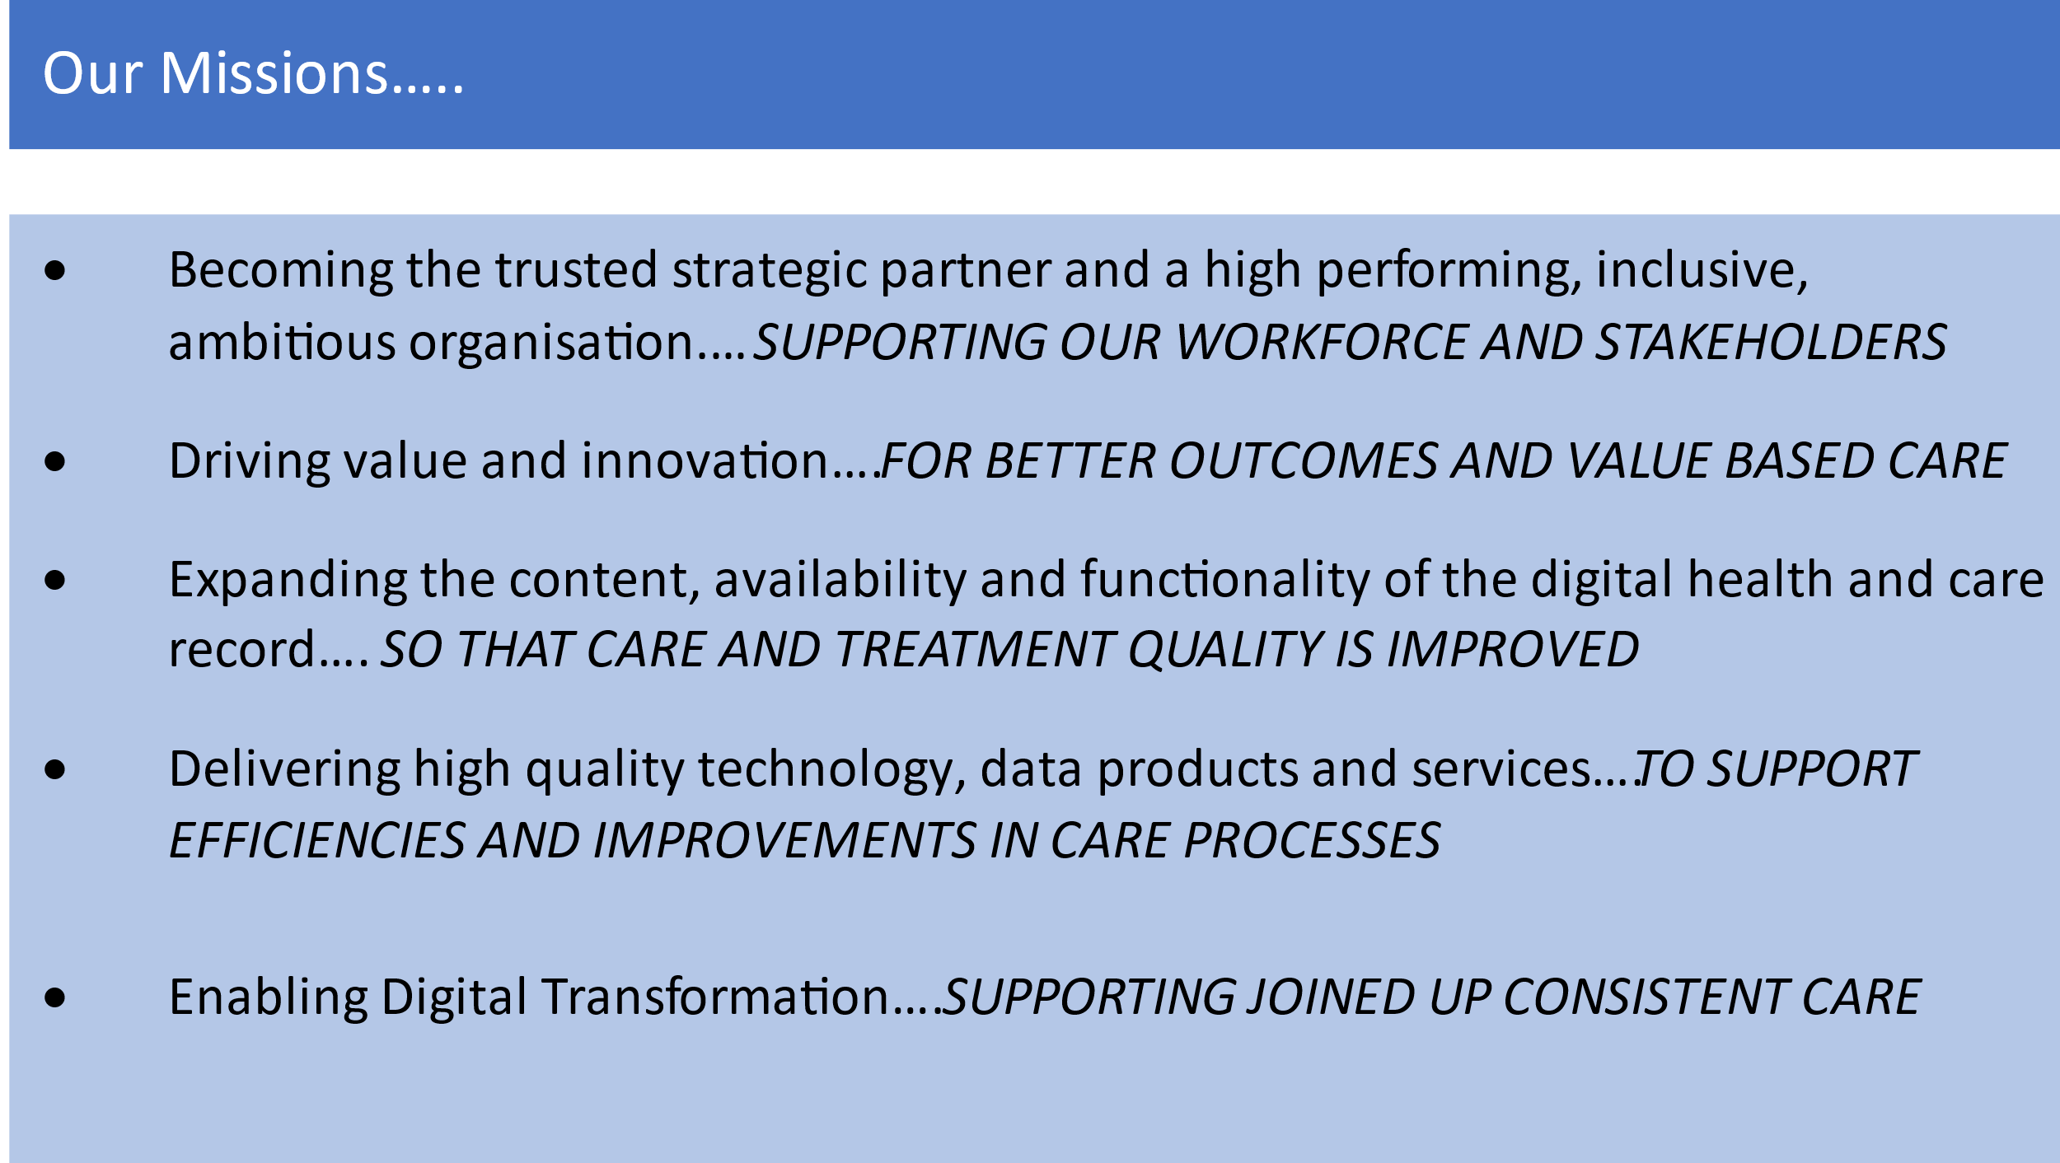

Figure 1 – Our Mission

This strategy will also support delivery the Welsh Government “a Healthier Wales: Our plan for Health and social care” strategy and support DHCW in aligning with the six mission statements in the Digital Strategy Wales

BACKGROUND
Currently national and DHCW digital data and systems are stored and operated primarily from two on premise facilities. These currently contain approximately 2,800 servers at the date of this document, of these 500 distinct servers are presented from public cloud, equating to 18% of total national estate. The current on-premise capacity has been funded through a combination of primarily capital investments over a number of years. It is supported annually by £7.96million of revenue costs comprising 70 Staff, service contracts with licences and energy costs. In order to achieve changes in capacity the organisation currently has to expend time and effort to develop business cases and procure and install server capacity at our data centres which can take months and in some cases years.

DHCW is both a supplier of services to Wales and a consumer of third-party services in its own right. These services used in NHS Wales hold large quantities of data, its estimated that the data held by DHCW for these services is currently growing at approximately 20-21% per annum with consequential financial pressures. The data being held on behalf of the specific healthcare providers can lead onto improvements in patient care, patient safety and ultimately patient outcomes including preventative measures for the wider population. This data needs to be scalable, secure and reside on reliable Information Communication Technology (ICT) infrastructure and be able to meet the changing demands of the service.

DHCW has been gradually migrating to cloud. The DHCW cloud journey started in 2016, for some of the cloud services that we have adopted. DHCW was an early pilot adopter of Microsoft Office 365 alongside two other NHS Wales organisations; as part of this implementation, it adopted Microsoft Azure Active Directory (a cloud-based authentication and identity management service) as a supporting technology. Subsequently, in addition to the wide-scale rollout of Microsoft 365 technologies across the organisation, DHCW has adopted a range of further Software as a Service (SaaS) services. Further to this, it has migrated its former on-premises DMZ services including Mura Content Management Systems to a combination of Platform as a Service (PaaS) and Infrastructure as a Service (IaaS) implementations and has recently completed the migration of its on-premises Test and Development environments to a cloud-hosted IaaS VMWare platform. Finally, it has deployed a variety of other hybrid SaaS/PaaS/IaaS services to meet specific needs (e.g., the Test, Trace and Protect Service supporting the Welsh Government’s pandemic management strategy, the Terminology Service component of the Welsh Reference and Terminology Service, the proof-of-concept API Management and Developer Portal, various integration services with third-party cloud services).

As a modern digital organisation, the expectations in terms of response, pace and dealing with greater variations in demand mean the benefits from adopting Cloud solutions are more attractive. Such approaches sit well with a more product orientated service model and enable greater options in relation to the service model and support but also support the new open architecture and data access philosophies being adopted by the organisation. With the Welsh Government direction towards Cloud provision DHCW has developed this document to set out the proposed approach to embrace a cloud centred digital provision.

Strategic Context

What do we mean by the cloud?
Cloud is more than just someone else’s datacentre; Cloud is a modern way of doing ICT. Cloud computing is the on-demand availability of computer system resources, especially data storage and computing power, without direct active management by the user. These systems are typically remote from the customer, in a shared data centre which is accessed over the Internet (though supplemental private circuit access is becoming more common). Charges are typically based on consumption, whether that be of bandwidth, storage or compute or are on a monthly subscription basis. The typical premise of Cloud computing is as follows:
- Resources can be created very quickly, typically within minutes
- Compute or storage capacity can quickly be scaled up or down as required
- Costs are based on usage, these are typically revenue rather than capital expenditure, however some items can now be capitalised
- Some or all the maintenance is undertaken by the vendor
Further information on Cloud computing is available in APPENDIX A – Cloud Service Offerings.

Scope
This strategy focuses in particular on the services and systems that DHCW either hosts or manages either directly or indirectly on behalf of NHS Wales and other consumers beyond as a supplier. These services and systems are collectively known as national services.

In order to provide a comparative baseline with good practice, this document follows the Gartner recommended approach to developing Cloud Strategy documents, best summarised with the following infographic.

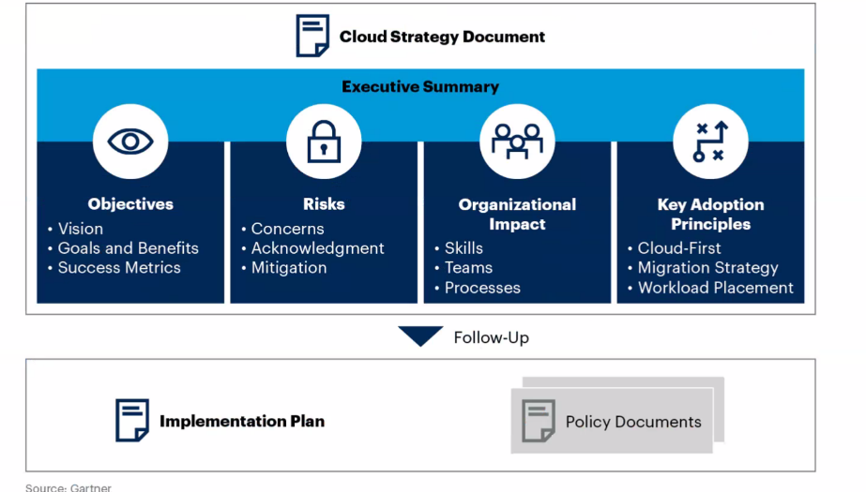

Figure 2 – Cloud strategy overview
As such, detailed policy and/or implementation plans are considered out of scope. They are/shall be supplementary documents to this strategy.

Strategic Vision
As described above, DHCW (and its predecessor organisations) has already adopted a number of cloud solutions, to meet a variety of operational, and often tactical, needs. DHCW established a Cloud working group that developed a DHCW Cloud vision:

Our vision is to be a Cloud First organisation from 2022 and to have migrated over 50% of our services to public cloud by 2024 supported by the development of a Cloud Centre of Excellence professional cloud management processes and learning from the best.

This strategy now formalises the process of cloud adoption to encompass the wider range of services provided and consumed by DHCW, with a view to achieving the following objectives and metrics:

- “Cloud First” organisation from April 2022.
- Enhance existing Governance measures for public cloud by May 2022.
- Make available the initial National Data Resource via cloud by July 2022.
- Develop product roadmaps that align to “cloud first” by 2023, with a key focus of Internet first, bringing data closer to the patient.
- Deliver 40% of national services from public cloud by January 2024 with an ambition to increase this target to 65% by 2026.
- Reduce reliance on large bespoke Capital expenditure by 2025 and shift to a revenue-based financing model.
- Develop an organisational Cloud Centre of Excellence by 2022/23

Organisational benefits
The adoption of this Cloud Strategy will enable the organisation to achieve a variety of benefits, both to business processes and in terms of technical modernisation. It is essential that the move to cloud is championed at an executive level and perceived as a significant change programme to ensure success and it is owned at an operational level (requiring a change in working practice/s). Some of the key anticipated benefits are described below.

Adaptability to variable demand
At present, it is difficult, if not impossible, for DHCW to rapidly scale up (or, for that matter, down) its services to meet changes in demand – whether this is something as simple as reduced load at weekends and out of hours, or for more complex examples such as the implementation of a new population-scale vaccination programme at short notice. Cloud services, if configured correctly, can help shorten project deployment timescales and even automate the provisioning or deprovisioning of capacity to meet such changes in near-real-time.

Enhanced collaboration
The shortfalls identified by the Welsh Government Architecture Review of 2019 indicate a clear determination to make data resources available to partner organisations in a much more consistent and standards-based manner than previously. Adoption of Cloud Services is a key driver to achieving this, both through implementation of technologies such as API Management, but also through further deployment of secure cloud-based data sharing, “big data” analysis, and artificial intelligence (AI) capabilities.

Shift to high-value activities
The current DHCW hosting model puts a significant burden on staff across operational teams in terms of routine maintenance and other low-level management tasks, such as patching of applications and operating systems, and replacement of broken hardware components. By offloading responsibility for these activities to the Cloud supplier or to the greater automation capabilities brought by Cloud adoption, these staff can be freed-up to focus on more productive activities. This will enable the shift to multi-functional product teams which will have an agile, end user focused approach to product delivery.

Capital Cost savings
Widespread adoption of Cloud services will allow, over time, a corresponding reduction in need for on-premises infrastructure (e.g., data centre rack “footprint”). This in turn will permit savings to be realised in the large costs of procuring and maintaining these environments so long as the most appropriate cloud technology/services are adopted, and efficient processes are put in place for driving value from the cloud. Furthermore, the adoption of Cloud services will provide opportunities for reduced reliance on capital funding as a means of supporting the organisation’s infrastructure: whilst this model aligns well to a project-based organisation, it is increasingly the case that DHCW’s services are achieving maturity, and so there is consequently a need for a more reliable funding model than capital to support ongoing service delivery.

Increased reliability and availability of services
Whilst DHCW has been largely successful in delivering highly available, reliable application services to its clients, this has required, and continues to require, significant investment to achieve on-premises deployments. Many of the technological approaches to delivering this are routinely available in the Cloud, where the advantages of so-called “hyperscale” are such that the larger Cloud providers can meet and exceed extremely demanding reliability and availability SLAs.

Environmental improvements
Public cloud suppliers, by dint of scale, are able to invest in, and make available, more modern, energy-efficient infrastructure, and have made commitments to being powered using 100% renewable sources in the very near future along with investment in carbon offsetting practices. These, combined with the opportunity to use improved orchestration toolsets to marry service capacity with demand, will permit DHCW to reduce its overall environmental footprint. As part of our Decarbonisation Strategic Delivery Plan produced in 2021, DHCW has identified improvement targets relating to procurement and the efficiency of data centre consumption and it is envisaged this will be an ongoing requirement that will need to be addressed in the medium and longer term.

Measuring Success
To determine the effectiveness of our cloud strategy, we will measure our cloud implementation process against the metrics listed in Table 1. We will also conduct a biannual assessment of the progress against these metrics to adjust the implementation plan as needed.

Goal | Metric | Success Value | Completion Date
Enhanced governance structure in place for Cloud workload placement | Approved Governance structure in place | Structures in place | May 2022
National Data Cloud Platform service created | National Data Cloud Platform in service | live service | July 2022
Cloud Native focus Product roadmaps | National services with cloud native product roadmap | Documents in place | 2023
Increase % of public cloud provided national services | percentage of national services in public cloud increased to 40% | 40% | Jan 2024
CapEx reduction | Capital cost reduced | Reduction of 40% from 2019/2020 funding level | 2025
Increase % of public cloud provided national services | percentage of national services in public cloud increased to 65% | 65% | Jun 2026
Table 1 – Success Metrics

Cloud Strategic Principles
The purpose of this section is to define the high-level strategic principles for the provision, operation and consumption of cloud services by DHCW. It highlights the key principles that the organisation aspires to adopt through implementing this strategy.

Cloud First
When procuring new or existing services, public sector organisations should consider and fully evaluate potential cloud solutions first before considering any other option.

Multi Cloud
For SaaS solutions and specialist PaaS services, we will choose our provider based on analysis of capabilities in the marketplace. For IaaS and generic PaaS deployments we will identify a single provider of these services.

Cloud Tiers
When we don’t buy SaaS we will develop and host applications on PaaS wherever possible, using the PaaS services specific to the portfolio of the chosen cloud provider. We will only use IaaS when PaaS and SaaS solutions aren’t available or fail to meet our requirements.

Interoperability and Portability
Wherever possible, we will maintain data and application interoperability and portability for our services between private, hybrid and public cloud offerings.

Security
Security of data and systems will be a guiding principle of all future solutions from the outset, and this will be a feature of any new solution which we consider purchasing. All solutions we build will integrate with a Cloud-based SIEM. Our cloud security processes will adapt to support the agility of the cloud.

Skills
We will equip our teams with the skills they need to take advantage of the Cloud, supporting their changes in ways of working. We will support staff on this journey and any skills gaps will be addressed through effective workforce planning. Our ambition is to create a Cloud Centre of Excellence.

Governance
Our governance structures will support cloud delivery and new ways of working, allowing for more rapid provision of services.

Business Processes
A number of key supporting business processes will need to be reviewed and aligned to enable us to leverage the benefits of the cloud, this includes finance and procurement processes.

Continuous Optimisation
We will ensure cost-benefit from cloud through automated use of its flexibility and scalability; system capacity will be reduced in line with system demand. Tracking usage patterns and demands will occur on a regular basis to ensure continuous optimisation.

Service User Focus
Our services will be designed around user needs, delivered to the user more rapidly and be available across multiple device types from multiple locations. Where possible and appropriate services will be Internet facing whilst maintaining strong user security.

Identity
We will provide federated identity services for staff and architect our cloud services to provide single patient identities in the future.

Ease of Consumption
Accelerate business access to cloud innovation though user driven self-service consumption, within the preapproved service offerings. Our colleagues will be able to use templated service offerings to build infrastructure and services for our users in a controlled manner.

Risks associated with this strategy
We have identified 19 risks related to the adoption of cloud services detailed in Appendix D, the risks have been assessed based on likelihood and impact. The list has been collectively built with input from Infrastructure Design and Operations, Application Development, Cybersecurity, Finance, Commercial, Information Services, National Data Resource team, planning and programmes, and possible mitigations developed. The risks have been categorised as Business, Commercial, finance, security, technical and work force.

The key risks with scores above 10 which indicates there is likely occurrence and moderate impact:

- BUSINESS: Cloud providers may have outages that DHCW don’t control
- COMMERCIAL/TECHNICAL: DHCW may not be able to guarantee performance
- FINANCE: Lack of sustained revenue for cloud services, current revenue funding is supported by capital purchases
- WORKFORCE/SKILLS: DHCW don’t possess the required skills

For each of risk mitigation actions have been identified and incorporated into the forward plan.

Organisational Impact of Cloud Adoption
Cloud is the fundamental backbone to supporting the new organisation for product delivery and development. The technical skill mix within DHCW is currently optimised for an on-premises approach to system design and operations. There will be need to change the operating structures and governance processes to enable new developments but also to support the current product portfolios.
There is a need for a new governance process to enable the new product developments. A new Cloud Governance Group is being developed that will act as a supporting team to the current Welsh Informatics Assurance Group (WIAG). This will go-live in Quarter 1 2022/23 and will support assurance group decisions by providing commercial, finance, technical, security and IG assurance. The role of finance and commercial is critical to ensure successful adoption and management.

Existing on premise developments will be incorporated into the product strategies. To oversee, develop and support cloud capability and adoption, DHCW plans to develop a Cloud Centre of Excellence. The format and remit of this will be developed over the first half of 2022/23.
In order to ensure success in its cloud journey DHCW will need to transform its current teams and their skill sets; furthermore, roles and governance need to be enhanced and made suitable for the cloud computing model.

Cloud Architect approach
Gartner research from 2018/2019 highlights three top challenges of cloud being staff skills, complexity and stakeholder resistance. To address these challenges the organisation will look to appoint / nominate cloud architect(s). This role is both technical and non-technical, with main responsibilities that cover the following areas

- Develop cloud strategy, co-ordinate adoption
- Develop and co-ordinate cloud architecture
- Lead cultural change for cloud adoption
- Act as Broker of cloud services to developers and lines of business

The cloud architect(s) will form a cloud adoption framework, which will cover

- Develop the Cloud strategy
- Build / verify the cloud foundations
- Design and risk mitigations
- Enable governance
- Achieve operational excellence
- Build skills and assess applications
- Select providers and services
- Architect cloud services and mitigate risks
- Estimate billing and establish governance
- Provision and automate cloud services
- Operate cloud environments at scale

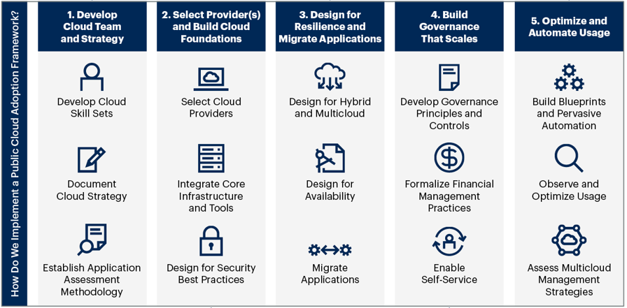

Figure 3 – Public Cloud Adoption Framework

Traditional ICT delivery is focused on engineers with specialised skills in specific domains. There needs to be a shift from domain focused to cloud engineers, with engineers moving from specialists to ‘versatilists’.

Further to this a cloud operating model approach will be selected and documented which will cover the engagement of cloud functions with business operations, detailing the processes, tools and resources necessary for delivery. The cloud adoption model will lead onto preparations to switch to DevOps delivery of services, allowing DHCW to become more agile for software deliver.
Many of DHCW existing business and technology processes are not currently suitable to align with cloud adoption, such examples would include procurement, provisioning and service costing for Service Level Agreements. The implementation and governance workflows will identify and support changes to manage this alignment. Procurement adaption to the characteristics of cloud will focus on framework, rather than bill of materials (BOMs). Further work has been undertaken on the

governance process and structure, together with the NDR team. The foundations have been described, a commercial strategy that enables

appropriate cloud adoption together with the underpinning enabling infrastructure is drafted and included in the forthcoming IMTP.

Teams and Skillsets
DHCW will undertake training of technical staff across a target range of digital skills, some of which will include completely new skillsets for the organisation. Without this skills transition, DHCW will not be able to fully leverage the benefits of the cloud resulting in a restriction of the functionality implemented using cloud technologies and therefore less likelihood of realising cloud benefits.
This will be achieved through a skills plan based on roles within DHCW, followed by a skills gap analysis. Training needs, with opportunities to gain certification will then be identified as part of employee professional development.

Initial migration to cloud will require additional resources to boost the existing staff during the ‘skilling’ phase. This resource boost will use a combination of recruitment of skilled staff, professional services and short-term contracts, utilising existing frameworks available to DHCW.

Cloud Centre of Excellence - CCOE
Technical professionals must ensure DHCW gains the right skills and structure to drive cloud adoption success. A Cloud Centre of Excellence, supported by an advisory group, is the best-practice approach. DHCW will create a Cloud Centre of Excellence. This cross functional team forming the CCOE will have three core pillars of Governance, Brokerage and Community. Governance will focus on the policies, governance tools and business processes, providing the correct risk and financial management using DHCW risk and financial appetite criteria. Brokerage will focus on the choice of providers, solutions, contract negotiation and vendor management. Community will focus on the organisational approach, raising awareness, capturing and circulating best practices to drive cloud transformation forward.

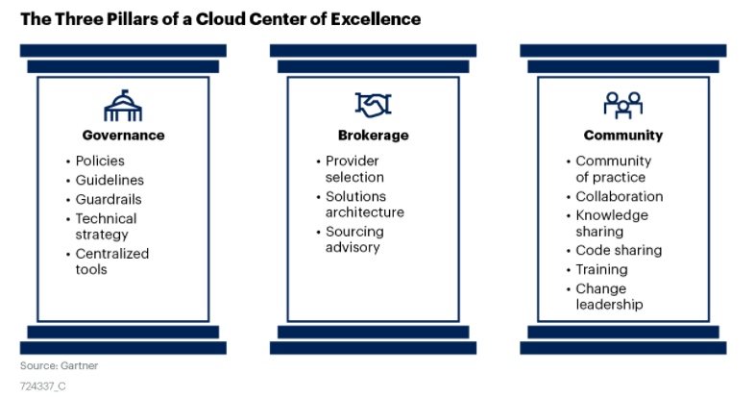
Figure 3 – Pillars of a Cloud Centre of Excellence (CCOE)

Governance Approach
Cloud services will require DHCW to transform existing processes (and where appropriate acquire new process/es) to facilitate adoption. Governance requires both preventative and retrospective controls. Preventative controls stop unapproved or inappropriate actions prior to their execution, whilst retrospective controls detect and remediate compliance issues on existing resources. Establishing presence in multiple clouds increases the complexity for establishing and enforcing governance.
Governance will look to:

- Create policy definitions independent of provider specific implementations
- Balance agility and autonomy for those staff directly involved in cloud work with the need to protect the organisation. Assume native cloud tools will be used, and access will be managed through policies implemented via programmatically enforced guardrails
- Understand the gaps of provider toolsets and expand the toolsets to bridge gaps
- Retrofit existing cloud environments to enforce governance policies in a preventative manner. Complement preventative controls with retrospective controls for policies that cannot be enforced at provisioning
- Ensuring that governance is appropriately managed throughout product lifecycle
- Usage is appropriately managed to drive out value

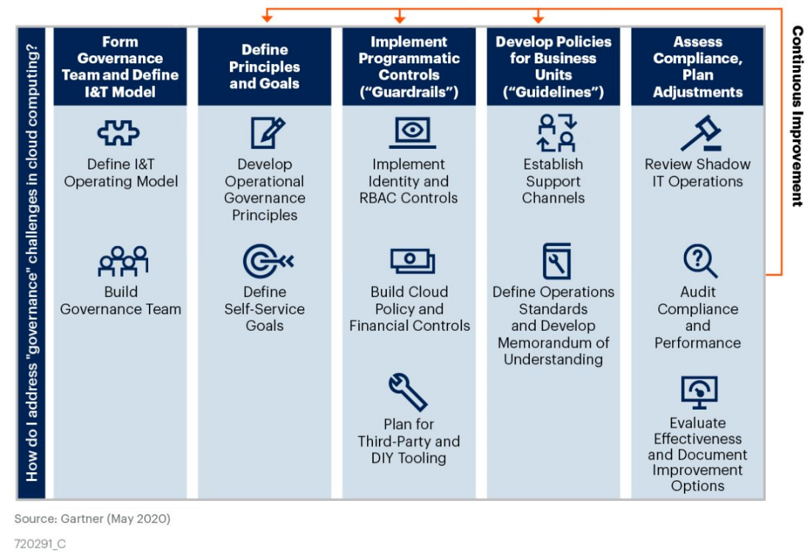
A Cloud Governance Group or Cloud Council will be created to align with the organisational Cloud Strategy. This group will describe the governance principles, aim to align with Cloud providers’ governance approaches, implement guardrails (designed to stop bad outcomes) and guidelines (communicating risk boundaries). The Cloud Council will consist of roles covering a range of organisational specialist knowledge domains, the Council will have responsibility for:

Figure 4 – Addressing Cloud Governance

- Defining the policy goals
- Defining policies addressing the Areas of Cloud Management for Governance
(see infographic below)
- Implementing preventative controls
  - Identifying policies allowing preventative controls to be established
  - Configure using native cloud tooling
- Gaining total visibility
  - Enabling and locking down logging for cloud resources
- Creating audit process to implement retrospective controls
  - Establishing continuous automated audit compliance / performance
  - Mapping remaining policies via automated tools for policy checks and enforcement
  - Defining remediation outcomes
  - Implementing automated remediation
- Implementing a strategy for integration of tooling across providers

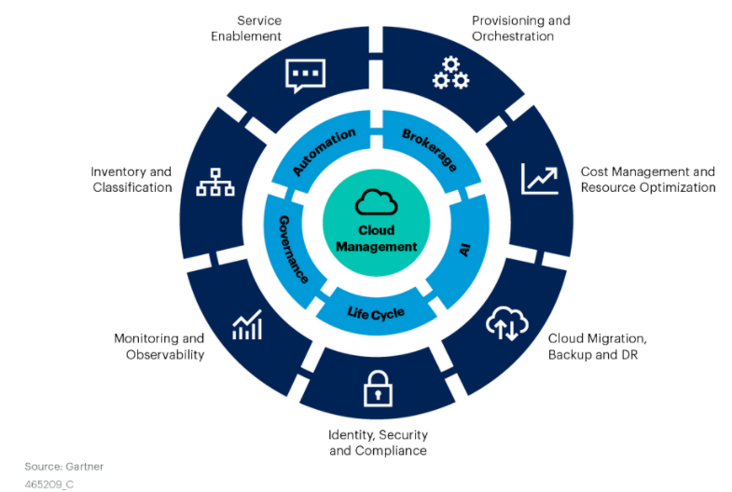
Governance policies of cloud can be broken down into several areas of management, best shown in the following infographic.
Figure 5 – Areas of Cloud Management for Governance

The terms in the graphic above are realised into DHCW specific areas:
Cost Management and Resource Optimisation - Financial
- Controls will be developed to protect DHCW against uncontrolled deployment of Cloud resources or services
- Controls will be in place to manage and monitor the spend of cloud resources
Cost Management and Resource Optimisation - Technical
- Controls and processes will be in place to optimise resources

Cost Management and Resource Optimisation - Commercial and contractual arrangements
- Controls will be in place to manage both procurement and contractual reviews for cloud providers, adapting for the agile needs of Cloud resources

Identity, Security and Compliance - Information Governance & Security
- Building on the existing Cloud Risk Assessment process, controls will be in place to manage the assessment and mitigations of risk with regard to Information Governance obligations and security measures
Cloud Migration Backup and DR – Migration & Technical
- The migration priority for existing applications based on risk, benefit, efforts and feasibility
- The migration strategy for existing applications. We will prefer the “Rearchitect” approach (see section 8.3) to achieve appropriate cost-effective cloud adoption, but we will not fully dismiss approaches such as “rehost” or “revise” where the rearchitect approach options have been exhausted.
Service Enablement – Placement
- The optimal application placement between public cloud providers and our remaining data centres.
Provisioning and Orchestration & Monitoring and Observability - Technical
- Standards will be developed and maintained to ensure an elevated level of repeatable quality is delivered
- Standards and Processes will be developed to enhance existing monitoring configurations and provide rightsizing data to better manage cloud resources for cost effectiveness
Inventory and Classification – Service Management
- Standards and processes will be developed to allow cloud resources to be successfully captured and systems service mapped alongside on-premises systems

Exit Strategy
When entering into a public cloud-based services, it is essential that there is a clear exit strategy for risk-management purposes. Cloud failure risks across the cloud tiers (IaaS, PaaS, SaaS) are usually low and an exit strategy will be focused on registering and managing risks, but not limited to service failure or vendor lock-in. Exiting public Cloud is not always technically or economically feasible; viable exits are likely to be expensive, effortful and risky as well as technically and operationally challenging. Conversely improving portability to ease exit options increases costs as well as time and effort as achieving the ability to allow cloud-to-cloud application portability (or exiting) requires trade-offs through the application lifecycle.

An Exit Strategy will be developed as a separate document to accompany this Cloud Strategy document.

Migration Approach and High-Level Timeline

Overview
In line with Integrated Medium-Term Plan (IMTP) and this document, DHCW will look to provision new services directly in public cloud where appropriate and to migrate on-premises servers to make use of public cloud services. A balance of the principles, visions, Infrastructure age, infrastructure support costs, security requirements, application product roadmap and risk appetite of the product and organisation will help define the speed and timings at which both new and existing services will migrate.
The overall timeline approach will establish

- Commercial strategy
- Data strategy
- Governance processes
- Resilient connectivity to public cloud provider(s)
- API Management solution (new service)
- National Data Platform (new service)
- Phase 1 of on-premises applications migration (existing services)
- Phase 2 review other on-premises application (existing services)

Provision of new cloud services
The cloud first principle states when procuring new or existing services, public sector organisations should consider and fully evaluate potential cloud solutions first before considering any other option.

Deriving value from data is a key ambition and to achieve this at scale and to allow rapid data analysis a move to cloud is essential. Whilst current on-premises datasets and analysis tools are available locally and nationally, the scalability, analysis capability and artificial intelligence algorithms in public cloud surpass any potential improvements that could be acquired through further advances in on-premises technologies.

Our aim is to make the products and services that we invest effort in developing to be as portable as possible, while recognising the opportunities that specialist (and sometime proprietary) cloud capabilities can offer to accelerate delivery.

The trade-off we need to consider is between “time to value” on the one hand and “cost to exit” on the other. Open-source approaches reduce the cost, time and effort to port to a different cloud provider in future but may require more effort to deliver value. Whereas specialist cloud capabilities can sometime offer accelerators to deliver value really quickly but can result in a higher barrier to exit. The important thing is to be aware of the trade-off and understand and be content with the implications of the decisions we make.

Two key initiatives will be progressed as cloud first these are National Data Resource (NDR) programme and the API management solution. These will underpin delivery of the commitments made in A Healthier Wales with goals to deliver a more joined up approach to health and care data across Wales.

National Data Resource Programme

The National Data Resource (NDR) programme is a strategic imperative for health and care in Wales and an essential component of the Digital Architecture Review. The NDR programme will bring together and open up access to data from all organisations that play a role in a patient’s health and care in Wales.

NDR has recently worked with Gartner to produce a data strategy. One aspect of the data strategy has been to help define a conceptual and logical architecture for a data platform to support the ambitions of the programme and A Healthier Wales. The data platform will be responsible for the acquisition, movement, transformation, storage, serving and governance of data as well as providing the analytical, data science and machine learning tools needed to extract value from data. A subsequent engagement with Gartner has provided us with an independent assessment of major cloud vendors against our required capabilities in the context of NHS Wales requirements, helping to assure our own direction of travel in selecting a major cloud provider as the basis for the data platform.

API Management

The API Platform has been identified as a key enabler for the NDR architects proposed Architectural Building Blocks (ABB), providing security for APIs and enabling the free flow of data between systems. The building blocks are central to the NDR’s long-term vision and address the challenges highlighted in the Digital Architecture Review (2019).

Below is a proposed timeline for the deployment of the APIM and initial NDR platform is shown below. A separate Data Strategy will detail the strategic direction of NDR and the Architectural Building Blocks.

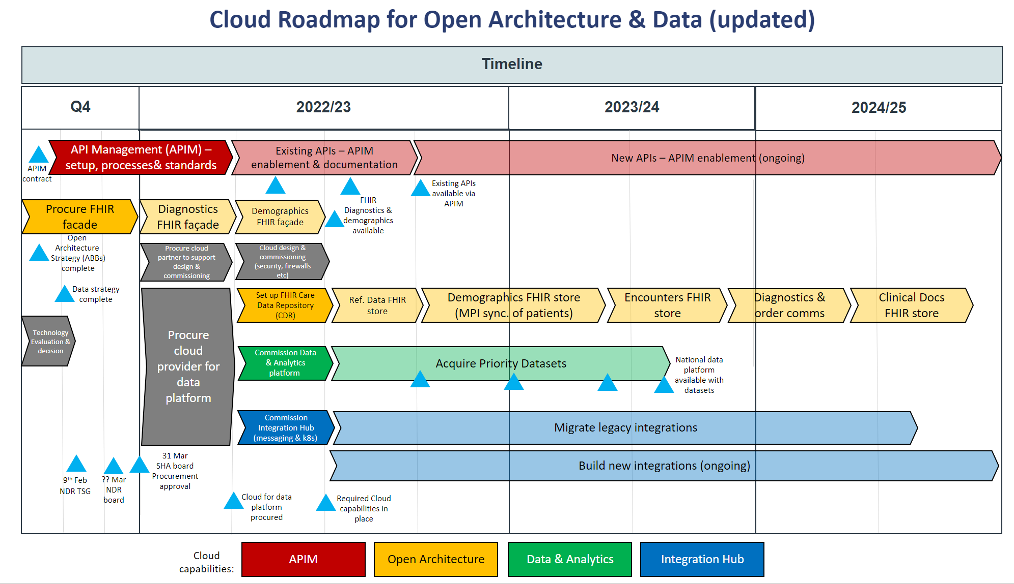
Figure 6 – Timeline of APIM and NDR platform

Migration of Existing Services - Phased approach
Existing Services

The approach for existing services will be to migrate everything, defined as “migration should be favoured for all workloads that are technically feasible, although the timing of that migration will be dependent on business factors.”

There are five key options for migration, ‘Rehost’ being low risk (effort), low reward (benefit of cloud), both risk and reward increase as the list is descended.

- Rehost – Essentially lift and shift to cloud
- Revise – Minor modifications to allow consumption of PaaS or CaaS (Container as a service)
- Rearchitect – Major changes to the application to consume more cloud-native technologies
- Rebuild – Start from scratch jettisoning existing code and develop new
- Replace – Replace exiting COTS or custom system with a SaaS offering
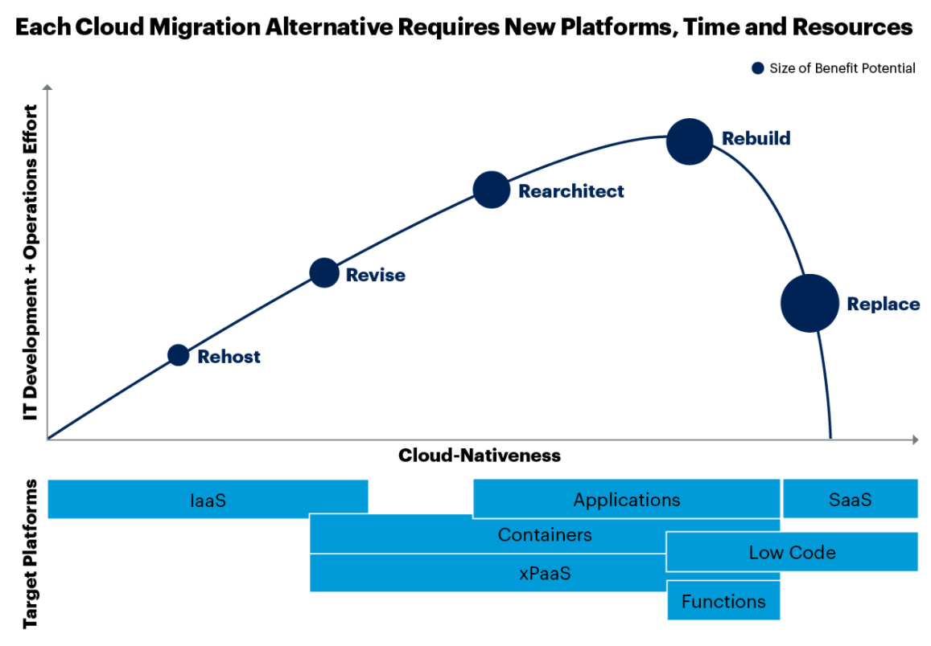
Figure 7 – Cloud Migration strategies for applications

As described in section 23, the speed of the migration of on-premises services to make use of public cloud services will be affected by a variety of factors, and the organisation will need to balance these factors in determining detailed plans. The migration of existing services will be driven by organisational priorities, emerging from the overall architectural roadmap as defined by the ABBs, the individual application team product roadmaps and the evolving requirements to support the needs of the NDR programmes.

The detailed timetable and migration approach for individual applications and services are outside the scope of this particular strategy. However, it is reasonable to assume that in most cases the most suitable approach to migration will be:

- Rearchitect – defined as “altering the application so that you can shift it to a cloud-optimized architecture, making heavy use of cloud-native capabilities.” This approach to migration is an in-depth undertaking requiring changes to culture, technology, people, processes and platforms. Product roadmaps for services provided will be further developed aligning to both cloud and data strategies as well as the Application Building Blocks

However, we will not rule out other options, where rearchitect options have been thoroughly exhausted.

Implementation Timescales

Continuous revenue funding will be sought from Welsh Government. Funding will allow the build and migration phase of the implementation to commence; cementing the delivery of the digital transformation set out in this cloud strategy document.

The proposed timelines allows for:

- Allow pre-requisites to be completed first
  - Including enhance resilient links (required for migration of any critical services)
  - Additional recruitment and skills framework assessment
  - Discovery and design phase
  - Enhanced Governance establishment
- Agreement to Proof-of-Concept application migration deliveries
- Alignment with resource capacities
- Agreement to align with DHCW IMTP for 2022-2023, 2023-2024

Service complexity allowing, the approach for migration will follow the timeline process pattern suggested.

Figure 8 – Build / Migrate and test migration timeline breakdown

The figure details the process to migrate to cloud, to maximise resilience and provide assurances for security and acceptance testing to reduce the risk levels of a lift and optimise approach
This workstream will actively decommission systems and their associated data from the datacentres once the Cloud system solution has gone live. As part of the decommission it will be necessary to end and alter contracts, such as hardware warranty support where appropriate.

Implementation timeline
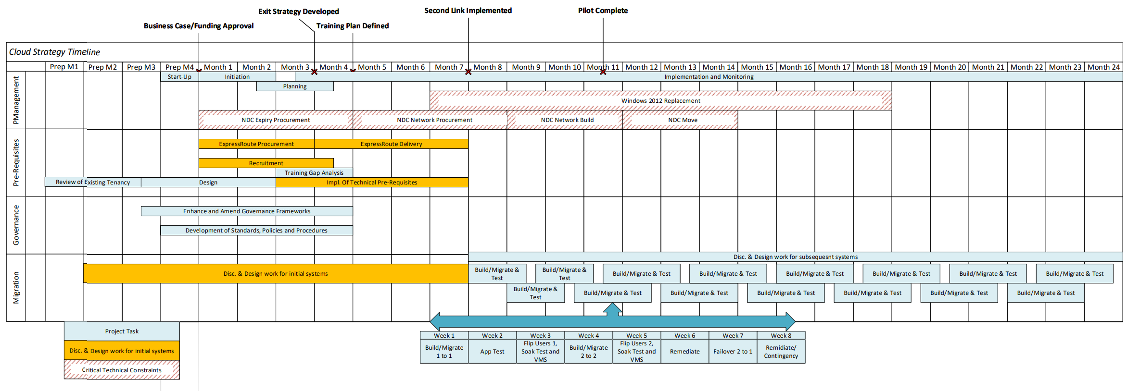
The following cross-functional flowchart image provides a working timeline for the migration of an initial cohort of applications, together with the essential key activity that will directly impact this package of work. As described in Section 22, further work will be needed to define the detailed timetable for individual application migrations.
Figure 9 – High-Level Implementation Timeline

Conclusion
DHCW has a vision to move to public cloud to help transform the way they deliver products in a faster, efficient safe and effective way to enable better health and care. Gartner (Figure 2) recommends that a Cloud strategy has a key set of ingredients; a set of strategic cloud principles, measurable objectives that has been risked assessed and how the organisation will enable the delivery.

Underpinning the DHCW cloud strategy will be the governance and procure processes, development of the Cloud Centre of Excellence each of those aspects have been described and detailed and will be part of the implementation plan. The key aspects of the cloud strategy have been included in the detailed IMTP /NDR programmes plans.

All new cloud product developments will require the associated cloud funding as part of the business case including the set-up costs and a provision for operational consumption variability & growth. For the current products the transition costs whilst on prem and cloud will need additional funding. The requirements and timing of the funding is yet to be defined and will be undertaken as part of the product strategies. This leaves a requirement for additional funding for the DHCW cloud governance and Centre of Excellence, a business case for this requirement will need to be drafted.

The DHCW strategy has been developed collectively within DHCW with involvement from all Directorates and the NDR programme, with professional insights and learnings. It’s a bold and ambition undertaking and the Cloud Strategy Team are focused on the implementation plans.

APPENDIX A – Cloud Service Offerings
There are three main deployment models for cloud:

Private cloud

The cloud infrastructure is provisioned for exclusive use by a single organization comprising multiple consumers (e.g., business units). It may be owned, managed, and operated by the organization, a third party, or some combination of them, and it may exist on or off premises.

Public cloud

The cloud infrastructure is provisioned for open use by the general public. It may be owned, managed, and operated by a business, academic, or government organization, or some combination of them. It exists on the premises of the cloud provider

Hybrid cloud

The cloud infrastructure is a composition of two or more distinct cloud infrastructures (private, community, or public) that remain unique entities, but are bound together by standardized or proprietary technology that enables data and application portability (e.g., cloud bursting for load balancing between clouds).

There are three main service offerings from cloud vendors, which are detailed below.

Platform as a Service (PaaS)

Platform As a Service (PaaS) – A vendor provides the platform, storage, servers and networking, and the user manages the applications and data on this platform. Examples of this are parts of Azure such as Webapps, SQL Azure.

Software as a Service (SaaS)

Software as a Service (SaaS) – A software vendor provides access to their product over the internet. All hosting, operating system management, servers, networking etc is taken care of by the vendor. Office 365 is an example of this.

Infrastructure as a Service (IaaS)

Infrastructure as a Service (IaaS) – This gives the ability for virtual servers and virtual infrastructure to be created in an environment where the underlying physical hosts are managed by the provider. Examples of this include Microsoft Azure and Amazon Web Services for virtual server hosting.
It is to be noted that these types of cloud computing are not mutually exclusive, and organisations may implement all three varieties simultaneously, dependent on their needs.
As is evident from the descriptions, each flavour of Cloud requires a different level of management and support overhead, and also each flavour of cloud differs in the level of benefit it provides when compared to a traditional on-premises, or managed physical architecture. The following diagram illustrates this:

For more information, please see NIST SP 800-145, The NIST Definition of Cloud Computing.
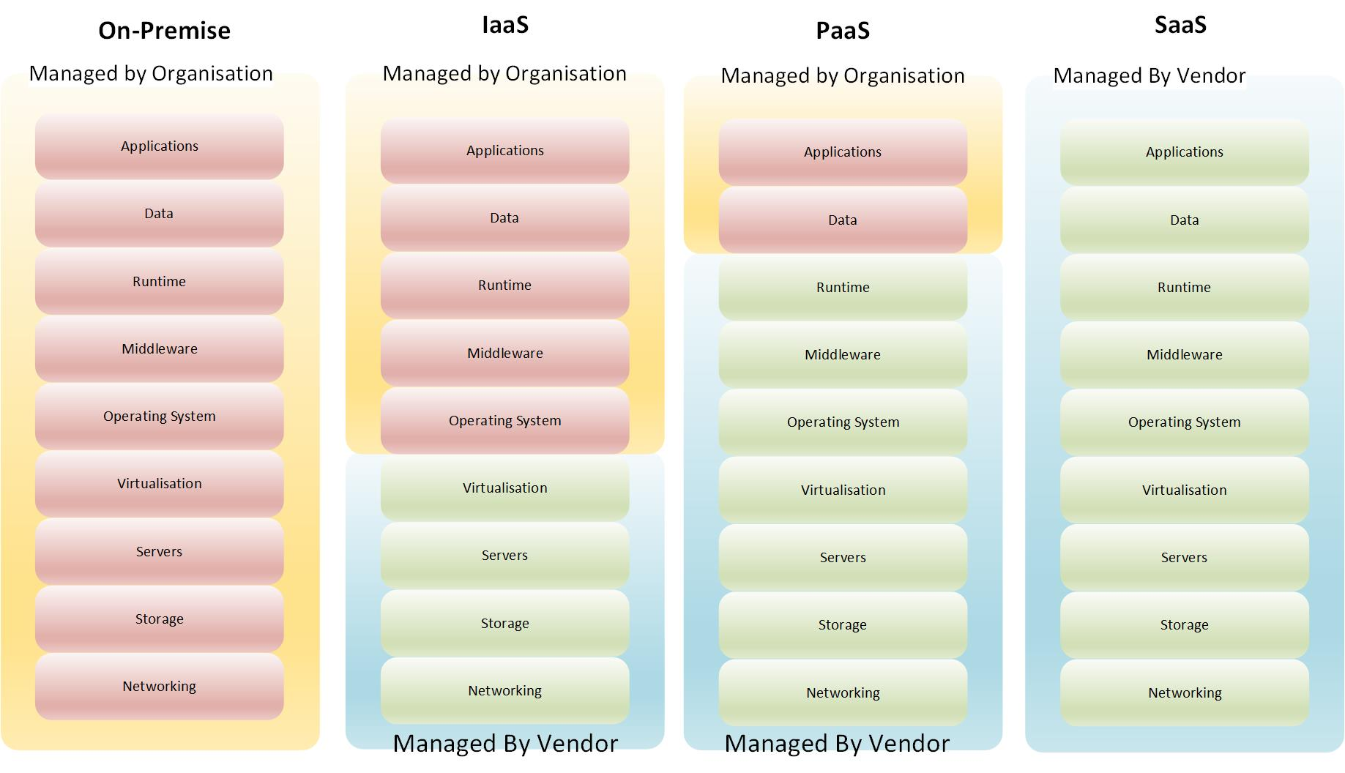
Figure 10 – Division of responsibility for cloud types and on-premises

APPENDIX B - List of services running in Public Cloud
iPassport - Quality Management System
AdminControl - Meeting paper management service
Microsoft Azure Devops Service - for developer source control
Prolaborate – Architectural document design sharing service
Microsoft Azure Active Directory - a cloud-based authentication and identity management service
TTP- Test, Trace and Protect Service supporting the Welsh Government’s pandemic management strategy
Terminology Service component of the Welsh Reference and Terminology Service
Proof-of-concept API Management and Developer Portal
various integration services with third-party cloud services etc
Moodle – eLearning solution
Secure File Sharing Portal – a secure method of transferring data including PII to and from NHS Wales – e.g., for legal purposes to solicitors
Cleric services – WAST planning tool
Student award system

APPENDIX C – Cloud Principles
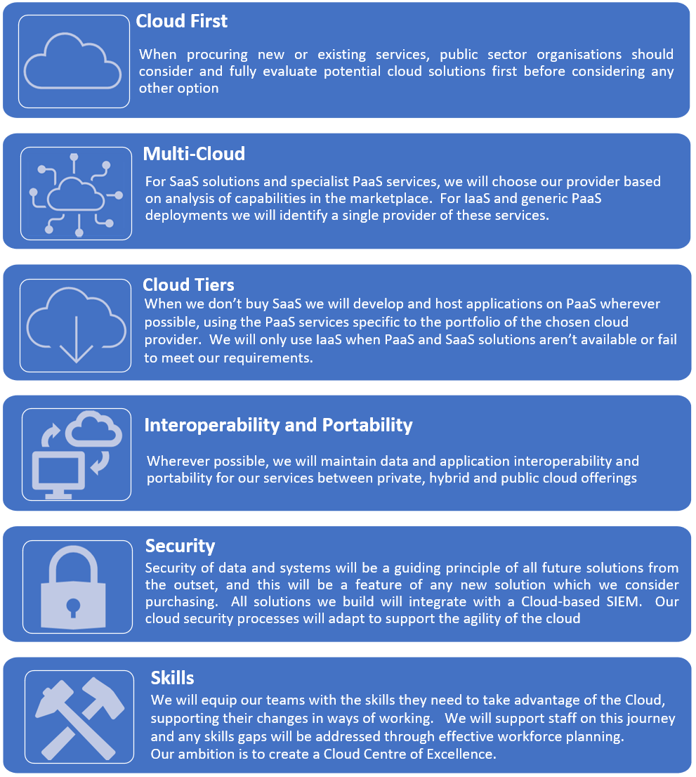

Figure 11 – Cloud Principles (1 of 2)

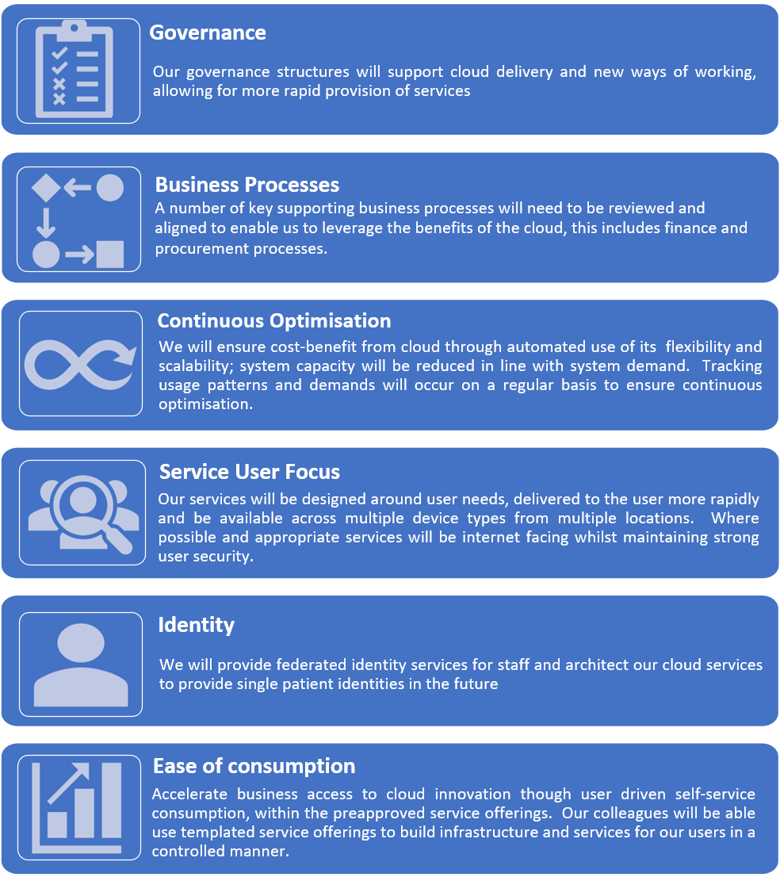

Figure 12 – Cloud Principles (2 of 2)

APPENDIX D -Risk
LIKELIHOOD – TAKES INTO ACCOUNT FREQUENCY AND PROBABILITY
Frequency – How often might it happen? | 1.  Rare  This will probably never happen/recur (except in very exceptional circumstances). | 2.  Unlikely  Do not expect it to happen/recur but it is possible that it may do so. | 3.  Possible  It might happen or recur occasionally | 4.  Likely  It might happen or recur  occasionally. | 5.  Almost Certain  it will undoubtedly happen/recur,  possibly frequently.
Probability – will it happen?  (What is the chance the adverse consequence will occur in a given reference period?) | (0-5%*) | (5-25%*) | (25-75%*) | (75-95%*) | (>95%*)

IMPACT – HOW WILL THIS RISK IMPACT THE ORGANISATION
Domain | 1 Negligible | 2 Minor | 3 Moderate | 4 Major | 5 Catastrophic
Financial | Unplanned financial impact under 0.1% of budget | Unplanned financial impact between 0.1% and 0.25% of budget | Unplanned financial impact between 0.25% and 0.5% of budget | Unplanned financial impact between 0.5% and 1% of budget | Unplanned financial impact > 1% of budget
Compliance | No or minimal impact or breech of guidance/ statutory duty | Minor non-conformity with statutory legislation /  Reduced performance rating if unresolved | Single breech in statutory duty /  Challenging external recommendations/ improvement notice | Enforcement action /  Multiple breeches in statutory duty Improvement notices /  Low performance rating /  Critical report/ special measures/ replacements of management | Multiple breeches in statutory duty /  Prosecution/  Complete systems change required /  Zero performance rating/  Severely critical report

Patient/Citizen Safety | Minimal injury requiring no/minimal intervention or treatment No time off work /Informal complaint/inquiry /  Peripheral element of treatment or service suboptimal /  Informal complaint/inquiry | Minor injury or illness, requiring minor intervention / Formal complaint (stage 1) /  Minor implications for patient safety if unresolved | Moderate injury requiring professional intervention/  An event which impacts on a small number of patients /  Formal complaint (stage 2) complaint /  Major patient safety implications if unresolved | Major injury leading to long-term incapacity/disability / Mismanagement of patient care with long-term effects /  Multiple complaints/ independent review Low performance rating /  Non-compliance with national standards with significant risk to patients if unresolved | Incident leading to death /  Multiple permanent injuries or irreversible health effects /  An event which impacts on a large number of patients /  Gross failure of patient /  Totally unacceptable level or quality of treatment/service
Safety and Wellbeing | Short-term low staffing level that temporarily reduces service quality (< 1 day)/ >80% appraisal compliance rate | Low staffing level that reduces the quality of services/ >75% appraisal compliance rate | Late delivery of key objective/ service due to lack of staff/RIDDOR/agency reportable incident / Unsafe staffing level or competence (>1 day)/  Low staff morale/ >70% appraisal compliance rate | Uncertain delivery of key objective/service due to lack of staff /Loss of key staff /Very low staff morale / >65% appraisal compliance rate | Non-delivery of key objective/service due to lack of staff  /Ongoing unsafe staffing levels or competence Loss of several key staff / >60% appraisal compliance rate
Service Delivery | Recovered within the Service Level Agreement timeframe and is a non-recurrent event | Recovered slightly outside the Service Level Agreement timeframe and is a non- recurrent event | Recovered outside the Service Level Agreement timeframes/potential ongoing recurrent service disruption | Recovered outside the Service Level Agreement timeframes/Frequent service disruption | Permanent loss of service or facility
Development of Services | Insignificant cost increase/ project slippage slightly outside tolerance | <5 per cent over project budget Schedule slippage | 5–10 per cent over project budget /  Schedule slippage | Key objectives not met /  Non-compliance with national objectives  10–25 per cent over project budget Schedule slippage | Incident leading >25 per cent over project budget Schedule slippage /  Key objectives not met
Reputational | Rumours /  Potential for public concern/ | Local media coverage – short-term reduction in public confidence /  Elements of public expectation not being met /  Local resolution /  Single failure to meet internal standards/  Reduced performance rating if unresolved | Local media coverage – long-term reduction in public confidence / Repeated failure to meet internal standards /  Local resolution (with potential to go to independent review) | National media coverage with <3 days service well below reasonable public expectation / Critical report | National media coverage with >3 days service well below reasonable public expectation. MP/MS concerned (questions raised)/ Total loss of public confidence / safety if findings not acted on / Inquest/ombudsman inquiry / Gross failure to meet national standards
Information – Storing and maintaining | Minimal or no loss of non-vital data/ minimal or no impact on reputation/ minimal or no failures in responsibilities | Insignificant loss of data causing minor reduction in service quality/ minor impact on reputation/ minor failures in responsibilities | Minimal loss of data causing moderate reduction in service quality/ moderate impact on reputation/ moderate failures in responsibilities | Retrievable loss of multiple data sets causing reduction in service quality/major impact on reputation/ major failures in responsibilities | Irretrievable loss of data/catastrophic impact to reputation/ gross failure in responsibilities
Information – Access and Sharing | Access interruption for <1 day/ negligible impact to reputation/ no failure in responsibilities | Access interruption for more than 1 days/minor impact to reputation/ no failure in responsibilities | Access interruption for more than 2 days/ /moderate impact to reputation/ gross failure in responsibilities | Access interruption for more than 3 days/ major impact to reputation/ gross failure in responsibilities | Access interruption for more than 4 days/ catastrophic impact to reputation/ gross failure in responsibilities
Corporate Social Responsibility | Minimal or no impact on the environment or decarbonisation objectives/Minimal non-compliance with Welsh Language Standards | Minor impact on environment or the decarbonisation objectives / Minor non-compliance with Welsh Language Standards | Moderate impact on environment or the decarbonisation objectives / Moderate non-compliance with Welsh Language Standards | Major impact on environment or the decarbonisation objectives / Major non-compliance with Welsh Language Standards/Investigation opened by the Welsh Language Commissioners office | Catastrophic impact on environment or the decarbonisation objectives / Catastrophic non-compliance with Welsh Language Standards/ Fine issued by the Welsh Language Commissioners office

Perceived Risk | Score | Possible Mitigation Strategies
1 BUSINESS:  DHCW may face internal resistance to cloud adoption | 3x2=6  Possible/minor | Seek executive sponsorship | provide training and internal exemplar migrations with lessons learnt |  | Manage a cloud community program to influence behaviour and transform internal culture
2 BUSINESS:  If DHCW fail to the communicate to citizen that data location will be changing, we may suffer reputational damage | 3x3=9  Possible/moderate | Ensure robust and clear communications are issued well ahead of migration | Implement cyber security measures to ensure data storage is at least as secure as current arrangements |  | Cloud services will operate from locations in the UK, unless there is a compelling reason to use other locations
3 BUSINESS:  Cloud providers may have outages that DHCW don’t control | 3x4=12  Possible/major | Build decision frameworks to select the cloud layer that gives you the required level of control | Design for failure: Implement IaaS high-availability architectural best practices that allow control of the application failover |  | Stipulate a cyber insurance contract
4 BUSINESS:  If DHCW use cloud-native services, it could be locked into a specific cloud provider | 3x2=6  Possible/minor | Design / engineer portability into services and develop an exit strategy | Develop a multicloud strategy |  | Minimize dependencies to the cloud-native services, and build applications on abstracted runtimes, such as Kubernetes
5 BUSINESS:  Governance may restrict the flexibility, speed and agility of cloud | 3x3=9  Possible/minor | Rework DHCW governance procedures to ensure they allow rapid deployment of services |  | Ensure governance processes across different business areas are aligned to ensure minimal delays |  | Establish frequent design/deployment governance groups with attendance from all key stakeholders
6 COMMERCIAL:  Cloud providers may go out of business or raise prices | 3x3=9  Possible/moderate | Develop an exit strategy |  | Develop a multicloud strategy |  | Design for portability
7 COMMERCIAL:  TECHNICAL:  DHCW may not be able to guarantee performance | 3x4=12  Possible/major | Develop a hybrid IT strategy |  | Purchase the appropriate configuration option and service level |  | Mock designs up in lab environment and simulate load. Develop, design for scalability
8 COMMERCIAL:  Poorly defined requirements may result in DHCW procuring a solution that is not fit for purpose | 3x2=6  Possible/minor | Analyse data from initial deployments/pilots to build requirements |  | Seek input from external organisations/ experts |  | Have multiple internal review points for requirements
9 COMMERCIAL:  DHCW don’t trust the cloud provider | 2x2=4  Unlikely/minor | Scrutinize compliance reports from third-party auditors |  | Build decision frameworks to select a trustworthy cloud provider |  | Check historical performance of the cloud provider
10 COMMERCIAL:  Large scale route to market for Cloud services unknown | 3x2=6  Possible/minor | Develop a commercial strategy for cloud procurement |  | Develop a cloud commercial comparison document
11 FINANCE:  Lack of sustained revenue for cloud services, current revenue funding is supported by capital purchases | 4x3=12  Likely  moderate | Create business case to seek correct funding and sustained funding |  | Develop financial management processes for public cloud, to optimize revenue whilst maintaining performance and availability |  | Ensure that the product-based framework offering is sustainable through a transparent SLA process.
12 FINANCE:  DHCW may overspend in the cloud, because we don’t have an upper capacity limit | 9  Possible/Moderate | Develop financial management (governance) processes for public clouds |  | Assign and enforce budget limits on a per-workload basis |  | Use cloud provider quotas to limit the number of resources we can provision
13 FINANCE:  If DHCW do not have comprehensive reports on costs or we do not track them effectively we risk significant overspend | 9  Possible/moderate | Ensure new governance processes are in place to track all cloud deployments |  | Put in place dedicated resource to track costs |  | Ensure all services are tagged appropriately in the cloud, to ensure that costs can be traced to the service they are delivering
14 SECURITY:  DHCW may experience increase cyber-attacks, because we don’t control our perimeter | 9  Possible/moderate | Implement cloud security best practices (such as micro-segmentation and security posture management) |  | Develop cloud data protection strategy (such as encryption and anonymization) |  | Build a decision framework to select a cloud provider with an appropriate data protection policy
15 TECHNICAL:  Using multiple clouds will add complexity in terms of management and monitoring (e.g., for cyber security issues, patching, etc.) | 9  Possible/moderate | Consider tooling which can monitor multiple environments from a single dashboard |  | Use PaaS services wherever possible to minimize security burden |  | Ensure there are dedicated staff monitoring security of the DHCW environments
16 TECHNICAL:  Evergreen nature of cloud services could impact functionality | 9  Possible/moderate | Re-architect applications to use out-of-the box capabilities wherever possible |  | Ensure a forward-look of functional changes is available and undertake impact assessments regularly |  | If possible, setup a test environment to receive these changes prior to the live environment, to test for issues
17 TECHNICAL:  FINANCE:  Failure to update services to use latest cloud offerings could erode cost/functionality benefits | 6  Possible/minor | Regularly review the cloud marketplace for functional and cost benefits |  | Regularly review our application suite to ensure it is deployed in the most cost-effective way through governance and optimisation |  | During development cycles, ensure our applications are deployed in the simplest way possible
18 WORKFORCE/SKILLS: DHCW don’t possess the required skills | 20  Almost certain/major | Develop staff engagement processes and from this build a training program to develop the required skill set |  | Seek the guiding hand of an MSP/professional services organisation |  | Seek research and advisory services
19 WORKFORCE/SKILLS:  Using multiple providers means higher likelihood of a skills shortage, as there would be more skills to learn | 12  Likely/moderate | Use a primary provider for standard workloads |  | Use alternative clouds where there is a sound argument to do so (for example niche services) |  | Limit the complexity of alternative cloud deployments where possible

Table 2 – Risk Assessment and Mitigation
A more complete and detailed risk assessment and mitigation effort will be performed as part of the implementation plan, and it is out of scope of this document.

REFERENCES
DOCUMENT LINK | DOCUMENT TITLE
https://www.gartner.com/document/4001349 | Solution Path for Implementing a Public Cloud Adoption Framework
https://www.gartner.com/document/3995502 | Decision Point for Migrating Your Data Center to Public Cloud IaaS and PaaS
https://www.gartner.com/document/3997300 | Designing a Cloud Strategy Document
NIST SP 800-145, The NIST Definition of Cloud Computing | The NIST Definition of Cloud Computing
pol-cg-004-risk-management-policy-pdf | DHCW Risk Management Policy
https://www.gartner.com/document/code/724325 | How to Build a Cloud Center of Excellence (Part 1 — Designing for Cloud Adoption Success)
https://www.gartner.com/document/code/724337 | How to Build a Cloud Center of Excellence (Part 2 — Implementing the Foundations for Cloud Adoption Success)
https://www.gartner.com/document/code/720291 | Solution Path for Public Cloud Governance
https://www.gartner.com/document/3997270 | Implementing Governance for Public Cloud IaaS and PaaS
https://www.gartner.com/document/3899275 | Implementing Governance for Public Cloud IaaS
Decision Point for Choosing a Cloud Migration Strategy for Applications (gartner.com) | Decision Point for Choosing a Cloud Migration Strategy for Applications
Doc 003a - NHS Wales guidance_ Cloud services v1.0.docx (sharepoint.com) | Welsh Government guidance to NHS Wales on use of Cloud services as signed off by NIMB, 23 April 2018
NHS and social care data: off-shoring and the use of public cloud services - NHS Digital | Cloud risk framework and Cloud security good practice guide underpinning the WG guidance on cloud services
Digital strategy for Wales [HTML] | GOV.WALES | Digital Strategy for Wales
A Healthier Wales (gov.wales) | A Healthier Wales: Our plan for Health and Social Care
Table 3 – References

DEFINITIONS
TERM | DEFINITION
ABB | Architectural Building Blocks
AI | Artificial Intelligence
API | Application Programming Interface
APIM | API Management
App | Application
AWIP | All Wales Infrastructure Programme
BOMs | Bill Of Materials
CaaS | Container as a Service
CCOE | Cloud Centre of Excellence
Ci/CD | Continuous integration/ Continuous delivery(deployment)
COTS | Commercial Of the Shelf (software)
DevOps | Software Development (Dev) and IT Operations (Ops)
DHCW | Digital Health and Care Wales
DR | Disaster Recovery
DSPP | Digital Services for Patients and the Public
IaaS | Infrastructure as a Service
IAC | Infrastructure as Code
ICT | Information & Communications Technology
IG | Information Governance
IMTP | Integrated Medium Term Plan
IT | Information Technology
NDR | National Data Resource
NIMB | National Informatics Management Board
NIST | National Institute of Standards & Technology (US)
PaaS | Platform as a Service
PII | Person-Identifiable Information
SaaS | Software as a Service
SIEM | Security Information and Event Management
SLA | Service Level Agreement
SQL | SeQueL – common relational database technology, most associated with Microsoft, but other versions of SQL are available
TTP | Trace, Trace, Protect
VMS | Vulnerability Monitoring Service
WAST | Welsh Ambulance Service Trust
WG | Welsh Government
WIAG | Wales Informatics Assurance Group
Table 4 – Definitions

DHCW Annual Plan 2022-2023 page 9 - vision /mission, page 9,11
A Healthier Wales (gov.wales) & Digital strategy for Wales [HTML] | GOV.WALES
Approximately 400 test and development, 100 production servers
Telecommunication circuit - Wikipedia – a private complete path between two points allowing communications between
What are data centers? – compute is the memory and processing power to run the applications
further reading about DHCW Services - https://dhcw.nhs.wales/files/publications/an-introduction-to-digital-health-and-care-wales/
Government Cloud First policy - GOV.UK (www.gov.uk) – cloud first means public cloud, rather than community, hybrid or private deployments. See also cloud first principle later in document
Where applicable, for example community care applicable services
PAC5-27-19 P1 - WG Evidence Paper on Informatics Systems.pdf (senedd.wales)
Internet site for National Data Resource | Digital Health Wales
Definition of API management - Wikipedia

