DIGITAL HEALTH AND CARE WALES
CLOUD STRATEGY

Agenda Item | 5.2

Name of Meeting | SHA Board
Date of Meeting | 31 March 2022

Public or Private | Public
IF PRIVATE: please indicate reason | N/A
 | Executive Sponsor | Claire Osmundsen-Little Executive Director of Finance & Business Assurance
 | Prepared By | Matt Palmer Cloud Strategy Team
 | Presented By | Claire Osmundsen-Little Executive Director of Finance & Business Assurance

Purpose of the Report | For Approval
Recommendation
The SHA Board is being asked to APPROVE the DHCW Cloud Strategy

Acronyms
LHB | Local Health Board | DHCW | Digital Health and Care Wales
SHA | Special Health Authority

SITUATION/BACKGROUND

The DHCW strategy has been developed collectively within DHCW with involvement from all Directorates and the NDR programme, with professional insights and learnings. It is a bold and ambitious under-taking and the Cloud Strategy Team are now focused on the implementation plan. The vision and strategic objectives are summarised below:

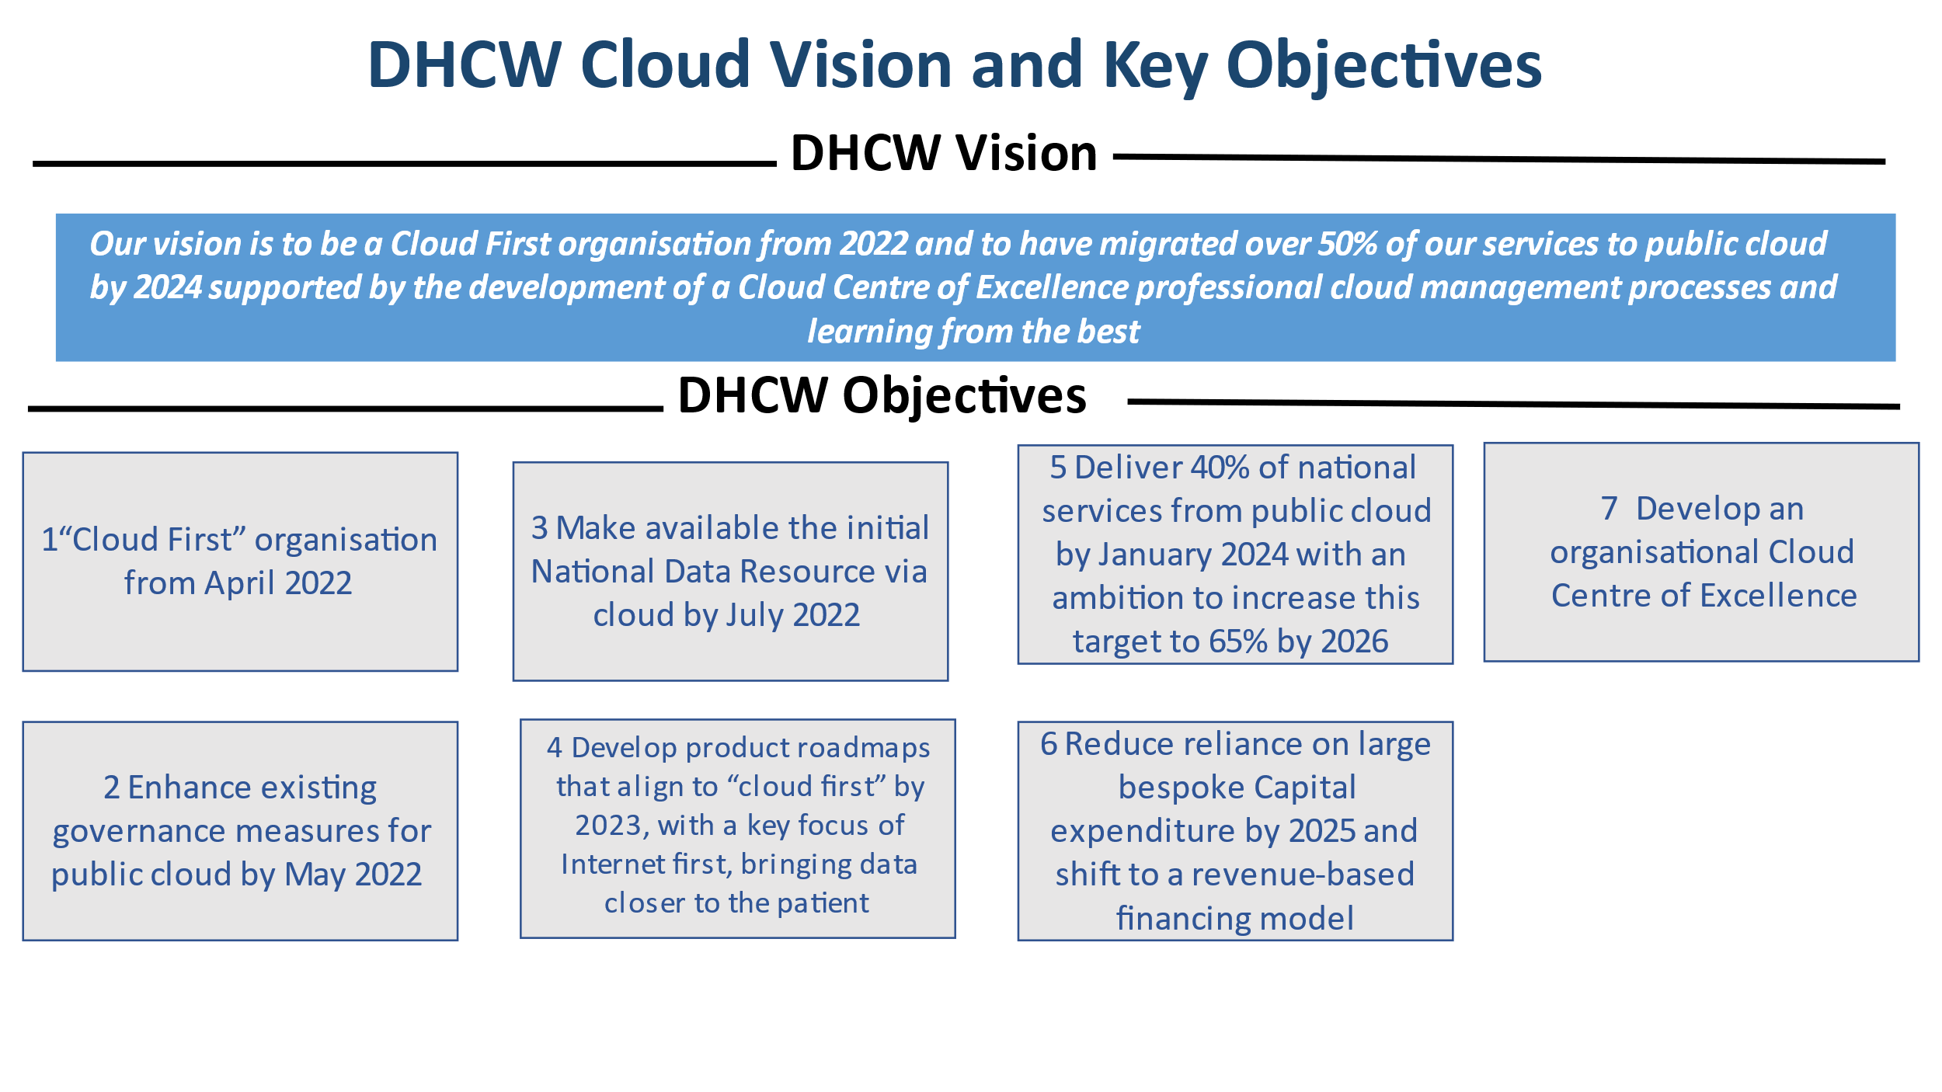

The document defines and communicates the organisation’s unified strategy and direction on the adoption of cloud computing technologies and services. It identifies the high-level approach and methodology the organisation will take.

The DHCW Cloud Strategy can be found in full at item 5.2i Appendix A.

SPECIFIC MATTERS FOR CONSIDERATION BY THIS MEETING (ASSESSMENT)

DHCW has been adopting Cloud, but the attached strategy defines the ambition of the approach to cloud adoption through its Cloud vision. It adopts the appropriate Gartner frameworks in the approach. Key considerations detailed in the document include:

Objectives - this includes defining the vision, goals and benefits and success metrics.
The key organisational benefits are detailed and summarised as

- Adaptability to variable demand
- Enhanced collaboration
- Shift to high-value activities
- Capital cost reduction
- Increased reliability and availability of services
- Environmental

DHCW have then identified what a successful outcome for cloud adoption would look like, together with a measure and a timescale for delivery.

Key adoption principles – the purpose of this section is to define the high-level strategic principles for the provision, operation, and consumption of cloud services by DHCW under the following headings:
- Cloud First
- Multi Cloud
- Cloud Tiers
- Interoperability and Portability
- Security
- Skills
- Governance
- Business Processes
- Continuous Optimization
- Service User Focus
- Identity
- Ease of Consumption

Risks - identification, classification and mitigating actions.
A detailed risk assessment was undertaken considering many aspects of DHCW from technical, commercial business and workforce. Each was risk assessed and all have mitigating actions that will be incorporated into the implementation plans.

Organisation impacts - considerations of the skills, teams and key processes.

The strategy document describes the adoption process following the public cloud adoptions framework including:
- Development of the cloud team and strategy - DHCW have a cloud team that has developed the strategy and considered how best to integrate the applications through the current WIAG process.

- Select providers and build cloud foundations - on the basis of a multi cloud strategy DHCW have developed a procurement road map that considers the most appropriate cloud provision for the technical product design. Infrastructure teams are designing and planning the necessary building blocks.

- Design for resilience and migrate applications - this will align with the products strategies.

- Build Governance that scales - a multi-disciplined team has designed principles and key controls.

- Optimise and automate- working on the key areas.

The document then details the proposed approach to upskill DHCW through a Cloud centre of excellence and it highlights the three key pillars.

Pillar 1 - Governance - A Cloud Governance Group or Cloud Council will be created to align with the organisational Cloud Strategy. This group will describe the governance principles, aim to align with Cloud providers’ governance approaches, implement guardrails (designed to stop bad outcomes) and guidelines (communicating risk boundaries). Within this there are key areas of focus across directorates within DHCW

- Finance/Technical /Commercial and contractual - Cost management and resource allocation
- Information governance and security - Identity, security, and compliance
- Technical - Cloud migration backup
- Technical - Service enablement
- Technical - Provisioning and Orchestration & Monitoring and Observability
- Service Management - Inventory and Classification
- Technical - relates to the current ICT and ADS Directorate inputs

Pillar 2 - Brokerage/Procurement - will focus on the choice of providers, solutions, contract negotiation and vendor management.

Pillar 3 - DHCW community of skills. Community will focus on the organisational approach, raising awareness, capturing, and circulating best practices to drive cloud transformation forward.

The document details a potential Exit Strategy and considerations from a risk management perspective.

The document then details the high-level implementation plans from a NDR /API management perspective but also in conjunction with the product and the ICT implications with indicative timescales. DHCW will look to provision new services directly in public cloud where appropriate and to migrate on-premises servers to make use of public cloud services. A balance of the principles, visions, Infrastructure age, infrastructure support costs, security requirements, application product roadmap and risk appetite of the product and organisation will help define the speed and timings at which both new and existing services will migrate.

The overall timeline approach will establish

- Commercial strategy
- Data strategy
- Governance processes
- Resilient connectivity to public cloud provider(s)
- API Management solution (new service)
- National Data Platform (new service)
- Phase 1 of on-premises applications migration (existing services)
- Phase 2 review other on-premises application (existing services)

KEY RISKS/MATTERS FOR ESCALATION TO BOARD

Risks: The cloud team has identified in total 19 risks which are detailed in the appendices of the strategy. The highest identified risks each have mitigation strategies:
- BUSINESS: The Cloud provider may have outages that DHCW cannot control.
- COMMERCIAL/TECHNICAL: DHCW may not be able to guarantee performance.
- FINANCE: Lack of sustained revenue for cloud services, current revenue funding is supported by capital purchases
- WORKFORCE/SKILLS: DHCW don’t possess the required skills necessary to support a cloud strategy.

Each of the above risks have mitigating actions that are built into the implementation plans.

The DHCW strategy has been developed collectively within DHCW with involvement from all Directorates and the NDR programme, with professional insights and learnings.

RECOMMENDATION

The SHA Board is being asked to APPROVE the DHCW Cloud Strategy.

IMPACT ASSESSMENT
STRATEGIC OBJECTIVE | All Objectives apply

CORPORATE RISK (ref if appropriate) | N/A

WELL-BEING OF FUTURE GENERATIONS ACT | A healthier Wales
If more than one standard applies, please list below:

DHCW QUALITY STANDARDS | ISO 20000
N/A

HEALTH CARE STANDARD | Governance, leadership and acccountability
If more than one standard applies, please list below:

EQUALITY IMPACT ASSESSMENT STATEMENT | Date of submission: N/A
No, (detail included below as to reasoning) |  | Outcome: N/A
N/A

APPROVAL/SCRUTINY ROUTE:
Person/Committee/Group who have received or considered this paper prior to this meeting
COMMITTEE OR GROUP | DATE | OUTCOME
Management Board | 17/03/2022 | Approved
IMPACT ASSESSMENT
QUALITY AND SAFETY IMPLICATIONS/IMPACT | No, there are no specific quality and safety implications related to the activity outlined in this report.
LEGAL  IMPLICATIONS/IMPACT | No, there are no specific legal implications related to the activity outlined in this report.
FINANCIAL  IMPLICATION/IMPACT | No, there are no specific financial implication related to the activity outlined in this report
WORKFORCE IMPLICATION/IMPACT | No, there is no direct impact on resources as a result of the activity outlined in this report.
SOCIO ECONOMIC IMPLICATION/IMPACT | No. there are no specific socio-economic implications related to the activity outlined in this report

