DIGITAL HEALTH AND CARE WALES
Data Centre Transition Update Report

Agenda Item | 5.1

Name of Meeting | SHA Board
Date of Meeting | 30th September 2021

Public or Private | Public
IF PRIVATE: please indicate reason | N/A
 | Executive Sponsor | Carwyn Lloyd-Jones; Director of ICT
 | Prepared By | Sophie Kift; Principal Project Manager
 | Presented By | Jamie Graham; Programme Manager

Purpose of the Report | For Assurance
Recommendation
The Board is being asked to:

NOTE the content of the report and RECEIVE for assurance

Acronyms
AVS | Azure VMware Solution | DC1 | Data Centre 1 (Legacy)
DC2 | Data Centre 2 | DC3 | Data Centre 3 (New)
DCT | Data Centre Transition | DHCW | Digital Health and Care Wales
BT/PSBA | BT/Public Sector Broadband Aggregation | TESTDEV | Test and Development
WCCIS | Welsh Community Care Information System

SITUATION/BACKGROUND

Since commencement of the Data Centre Transition Project’s Transition Batch Plan on Friday 30 July 2021, the DCT Project Team have completed six-of-eight Transition Batches and, as a result, 62% of infrastructure originally hosted at DC1 now resides in DC3. The DCT Project are pleased to report that Applications and Services have not experienced any unplanned disruption as a direct result of the Transition Batch Plan.

DCT Project Team continue to ensure preparation activities for upcoming weekends are completed, enabling Batches Seven and Eight to run equally as efficiently. The DCT Project is on-track to complete all physical transition activity by 03 October 2021.

Resources involved in the Architecture and Infrastructure workstream continue to implement changes relating to network operations at DC3. Additional support is also being provided to the Third-Party Suppliers of WCCIS after difficulty was experienced with BT/PSBA connectivity requirements. A decision has been made for DHCW to take ownership of the circuits required and this is being progressed via commercial routes.

The Cloud workstream continues to progress pre-requisite activities for the anticipated AVS Test and Development environment. Procurement activity is due to complete by 17 September 2021 and plans are in place to re-engage with affected Application/Services to prepare for their upcoming migration.

SPECIFIC MATTERS FOR CONSIDERATION BY THIS MEETING (ASSESSMENT)

After reviewing work completed by a third-party, the DCT Project Team identified a requirement for remedial cabling activity for the infrastructure transitioned in Transition Batch Four. The DCT Project Team developed options, and a recommendation was approved by DHCW Directors and a quorum of DCT Project Board members; the DCT Project Team combined Batch Five and Six in order for SCC to complete remedial cabling during the weekend of 03 September – 05 September 2021.

The DCT Project continues to provide communications to a wide range of stakeholders, detailing Transition Batch Plan progress and specifics surrounding dates and activities where impact is anticipated. In addition to this, the DCT Project Team have carried out a significant amount of engagement with both internal and external boards and have received positive feedback, e.g.:
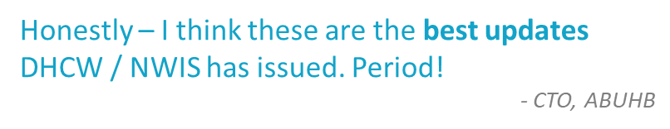
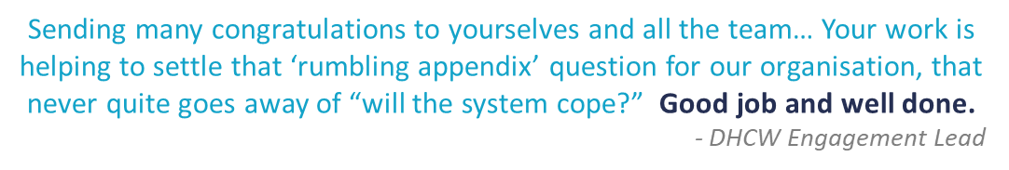

The DCT Project budget status remains Green. The budget forecast now shows an underspend of around £6k. This, coupled with further cost savings identified in the coming months, allows a small contingency for additional equipment (cables, SFP’s, etc.) if required.

As a result of the quality of work undertaken by SCC during the ‘Batch Four’ transition, we have agreed to withhold an additional £8.5k by way of penalty. Some of this will be reimbursed to Application Teams to cover a duplicate overtime bill, the remainder will be reflected in the next monthly forecast.

Forecast | £2,193,725
Budget | £2,200,000
+/- | £6,275

KEY RISKS/MATTERS FOR ESCALATION TO BOARD/COMMITTEE

Project ID: DCT/I-46

The issue surrounding the transition of WCCIS infrastructure from DC1 to DC3 requires escalation. WCCIS’s Third-Party Supplier – OneAdvanced – have taken responsibility of transitioning the infrastructure that they own. In order to do so, there is a requirement for dedicated PSBA, Internet and Site-to-Site circuits to be installed in DC3. To date, this process has been delayed and whilst implementation of the PSBA circuit is due to complete by 15 September 2021, confirmation of dates is outstanding for the Internet and Site-to-Site circuits.

Until all circuits are in-place, the Third-Party Supplier cannot confirm the details of their transition plan and there is a risk that transition will not be completed prior to the 31 October 2021 deadline. The DCT Project Team are aiming to mitigate this risk by:

Facilitating conversations between DHCW Technical Resources and OneAdvanced, to discuss workarounds if circuits cannot be made available in advance of transition (i.e., the temporary utilisation of DHCW circuits).

Continuing conversations with SRS Management, to gain agreement on hosting arrangements incl. incurred charges following contract expiry.

Project ID: DCT/R-87 and R-107

DCT/R-87 details risk to feasibility and progress of (1) AVS production build and (2) Test and Development (TESTDEV) migration activity. As part of the DCT Project scope, it is expected that the TESTDEV environment will migrate to the Cloud prior to the 31 October 2021 deadline. However, due to delays experienced as a result of ExpressRoute connectivity issues, the timeline has been shortened by a significant amount.

There is an adjusted proposal in place that will allow the DCT Project Team to achieve the deadline for migration – Applications/Services to migrate to Cloud between 22-27 October 2021 – but related R-107 has been raised to detail risk surrounding the transition of physical infrastructure. If Applications/Services migrate to Cloud on-time, the timeline to decommission the previous environment and transition the physical infrastructure is limited to four days. If Applications/Services do not migrate to Cloud on-time, the physical infrastructure and its related virtual machines will continue to operate out of DC1, which could result in incurred charges post-contract expiration.

Project ID: DCT/I-36

An issue has been identified in relation to the completion of the expected BT/PSBA circuits required at DC3. The DCT Project Team have been facilitating conversations between DHCW Technical Resources, BT and PSBA in order to obtain updates for the outstanding Treforest link, which was originally due for completion by 30 April 2021.

Whilst a temporary solution is in place in the form of the Western Power Distribution circuit, there is a risk of further delays to the permanent solution due to (1) COVID-19 impact on resources and (2) lack of SLA between PSBA and the cabling contractor.

The DCT Project Team will continue to obtain updates via Weekly SCRUM Meetings, with an additional action on Network Services to confirm 100G bandwidth via DC2 (additional contingency).

All other risks and issues are being managed via the DCT Project RAID Log, which can be viewed via this link.

RECOMMENDATION
The Board is being asked to:
NOTE the content of the report and RECEIVE for assurance

IMPACT ASSESSMENT
STRATEGIC OBJECTIVE | Delivering High Quality Digital Services

CORPORATE RISK (ref if appropriate) | 16659; 16660

WELL-BEING OF FUTURE GENERATIONS ACT | A resilient Wales
If more than one standard applies, please list below:

DHCW QUALITY STANDARDS | N/A
If more than one standard applies, please list below:

HEALTH CARE STANDARD | N/A
If more than one standard applies, please list below:

EQUALITY IMPACT ASSESSMENT STATEMENT | Date of submission:
No, (detail included below as to reasoning) |  | Outcome:
Statement:
Not applicable

APPROVAL/SCRUTINY ROUTE:
Person/Committee/Group who have received or considered this paper prior to this meeting
COMMITTEE OR GROUP | DATE | OUTCOME
Management Board | 16/09/2021 | Noted
Digital Governance and Safety Board (Earlier report) | 11/08/2021 | Noted
IMPACT ASSESSMENT
QUALITY AND SAFETY IMPLICATIONS/IMPACT | No, there are no specific quality and safety implications related to the activity outlined in this report.
LEGAL  IMPLICATIONS/IMPACT | No, there are no specific legal implications related to the activity outlined in this report.
FINANCIAL  IMPLICATION/IMPACT | No, there are no specific financial implication related to the activity outlined in this report
WORKFORCE IMPLICATION/IMPACT | Yes, please see detail below
WORKFORCE IMPLICATION/IMPACT | Specific workforce implications surround activities required to commence/complete in parallel of Transition Batch Plan.
SOCIO ECONOMIC IMPLICATION/IMPACT | No. there are no specific socio-economic implications related to the activity outlined in this report

