DIGITAL HEALTH AND CARE WALES
BOARD ASSURANCE FRAMEWORK REPORT

Agenda Item | 6.3

Name of Meeting | SHA Board
Date of Meeting | 28 July 2022

Public or Private | Public
IF PRIVATE: please indicate reason | N/A

 | Executive Sponsor | Chris Darling, Board Secretary
 | Prepared By | Bethan Walters, Risk and Regulation Officer
 | Presented By | Chris Darling, Board Secretary

Purpose of the Report | For Approval
Recommendation
The SHA Board is being asked to:
NOTE and DISCUSS the content of the report.
APPROVE the risk appetites agreed for each strategic mission / principal risk.
NOTE the control and assurance gaps and plan to address these via the BAF Dashboard Report.

IMPACT ASSESSMENT
STRATEGIC OBJECTIVE | All Objectives apply

CORPORATE RISK (ref if appropriate) | All

WELL-BEING OF FUTURE GENERATIONS ACT | A Healthier Wales
If more than one standard applies, please list below:
A Resilient Wales
DHCW QUALITY STANDARDS | Choose an item.
If more than one standard applies, please list below:
Good governance support all Quality Standards

HEALTH CARE STANDARD | Governance, leadership and acccountability
If more than one standard applies, please list below:
Staff and Resources, Safe Care, Effective Care

EQUALITY IMPACT ASSESSMENT STATEMENT | Date of submission:
Choose an item. |  | Outcome:
Statement:
Not applicable
Workforce EQIA page
IMPACT ASSESSMENT
QUALITY AND SAFETY IMPLICATIONS/IMPACT | Yes, please see detail below
QUALITY AND SAFETY IMPLICATIONS/IMPACT | Effective management of risk has a positive impact on the quality and safety of the organisation
LEGAL  IMPLICATIONS/IMPACT | Yes, please see detail below
LEGAL  IMPLICATIONS/IMPACT | There can legal ramifications if compliance risks are not managed effectively.
FINANCIAL  IMPLICATION/IMPACT | Yes, please see detail below
FINANCIAL  IMPLICATION/IMPACT | There can financial ramifications if compliance risks are not managed effectively.
WORKFORCE IMPLICATION/IMPACT | No, there is no direct impact on resources as a result of the activity outlined in this report.
SOCIO ECONOMIC IMPLICATION/IMPACT | No. there are no specific socio-economic implications related to the activity outlined in this report
RESEARCH AND INNOVATION  IMPLICATION/IMPACT | No, there is no specific research and innovation implications relating to the activity outlined within this report

Acronyms
DHCW | Digital Health and Care Wales | SHA | Special Health Authority
BAF | Board Assurance Framework | H&WB | Health and Wellbeing Group
GAF | Governance Assurance Framework | OD | Organisational Development
ISO | International Organisation for Standardisation | KPI’s | Key Performance Indicators

SITUATION/BACKGROUND

2.1 The Risk and Board Assurance Framework Strategy was approved by the Board in May 2021. Since then, work has been undertaken to establish the risk appetite for the organisation, the associated tolerances and what that means for Digital Health and Care Wales (DHCW) operationally.

2.2 The Board Assurance Framework Report included at 6.3i Appendix A is designed to provide the Board with timely information on what the principal risks are to the delivery of the SHA’s strategic missions and how the organisation is managing and/or mitigating the risks through the identified controls and assurances in place. It also highlights areas for improvement. The BAF report outlines the agreed risk domains and associated appetite and tolerances.

2.3 Included within the BAF report dashboard are:
- the principal risks as defined through the work undertaken in the risk workshops (Summer – Autumn 2021) that included Board member (Executive and Independent Member) input as well as senior leaders from the wider organisation
- The initial and target scores for the principal risks
- A RAG assurance self-assessment rating undertaken by the lead Director which takes into account:
  - the controls and assurances in place
  - the corporate risks assigned to the relevant mission and their associated activity to mitigate. NB: some corporate risks map to more than one strategic mission, but are only assigned to the primary strategic mission in the BAF report dashboard
  - key actions to improve controls and assurance systems owned by senior leaders across the organisation

2.4 Key terms used in the report:
- Principal Risks – are the primary risks to achieving our strategic missions
- Key Controls - are the mechanisms in place to protect against the threat of those risks, they help with the management of the risk and are made up of governance structures, policies and plans that further the protections against the principal risk
- Assurances - are the mechanisms to provide evidence that the organisation is operationally effective in relation to the specific risk, either through direct operational reporting or scrutiny and oversight from other sources. Checking the design and implementation of critical controls is an important component of assurance. Below you can see some examples of the 1st, 2nd and 3rd line assurances.

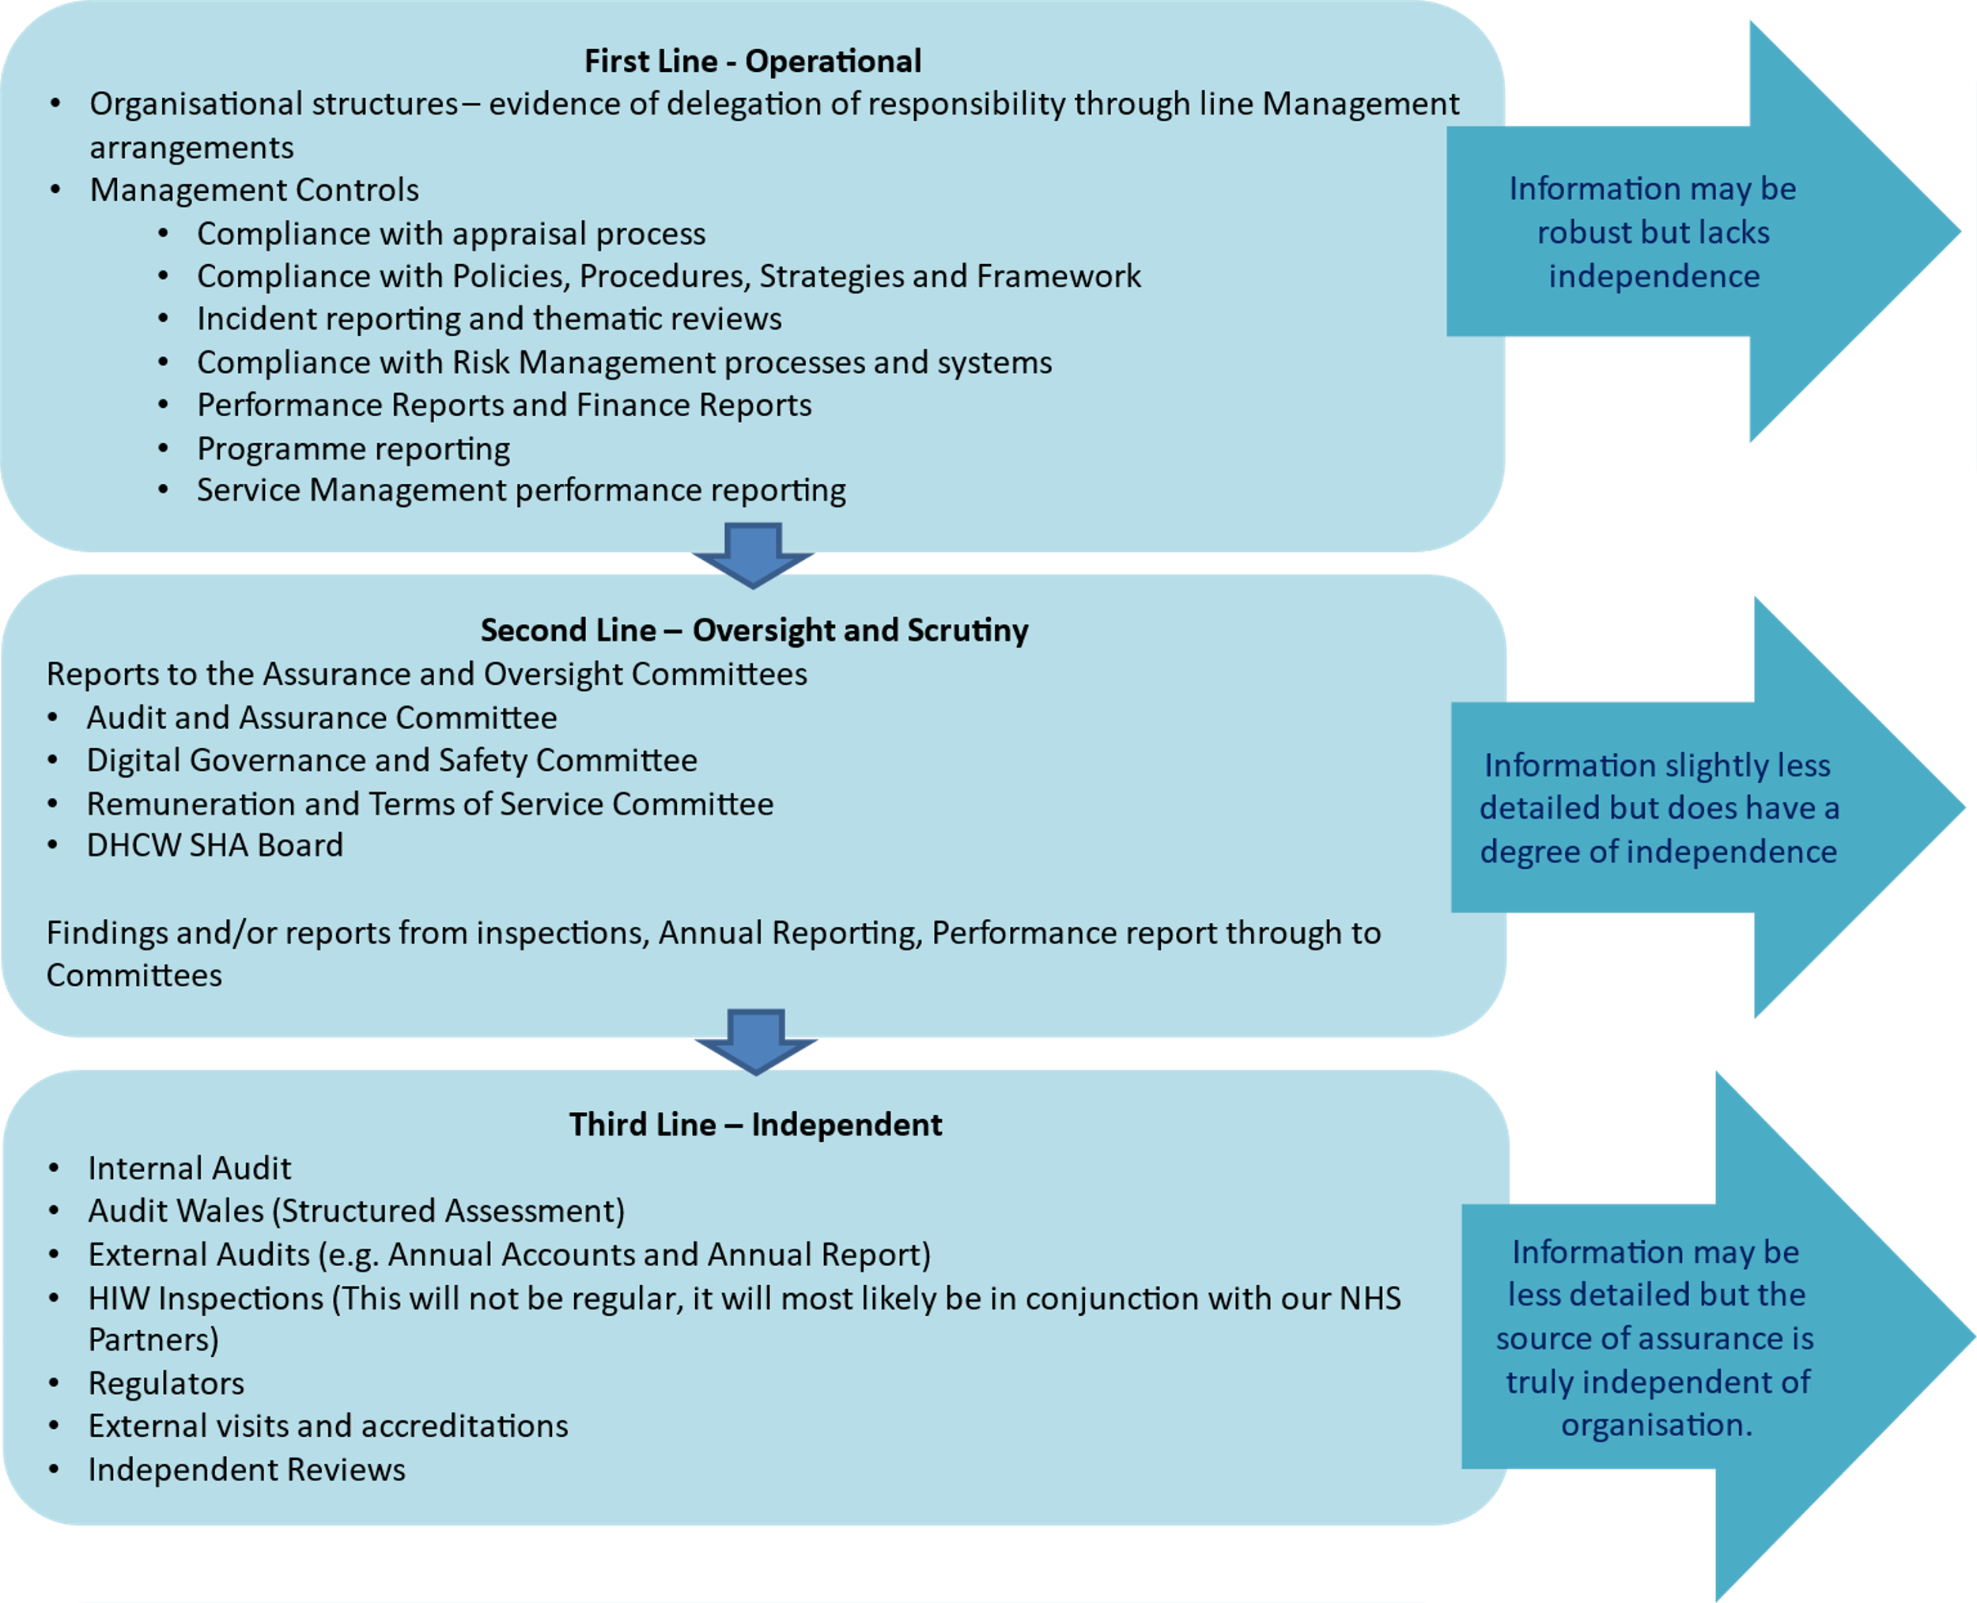

SPECIFIC MATTERS FOR CONSIDERATION BY THIS MEETING (ASSESSMENT)

3.1 The 26 May 2022 Board meeting received the final draft BAF Dashboard Report and identified the additional work required to finalise the risk appetite for each strategic mission and to validate the overall gap action plan and identify any changes required.

3.2 Included in slide 5 of the Board Assurance Framework Dashboard Report at item 6.3i Appendix A are the proposed risk appetites for each strategic mission for approval by the SHA Board. The risk appetite for each was discussed at the Board Development session held on the 30 June 2022.
Strategic Mission and Principal Risk | Risk Appetite
1. Enabling digital transformation supporting joined up, consistent care | CAUTIOUS
IF we do not co-design safe and secure services with users supported by common standards and collaborative ways of working THEN our development may not meet user needs RESULTING IN not being able to digitally transform services at pace | CAUTIOUS
2. Delivering high quality technology, data products and services to support efficiencies and improvements in care processes | CAUTIOUS
IF we do not deliver safe, secure, accessible, resilient products and services of high quality THEN the ability of health and care partners to deliver and modernise services is compromised RESULTING IN less effective, less sustainable care that could cause harm and would not meet the expectations of patients or professionals. | CAUTIOUS
3. Expanding the content, availability and functionality of the digital health and care record so that care and treatment quality is improved | MODERATE
IF we fail to expand the content, availability and functionality of the Digital Health and Care Record at the required pace THEN information could be incomplete, inconsistent, or held in different places RESULTING IN a reduced ability to use information to inform care and empower citizens, leading to poorer outcomes. | MODERATE
4. Driving Value and innovation for better outcomes and value based care | OPEN
IF we do not focus on making use of data and innovation to improve outcomes THEN we may not be optimising value for citizens RESULTING IN less sustainable health and care services and reduced or delayed benefit for the public and patients. | OPEN
5. Becoming the trusted strategic partner and a high performing, inclusive, ambitious organisation supporting our workforce and stakeholders | MODERATE
IF we do not become a trusted partner and a high performing inclusive organisation THEN people will not want to work with and for us RESULTING IN a failure to achieve our strategic ambition of delivering world leading digital services. | MODERATE

3.3 Discussion sessions took place with Executive owners and operational leads and managers to finalise the gap actions plans and the associated timeframes. The following additional items were identified:
Strategic Mission | Key Control/Assurance Gap | Gap | Planned Action
Trusted Partner | Key Control | Long term financial strategy | Create the long-term financial strategy
Trusted Partner | Key Control | Commercial Strategy for using third parties to increase workforce capacity | Agree commercial strategy and approach for using third parties to increase workforce capacity and identify implementation plan for embedding across the organisation
Trusted Partner | Key Control | Organisational Values Review | Undertake and review of the organisation’s values
Trusted Partner | Assurance Gap | Lack of assurance mechanism in relation to the effectiveness of the long term financial strategy | Create reporting on the Long-Term Financial strategy and associated plan
Trusted Partner | Assurance Gap | Commercial Strategy for using third parties to increase workforce capacity | Create a resourcing group to assess the effective use of the strategy and impact on workforce
Trusted Partner | Assurance Gap | Organisational Values Review | Undertake review and validation of the organisational values with the staff

3.4 The Board Assurance Framework will be reviewed twice a year for validity and progress by the Board. This will be May and November each year.

3.5 There has been progress on the actions within the Risk and BAF Workplan, the highlights are below:
Action | Status
Approval of Initial Dashboard report (with further work identified to strategic mission risk appetite and rationale) | Complete
Confirmation of risk appetite for each strategic mission / principal risk agreed at Board Development | Complete

KEY RISKS/MATTERS FOR ESCALATION TO BOARD/COMMITTEE

4.` The assurance summary provides an overview of the current risk score vs target and the rationale approved by the mission Executive owner.

RECOMMENDATION

5.1 The SHA Board is being asked to:
NOTE and DISCUSS the content of the report.
APPROVE the risk appetites agreed for each strategic mission / principal risk.
NOTE the control and assurance gaps and plan to address these via the BAF Dashboard Report (Item 6.3i).

APPROVAL / SCRUTINY ROUTE

Person / Committee / Group who have received or considered this paper prior to this meeting
PERSON, COMMITTEE OR GROUP | DATE | OUTCOME
SHA Board | 26 May 2022 | BAF Dashboard Report template approved
Board Development Session | 30 June 2022 | Risk appetite per strategic mission agreed

