FRA-DHCW-001

DHCW RISK AND BOARD ASSURANCE FRAMEWORK

The framework outlines how assurance will be gained on the conduct of DHCW business, its governance and the effective management of the organisation’s risks in pursuance of its aims and objectives. It shall set out clearly the various sources of assurance, and where and when that assurance will be provided.

Document Version | 1

Status | Draft

 | Document author: | Sophie Fuller, Corporate Governance and Assurance Manager
 | Approved by | Chris Darling, Board Secretary
 | Date approved:
 | Review date:

TŶ GLAN-YR-AFON 21 Heol Ddwyreiniol Y Bont-Faen, Caerdydd CF11 9AD
TŶ GLAN-YR-AFON 21 Cowbridge Road East, Cardiff CF11 9AD

STRATEGIC OBJECTIVE | All Objectives apply

WELL-BEING OF FUTURE GENERATIONS ACT | A healthier Wales
If more than one standard applies, please list below:
A globally responsible Wales

DHCW QUALITY STANDARDS | N/A
If more than one standard applies, please list below:

HEALTH CARE STANDARD | Governance, leadership and acccountability
If more than one standard applies, please list below:
Staff and Resources

EQUALITY IMPACT ASSESSMENT STATEMENT | Date of submission:
Yes, applicable |  | Outcome: No impact
Statement:
The policy was assessed for any possible or actual impact that it may have on any groups in respect of gender (including maternity and pregnancy as well as marriage or civil partnership issues) race, disability, sexual orientation, Welsh language, religion or belief, transgender, age or other protected characteristics.

The assessment found that there was no impact to the equality groups mentioned.

APPROVAL/SCRUTINY ROUTE: Person/Committee/Group who have received or considered this
COMMITTEE OR GROUP | DATE | OUTCOME
Audit and Assurance Committee | 18th Jan 2022 | Endorsed
Management Board | 14th Jan 2022 | Reviewed
Weekly Directors | 5th Jan 2022 | Reviewed
Management Board | 21st April 2022 | Endorsed
SHA Board | 26th May 2022 | TBC

IMPACT ASSESSMENT
QUALITY AND SAFETY IMPLICATIONS/IMPACT | Yes, please see detail below
QUALITY AND SAFETY IMPLICATIONS/IMPACT | The framework brings increased levels of quality and safety in the business of the Board and organisation.
LEGAL  IMPLICATIONS/IMPACT | No, there are no specific legal implications related to the activity outlined in this report.
FINANCIAL  IMPLICATION/IMPACT | No, there are no specific financial implication related to the activity outlined in this report
WORKFORCE IMPLICATION/IMPACT | No, there is no direct impact on resources as a result of the activity outlined in this report.
SOCIO ECONOMIC IMPLICATION/IMPACT | Yes, please detail below
SOCIO ECONOMIC IMPLICATION/IMPACT | Effective risk management and reporting provides the Board with assurance that socio economic considerations are made throughout business activity and decision making

TABLE OF CONTENTS

1 DOCUMENT HISTORY 6
1.1 REVISION HISTORY 6
1.2 REVIEWERS 6
1.3 AUTHORISATION 6
1.4 DOCUMENT LOCATION 6
2 PURPOSE 7
3 SCOPE 7
4 DEFINITIONS 7
5 REFERENCES 7
6 INTRODUCTION 7
6.1 THE ASSURANCE CYCLE 8
6.2 STRATEGIC OBJECTIVES 9
6.3 RISKS 9
6.4 CONTROLS 10
6.5 REPORTING 10
7 ROLES AND RESPONSIBILITIES 11
7.1 EXECUTIVE TEAMS AND THE MANAGEMENT BOARD 11
7.2 COMMITTEES 12
7.3 ASSURANCE AND ESCALATION 13
8 APPENDIX 1 – Digital Health and Care Wales Control Framework 16
9 APPENDIX 2 – Digital Health and Care Wales Board Structure 17
10 BOARD ASSURANCE FRAMEWORK ANNUAL REVIEW 18
10.1 ASSURANCE SUMMARY 18
10.2 ANNUAL ASSURANCE SUMMARY – RISK OVERVIEW 19
10.3 KEY CONTROLS ANNUAL ACTION PLAN 20
10.4 INDIVIDUAL ANNUAL PRINCIPAL RISK DASHBOARDS 21

DOCUMENT HISTORY

REVISION HISTORY
Date | Version | Author | Revision Summary
01/12/2021 | 0.1 | Sophie Fuller | Initial draft
31/01/2022 | 0.2 | Sophie Fuller | Second draft

REVIEWERS
This document requires the following reviews:
Date | Version | Name | Position
31/12/2021 | 0.1 | Chris Darling | Board Secretary
31/12/2021 | 0.1 | Julie Ash | Head of Corporate Services

AUTHORISATION
Signing of this document indicates acceptance of its contents.
Author’s Name: | Sophie Fuller
Role: | Corporate Governance and Assurance Manager
Signature: | e:

Approver’s Name: | Chris Darling
Role: | Board Secretary
Signature: | te:

DOCUMENT LOCATION
Type | Location
Electronic | Integrated Management System

PURPOSE
The Board Assurance Framework (BAF) for Digital Health and Care Wales (DHCW) lays out the systems and operating guidelines for how the Board ensure control and assurance relating to strategic risks relating to its agreed objectives outlined within its 3 year Integrated Medium Term Plan.

SCOPE
The framework applies to all DHCW activities.

DEFINITIONS
Acronyms
DHCW | Digital Health and Care Wales | SHA | Special Health Authority
SO’s | Standing Orders | SFI’s | Standing Financial Instructions
BAF | Board Assurance Framework | TOR | Terms of Reference
IMTP | Integrated Medium-Term Plan | WG | Welsh Government

REFERENCES
DOCUMENT | VERSION
Risk and Board Assurance Framework Strategy | 1
Risk Management Policy | 1

INTRODUCTION
All NHS organisations in Wales are required to demonstrate good governance and ensure they are operating robust systems and processes to support this.

The Board needs to be confident that the systems and processes are operating in a way that is effective and is driving the delivery of objectives by focusing on minimising risk.

It is the responsibility of the Board to:
- Determine and clearly articulate its objectives;
- Identify the principal risks that threaten the achievement of these objectives;
- Agree the key strategic and operational plans that will deliver those objectives, and which encompass the controls and actions in place to manage the identified risks;
- Monitor delivery through robust performance and assurance measurements;
- Ensure that plans are in place to take corrective action where they are not assured that objectives will be fully delivered; and
- Engage with and listen to staff.

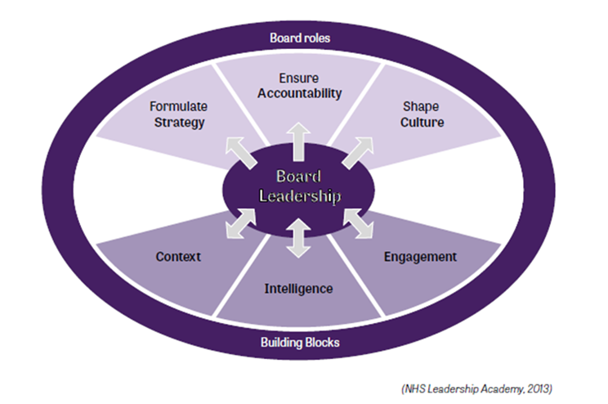
These requirements form the basis of the Board Assurance Framework.

An effective BAF:
- Provides timely and reliable information on the effectiveness of the management of major principal risks and significant control issues
- Facilitates escalation of risk and control issues requiring visibility and attention by senior management, by providing a cohesive and comprehensive view of assurance across the risk environment
- Provides an opportunity to identify gaps in assurance needs that are vital to the organisation, and to remove them (including using internal audit) in a timely, efficient and effective manner
- Can be used to raise organisational understanding of its risk profile, and strengthen accountability and clarity of ownership of controls and assurance therein, avoiding duplication or overlap
- Provides critical supporting evidence for the production of the Governance Statement
- Can clarify, rationalise and consolidate multiple assurance inputs, providing greater oversight of assurance activities for the Board/Audit & Assurance Committee in line with the risk appetite; and
- Facilitates better use of assurance skills and resources.

The BAF aligns principal risks, key controls, its risk appetite and assurances on controls alongside each objective. Gaps are identified where key controls and assurances are insufficient to mitigate the risk of non delivery of objectives. This enables the Board to develop and monitor action plans intended to close the gaps.

THE ASSURANCE CYCLE
The Board and the identified Committees within the scheme of delegation will undertake an annual self-assessment of the organisation’s performance against the key themes highlighted within Citizen Centered Governance Principles.

The assurance system must therefore be designed to ensure that the Board can make this annual assessment. The outcome of this self-assessment is also a fundamental component of the Annual Governance Statement (AGS) which is published each year as part of the annual report and accounts.

The BAF will also undergo an annual review by the Board and the Audit and Assurance Committee to ensure the information contained within it is appropriately focused.

STRATEGIC OBJECTIVES 2022/23
The elements identified in the BAF provides assurance to DHCW’s Board on the delivery of its objectives, outlined below:

- Enabling Digital Transformation
- Expanding the content, availability and functionality of the Digital Health and Care Record
- Delivering high quality technology, data products and services to support efficiencies and improvements in care processes
- Driving value and innovation for better outcomes and value based care
- Becoming the trusted strategic partner and a high performing, inclusive, ambitious organisation

RISKS
Against each objective the priority and the principal risk(s) which may stop the organisation achieving the objective will be set out.

Principal risks are defined as those that threaten the achievement of the organisation’s priorities. It is essential that the Board identifies and oversees the principal risks, rather than reacting to the consequences of risk exposure. The identification of principal risks should be repeated at all levels within the organisation. The Board should ensure it assesses risk(s) as part of the decision-making process.

The organisation’s Risk and Board Assurance Framework Strategy and Risk Management Policy outline the steps the organisation will take to identify, analyse, evaluate and control the risks that threaten the delivery of its strategic objectives and delivering against Integrated Medium-Term Plan (IMTP). The BAF Report will be used by the Board to identify, monitor and evaluate risks which impact upon strategic objectives.

The organisation has a Corporate Risk Register held in Datix, which details the top high-level risks for the organisation. This is shared at every Management Board and every SHA Board meeting for scrutiny and assurance. The relevant Committee will also be assigned risks, they will be responsible for scrutinising the management and mitigating action undertaken to provide assurance to the Board that effective management is taking place and thus minimising any impact or reducing the likelihood of occurrence.

CONTROLS
Key controls are defined as those controls and systems in place to assist in securing the delivery of the Board’s strategic objectives. As part of the assurance process, the Board, through its Committees where appropriate, will need to assess whether current controls are adequate to provide assurance compared with the level of risk; controls must be proportionate to the risks identified.

Examples of key controls are:
- Standing Orders
- Standing Financial Instructions
- Schemes of Delegation, their Terms of Reference and annual business work cycle plan
- The corporate risk register
- Policies, procedures and written control documents
- Integrated Medium-Term Plan
- Operational plan
- Performance data
- Financial Management information

Further details on the controls used within the framework is in section 8, appendix 1.

REPORTING
There is a reporting structure in place for reporting key risk information to the Board and Committees. There is a plan of business to be reported to the Board and Committees and the Corporate Risk Register allows the Board to identify what risks need to be reported upon. As already stated, Organisational risks will be presented at each Board meeting. Exception reports from service or locality will be presented to the Executive Management team and the relevant Committee routinely and be used to inform the development and review of the risk register.

DHCW’s Integrated Organisational Performance Report will provide the Board and Executive Team with a high-level summary of performance, particularly in relation to the organisation’s priorities for action.

Directorate / Discipline specific Performance Reports will provide the Executive Management Team a more detailed view of the performance to include annual delivery plan progress as well as the health of the operational services.

DHCW is also required to produce public disclosure statements as part of the assurance system. The Board Assurance system, as described in this paper, will culminate in the production of the Annual Governance Statement. These public disclosure documents together with the Financial Statements, Remuneration Report and other specific disclosures form the “Chapters” to the Annual Report.

ROLES AND RESPONSIBILITIES

EXECUTIVE TEAM AND THE MANAGEMENT BOARD
The Chief Executive of the SHA is employed and appointed by the Board (with the approval of Welsh Minsters). They are the Board’s principal adviser on the discharge of its functions and will be accountable to the Board. The Chief Executive’s role is to provide operational leadership to the public body and ensure that the Board’s aims and objectives are met, and the public body’s functions and targets are delivered. In summary, the Board focuses on strategy, performance and behaviour – the Chief Executive advises the Board on all matters and is solely responsible for operational issues. The Chief Executive is the Accountable Officer for the organisation. The makeup of the Board is detailed in Section 9, appendix 2.

To assist the Chief Executive in discharging their accountabilities, the Chief Executive is supported by the Executive Team which meets on a weekly basis for formative discussion and to support decision making.

The Executive Team meet more formally with the wider leadership management group monthly in the Management Board which is the executive discussion, development, performance management and decision-making forum. It has strong links to all relevant governance forums inside and outside the organisation.

Monitoring quality and performance information occurs at all levels of the SHA to provide team to Board reporting. Performance, risk and incident reports are received at each Management Board meeting, providing the Management Board with oversight that the SHA is meeting internal and external targets for digital safety and performance. These reports are also the mechanisms for identifying under-performance and documenting exception reports and action plans. These exception reports are received by the Committee under the scheme of delegation from the Board as appropriate.

Processes for monitoring performance, managing risk, receiving assurance and escalating concerns are outlined in this BAF. These processes commence at team level, with assurance and escalation of risk managed as appropriate through to Board level. Figure 1 below demonstrates the route assurance and escalation takes in the SHA.

Fig 1
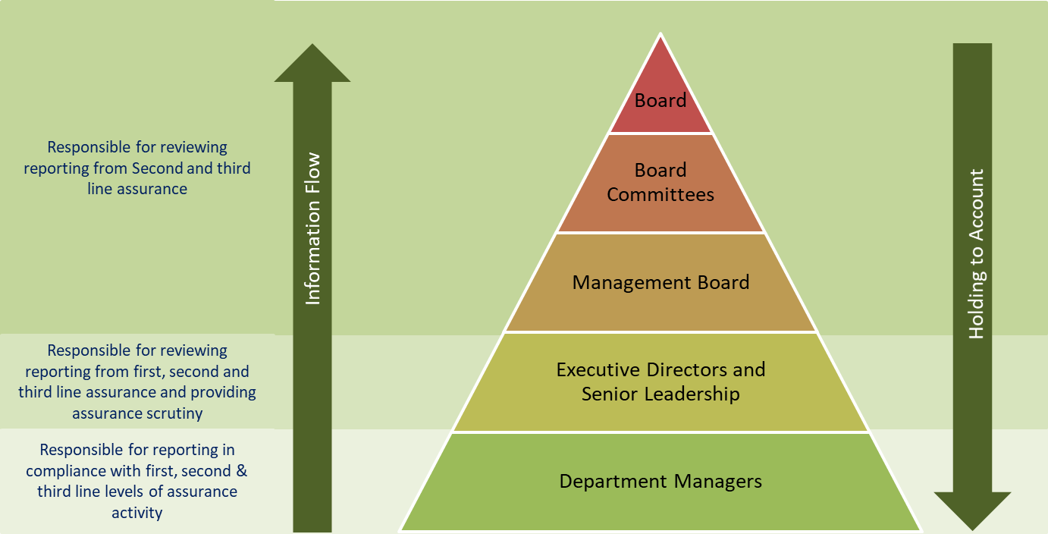

COMMITTEES
The Board may and, where directed by Welsh Ministers must, appoint Committees of the Board either to undertake specific functions on the Board’s behalf or to provide advice and assurance to the Board in the exercise of its functions.

The remit and terms of reference of these committees are reviewed each year, together with an assessment of Committee effectiveness, to ensure robust governance and assurance arrangements are in place. The Board receives a regular report from each committee, as outlined within their Terms of Reference (ToR) at the Board meeting following each Committee meeting. This provides an effective structure with defined information flows for receiving assurance and identifying areas of concern which require escalation. The remit, authority and responsibility delegated to these Committees is detailed in the Committee ToRs which form a schedule of the SHA’s Standing Orders.

AUDIT AND ASSURANCE
The Board’s Audit and Assurance Committee advises and assures the Board and Accountable Officer on whether effective arrangements are in place to support them in their decision making and in discharging their accountabilities for securing the achievement of DHCW’s objectives, in accordance with the standards of good governance determined for the NHS in Wales.

DIGITAL GOVERNANCE AND SAFETY COMMITTEE
The Board’s Digital Governance and Safety Committee advises and assures the Board and Accountable Officer on whether effective arrangements are in place to support them in their decision making and in discharging their accountabilities regarding information governance, security, digital assurance, information services and incident review and learning.

REMUNERATION AND TERMS OF SERVICE COMMITTEE
The Board’s Remuneration and Terms of Service Committee is responsible for providing advice and assurance to the Board on remuneration and terms of service for the Chief Executive, Executive Directors and other senior staff within the framework set by the Welsh Government. It also provides assurance to the Board in relation to DHCW’s arrangements for the remuneration and terms of service, including contractual arrangements, for all staff, in accordance with the requirements and standards determined for the NHS in Wales.

ASSURANCE AND ESCALATION

ASSURANCE
As already explained assurance is the overriding governance that brings together the identified areas of control to ensure the systems for monitoring performance, decision making, and escalation are working.

A good system will bring together and triangulate internal and external assurance sources and should also be a combination of quantitative and qualitative information.

The organisation uses several methods for obtaining assurance, the below table details some of the high-level methods used.

INTERNAL AND EXTERNAL ASSURANCE PRACTICES
Internal | External
Standing Orders | Structured Assessment via Audit Wales
Standing Financial Instructions | WG Reports/Reviews
Scheme of delegation | WG assessment of IMTP
Compliance against legislation | Internal Audit Reports
Annual Self-Assessment | Quality Accreditation Schemes – ISO, BS and other Certification Audits
Board and Committee Reporting | Welsh Language Commissioner
IMTP | Wellbeing of Future Generations Commissioner for Wales
Counter-fraud reports | Welsh Risk Pool
Serious Incident Reports | Digital Economy Act Assessment
Annual Governance Statement
Staff Survey

LEVELS OF ASSURANCE
Below outlines the different levels of assurance the organisation is using. These have different levels of independence associated with the nature of the information collected. Using multiple methods from each level is the recommended way to provide a range of assurance to the Board.
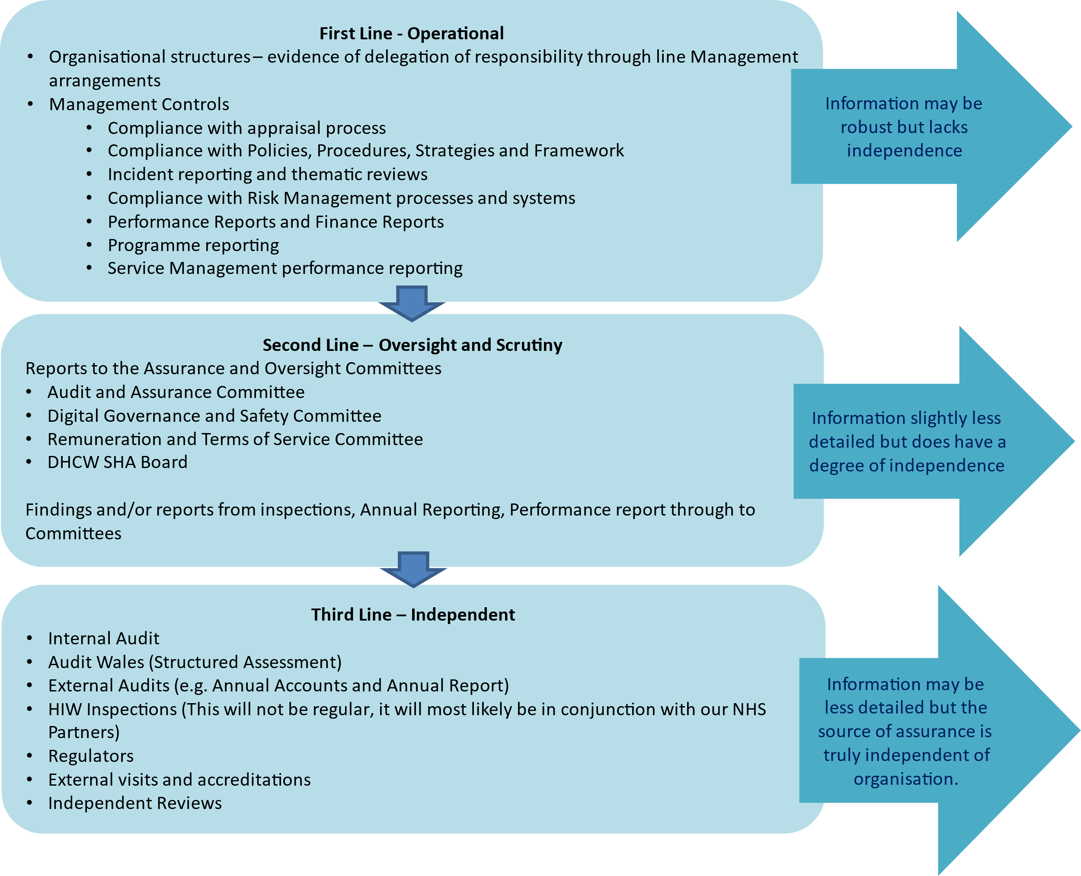

DHCW BOARD ASSURANCE OPERATING MODEL
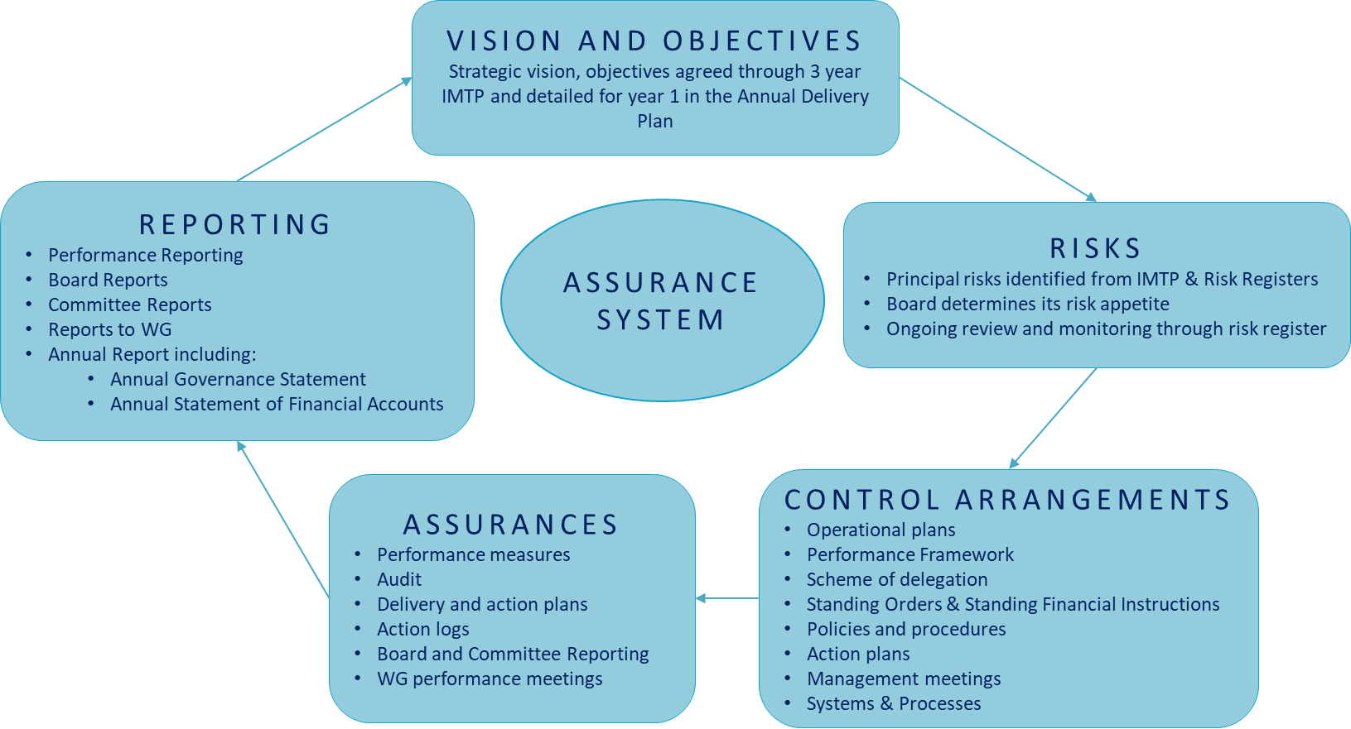

APPENDIX 1 – Digital Health and Care Wales Control Framework
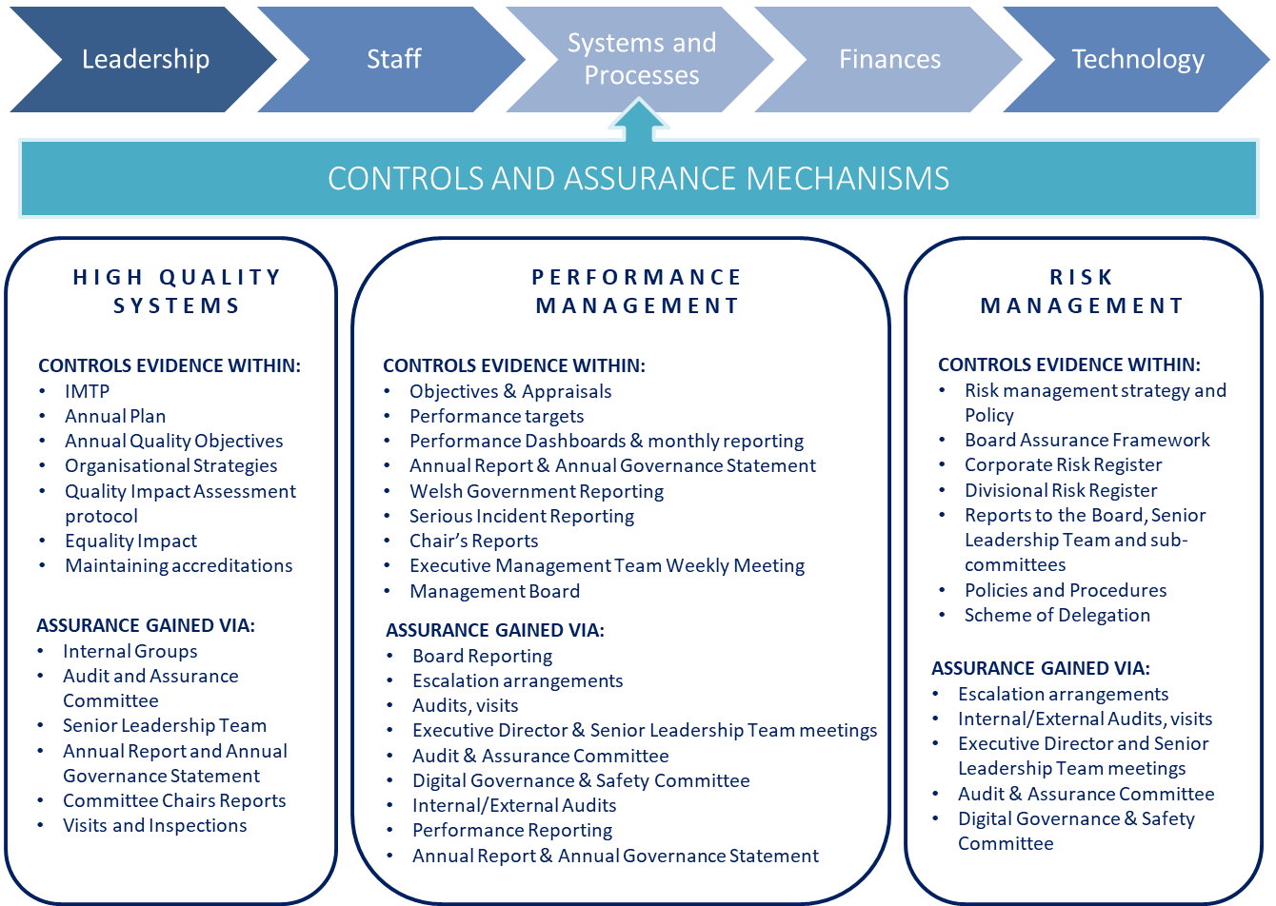

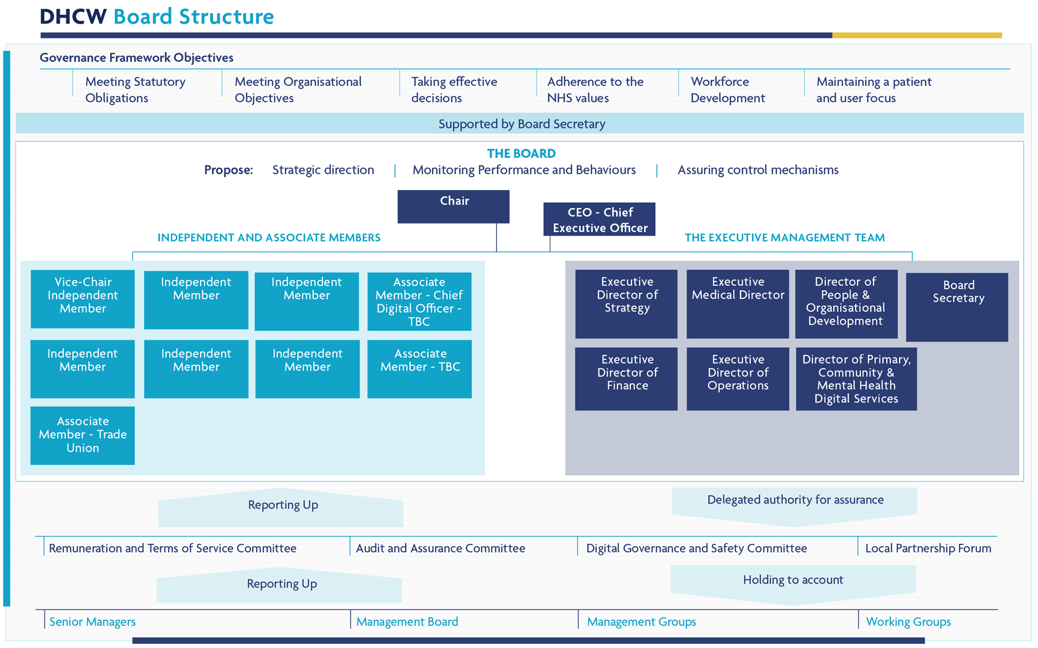
APPENDIX 2 – Digital Health and Care Wales Board Structure

PRINCIPAL RISKS BY STRATEGIC OBJECTIVE/MISSION

1. Enabling Digital Transformation supporting joined up, consistent care
IF we do not co-design services with users supported by common standards and collaborative ways of working THEN our development may not meet user needs and there will be complexity and silos across our systems RESULTING IN not being able to transform at pace
2. Delivering high quality technology, data products and services to support efficiencies and improvements in care processes
IF we do not deliver secure, accessible, resilient products and services of high quality THEN the ability of health and care partners to deliver and modernise services is compromised RESULTING IN less effective, less sustainable care that could cause harm and would not meet the expectations of patients or professionals
3. Expanding the content, availability and functionality of the digital health and care record so that care and treatment quality is improved
IF we fail to expand the content, availability and functionality of the Digital Health and Care Record at the required pace THEN information could be incomplete, inconsistent, or held in different places RESULTING IN a reduced ability to use information to inform care and empower citizens, leading to better outcomes.
4. Driving Value and innovation for better outcomes and value-based care
IF we do not focus on making use of data and innovation to improve outcomes THEN we may not be optimising value for citizens RESULTING IN less sustainable health and care services and reduced or delayed benefit for the public and patients.
5. Becoming the trusted strategic partner and a high performing, inclusive, ambitious organisation supporting our workforce and stakeholders
IF we do not become a trusted partner and a high performing inclusive organisation THEN people will not want to work with and for us RESULTING IN a failure to achieve our strategic ambition of delivering world leading digital services

