DIGITAL HEALTH AND CARE WALES
BOARD ASSURANCE FRAMEWORK REPORT

Agenda Item | 5.1

Name of Meeting | SHA Board
Date of Meeting | 26 May 2022

Public or Private | Public
IF PRIVATE: please indicate reason | N/A
 | Executive Sponsor | Chris Darling, Board Secretary
 | Prepared By | Sophie Fuller, Corporate Governance and Assurance Manager
 | Presented By | Chris Darling, Board Secretary

Purpose of the Report | For Approval
Recommendation
The Board is being asked to:
NOTE the content of the report
APPROVE the Principal risks to the strategic objectives/missions
APPROVE the Board Assurance Report format

Acronyms
DHCW | Digital Health and Care Wales | SHA | Special Health Authority
BAF | Board Assurance Framework | RAG | Red, Amber, Green

SITUATION/BACKGROUND

The Risk and Board Assurance Framework Strategy was approved by the Board in May 2021. Since then, work has been undertaken to establish the risk appetite for the organisation, the associated tolerances and what that means for Digital Health and Care Wales (DHCW) operationally.

The Board Assurance Framework (BAF) included at item 5.1i Appendix A contributes to the overall Governance Assurance Framework. The definition for key controls and assurances are included.

Below is an outline of the differences between the Board Assurance Framework and the Corporate Risk Register.
Board Assurance Framework | Corporate Risk Register
- Comprises strategic risks aligned to the organisation’s strategic objectives – the risks which prevent the SHA from achieving the strategy  - Risks are organisational wide in their scope and impact  - Usually contains a small number of risks  - Risks are identified, defined and assessed by the executive team or board (top-down)  - Decision to include risks in the BAF, remove them, or adjust risk scores, is taken by the board  - Focus on assurance and controls | - Typically comprises operational risks arising from the SHA’s day-to-day activities  - Some risks are organisational wide in nature, others are specific to particular services, projects or departments  - The number of risks varies but usually more than a BAF  - Risks are usually identified by services or departments themselves and escalated to corporate level (bottom-up)  - Escalation of risks to the corporate risk register, or de-escalation, is decided by the executive team (Lead Director), risk management group, Management Board  - Focus on risk mitigation

The Board Assurance Report Dashboard included at item 5.1ii Appendix B is designed to provide the Board with timely information on what the principal risks are to the delivery of the SHA’s strategic objectives/missions and how the organisation is managing and/or mitigating the risks according to their risk appetite through the identified controls and assurances in place. It also highlights areas for improvement.

SPECIFIC MATTERS FOR CONSIDERATION BY THIS MEETING (ASSESSMENT)

In line with the Board Assurance Framework each strategic objective will be owned by a director of the Board outlined below.

Strategic Objective/Missions | Director
1. Enabling Digital Transformation supporting joined up consistent care | Executive Director of Strategy
2. Delivering high quality technology, data products and services to support efficiencies and improvements in care processes | Executive Director of Operations
3. Expanding the content, availability and functionality of the digital health and care record so that care and treatment quality is improved | Executive Director of Strategy
4. Driving value and innovation for better outcomes and Value-Based care | Executive Medical Director
5. Becoming the trusted strategic partner and a high performing, inclusive, ambitious organisation supporting our workforce and stakeholders | Chief Executive Officer

Within the BAF report dashboard are:
- the assurance summary which provides an overview of the current risk score vs target risk score and the rationale discussed and agreed by the Board and owned by the mission owner.
- Agreed risk domains, associated appetite and tolerances.
- the principal risks as defined through the work undertaken in the risk workshops (Summer – Autumn 2021) that included Board member (Executive and Independent Member) input as well as senior leaders from the wider organisation.
- A RAG assurance self-assessment rating undertaken by the lead Director which takes into account:
  - the controls and assurances in place
  - the corporate risks assigned to the relevant objective and their associated activity to mitigate
  - key actions to improve controls and assurance systems owned by senior leaders across the organisation.

Key terms used in the report:
- Principal Risks – are the primary risks to achieving our strategic objectives/missions
- Key Controls - are the mechanisms in place to protect against the threat of those risks, they help with the management of the risk and are made up of governance structures, policies and plans that further the protections against the principal risk
- Assurances - are the mechanisms to provide evidence that the organisation is operationally effective in relation to the specific risk, either through direct operational reporting or scrutiny and oversight from other sources. Checking the design and implementation of critical controls is an important component of assurance. Below you can see some examples of the 1st, 2nd and 3rd line assurances.

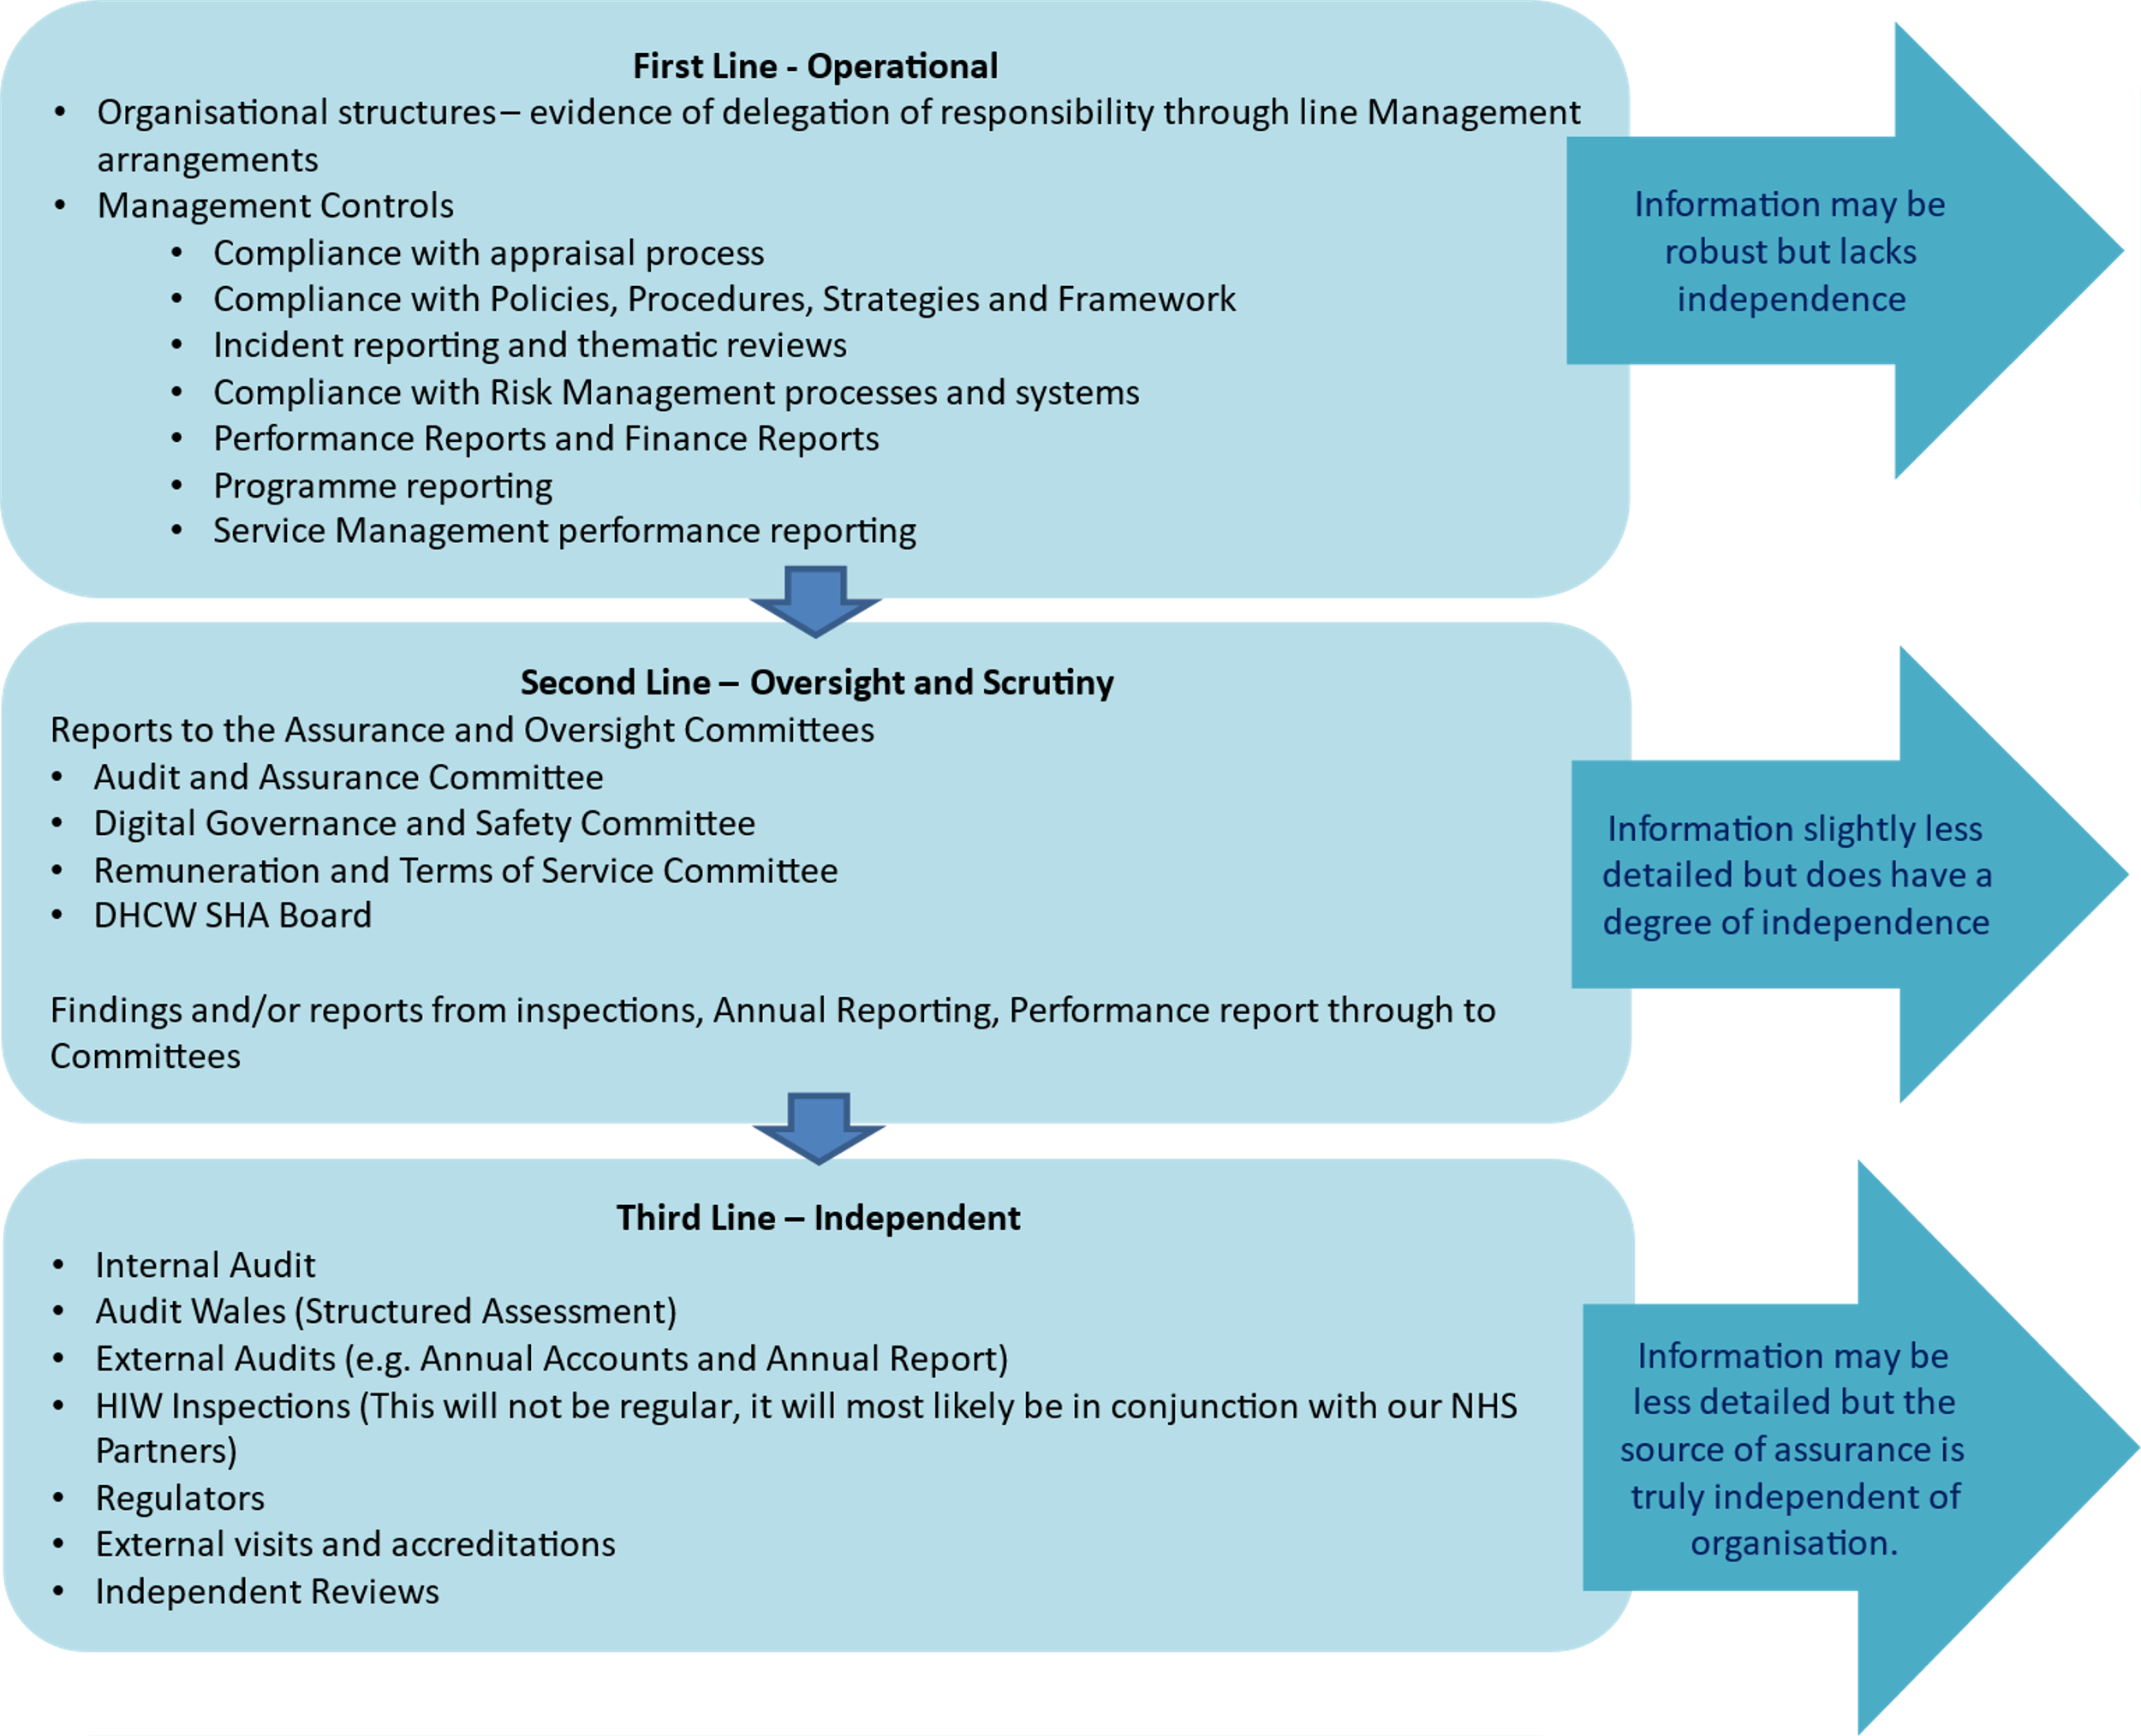

The Board Assurance Framework will be reviewed twice a year for validity and progress by the Board. This will be planned for May and November each year but may change as necessary.

KEY RISKS/MATTERS FOR ESCALATION TO BOARD/COMMITTEE

Work to identify the risk appetite for each strategic mission will take place in June and be presented to the SHA Board in July.

Work regarding the timeframe for completion of the gap in controls and assurance action plan will continue to be validated with all operational and strategic leads in June for reporting to the July SHA Board.

The current RAG self-assessment is a placeholder, each strategic mission owner will undertake a quarter one review of the action plan status and provide a self-assessment and narrative progress report. Within the dashboard this is indicated as an amber rating.

RECOMMENDATION
The Board is being asked to:
NOTE the content of the report
APPROVE the Principal risks to the strategic objectives
APPROVE the Board Assurance Report format

IMPACT ASSESSMENT
STRATEGIC OBJECTIVE | All Objectives apply

CORPORATE RISK (ref if appropriate) | All

WELL-BEING OF FUTURE GENERATIONS ACT | A healthier Wales
If more than one standard applies, please list below:

DHCW QUALITY STANDARDS | N/A
If more than one standard applies, please list below:
Good Governance supports all the quality standards

HEALTH CARE STANDARD | Governance, leadership and acccountability
If more than one standard applies, please list below:
Staff and Resources, Safe Care, Effective Care

EQUALITY IMPACT ASSESSMENT STATEMENT | Date of submission: N/A
No, (detail included below as to reasoning) |  | Outcome: N/A
Statement:
N/A
Workforce EQIA page

APPROVAL/SCRUTINY ROUTE:
Person/Committee/Group who have received or considered this paper prior to this meeting
COMMITTEE OR GROUP | DATE | OUTCOME
Audit and Assurance Committee | 18th January | ENDORSED
Board Development | 5th May 2022 | ENDORSED
Management Board | 16th May 2022 | ENDORSED
SHA Board | 26th May 2022 | TBC
IMPACT ASSESSMENT
QUALITY AND SAFETY IMPLICATIONS/IMPACT | Yes, please see detail below
QUALITY AND SAFETY IMPLICATIONS/IMPACT | Effective management of risk has a positive impact on the quality and safety of the organisation
LEGAL  IMPLICATIONS/IMPACT | Yes, please see detail below
LEGAL  IMPLICATIONS/IMPACT | There can legal ramifications if compliance risks are not managed effectively.
FINANCIAL  IMPLICATION/IMPACT | Yes, please see detail below
FINANCIAL  IMPLICATION/IMPACT | There can financial ramifications if compliance risks are not managed effectively.
WORKFORCE IMPLICATION/IMPACT | No, there is no direct impact on resources as a result of the activity outlined in this report.
SOCIO ECONOMIC IMPLICATION/IMPACT | No. there are no specific socio-economic implications related to the activity outlined in this report

