Terms of Reference and Governance Arrangements
Information Standards
Development and Assurance

This defines the Terms of Reference and governance arrangements for the Welsh Information Standards Board and the DSCN Subgroup in support of the information standards development and assurance process

Version No. 0.3
Status: Draft
Author: Gareth Griffiths
Approver: WISB
Date: 18/03/2021
Next Review Date: 25/03/2021
Tŷ Glan-yr-Afon
21 Heol Ddwyreiniol Y Bont-Faen, Caerdydd CF11 9AD
21 Cowbridge Road East, Cardiff CF11 9AD
Ffôn/Tel: 02920 500500
www.cymru.nhs.uk/gwybodeg
www.wales.nhs.uk/informatics

TABLE OF CONTENTS

1 DOCUMENT HISTORY 3
1.1 Revision History 3
1.2 Reviewers 3
1.3 Authorisation 3
1.4 Document Location 3
2 PURPOSE 4
3 BACKGROUND 4
4 THE PROCESS 4
4.1 Objectives 4
4.2 Approach 6
5 APPRAISAL 7
5.1 Role of WISB 7
5.2 WISB Meetings 7
5.3 WISB Membership 8
5.4 Role of the DSCN Subgroup 8
5.5 DSCN Subgroup Meetings 9
5.6 DSCN Subgroup Membership 9
5.7 Documentation and Papers 10
6 KEY RELATIONSHIPS 10
7 APPENDIX A 11

DOCUMENT HISTORY

Revision History
Date | Version | Author | Revision Summary
12/02/2021 | 0.1 | Gareth Griffiths | First draft of combined ToR for WISB and the DSCN Subgroup
19/02/2021 | 0.2 | Gareth Griffiths | Following internal review
18/03/2021 | 0.3 | Gareth Griffiths | Following review by WISB

Reviewers
This document requires the following reviews:
Date | Version | Name | Position
18/02/2021 | 0.1 | Rebecca Cook | Head of Information Design and Standards Development
18/02/2021 | 0.1 | Dr John Peters | WISB Chair

Authorisation
Signing of this document indicates acceptance of its contents.
Author’s Name: | Gareth Griffiths
Role: | Data Standards Manager, NHS Wales Informatics Service
Signature: |  | Date: | 19/02/2021

Approver’s Name: | WISB
Role: | Information standards assurance board
Signature: |  | Date: | 25/03/2021

Document Location
Type | Location
Electronic

PURPOSE
This document describes the Terms of Reference and governance arrangements for the Welsh Information Standards Board and the DSCN Subgroup in support of the information standards development and assurance process.

BACKGROUND
The Welsh Information Standards Board (WISB) was first formed under WHC (2006) 83 in May 2006 as the ‘Welsh Information Governance and Standards Board’. The establishment of a unified informatics service for Wales and the creation of a coherent assurance process in 2011 led to a review of the existing terms of reference and the renaming to the ‘Welsh Information Standards Board’.

These terms of reference were updated most recently to reflect changes applied to the process of developing and assuring information standards as a result of the COVID-19 pandemic.

THE PROCESS

Objectives

Overarching Aims and Purpose

“Aiming for a shared understanding of words and numbers in health and healthcare”

Information Standards Assurance contributes to the overall aim of data being captured, shared, stored, used and analysed consistently and coherently, throughout the NHS in Wales and in its relationships with its partner organisations. It is relevant to data used in all aspects of NHS business. It contributes to the improvement of information quality whilst working to minimise any unjustifiable burden of data collection.

Everyone, every day, working in the NHS is involved with data and information. This includes front-line clinicians, ward clerks, organisational managers, performance managers, statisticians and policy-makers.

Whether their role is to collect it, process it, analyse it or to improve patient care by applying it, they can only do this safely and responsibly if they all understand what it means, and share a commitment to improving its consistency.

Missing or misinterpreted data can result in simple inefficiency – time and effort is wasted on trying to improve data quality because the criteria had not been properly defined in the first place - or in actual harm - the wrong clinical details in the care record.

Artificial boundaries within the service can be created by different data/information definitions and standards for care delivery in primary, secondary and community settings. This may work against efforts to create seamless patient care.

Similar boundaries exist where the languages of clinical care and administration contradict each other, or fail to describe the same patient events. This often hampers efforts to develop and implement outcome and other quality improvement initiatives.

Information Standards Assurance exists to help all those aiming to drive forward improvements in any aspect of healthcare information and IT by identifying:
- what relevant data and information standards already exist
- how inappropriate or duplicate data collection burden might be reduced and data quality improved - thereby enabling valuable resource to re-focus on service improvement.
- how all steps in the collection, communication, storage and analysis of data can each impact on information quality and therefore its consistent interpretation, and
how selecting the right data and information standards will improve the project outcome resulting in enhanced benefits.

Key objectives
Through the information standards assurance process:
- Promote the need for business requirements for new or revised information standards to be clearly articulated as a basis for any development
- Promote the importance of data and information requirements being seen to support the business requirement thereby enabling improvement
- Encourage reduction of the burden of un-necessary data collection
- Promote the need for implementations to be properly planned and executed
- Support the convergence of data and information standards into a coherent set across the NHS and all its functions wherever desirable and possible
- Highlight the responsibility of sponsors, developers, collectors, users and analysers of data for the maintenance and improvement of information standards and thus quality

Scope
All data and information standards associated with all Wales developments are in scope, namely:
- Operational and clinical system data standards as well as data and information standards for all flows and secondary uses. Including the semantic interoperability to enable data exchange with unambiguous, shared meaning between information systems.
- All information requirements placed on the NHS, including policy and performance
- Data standards to include administrative, organisation, classification and terminology codes
- Methodologies which are derived directly from NHS Wales healthcare data will be taken forwarded for formal accreditation by WISB and published in the NHS Wales Dictionary of Analysis Methods.

Constraints
- The Board is required to meet monthly to handle the volume of business currently generated
- Assurance Bodies to which WISB reports and with which its business links, must be able to handle the necessary numbers and cycles of appraisal in a sufficiently timely manner
- Secretariat support for the Board is resource-limited
- Membership is voluntary and appraisals are carried out alongside Members’ paid duties

Assumptions
- Information requirements arising from the NHS itself and all Welsh Government Health Department, Department-sponsored public bodies and Department-funded programmes will continue to submit their data and information requirements to WISB for consideration.
- Lead responsibility for the prioritisation, planning and implementation of national information developments sits elsewhere.
- Responsibility for determining the lead assurance board and the sequencing of assurance sits elsewhere.
- New, improved or changed information requirements or standards will all be taken through assurance.
- WISB will consider submissions and advise the Sponsor on aspects of Business Case, financial implications, cost: benefit analysis and service impact aspects of developments according to their relative areas of responsibility.
- WISB will be mindful of the strategic intent to derive data for secondary uses from that collected to support operational services. WISB will review and provide advice on the appropriate standards for operational systems to promote this.
- System to system interoperability will be assured by the Welsh Technical Standards Board.
- Responsibility for ensuring that appropriate anonymisation is considered for all non-clinical secondary uses will be through cross referral or cross representation between WISB and relevant Information Governance bodies.
- Members’ skills and knowledge will cover the scope of the Board’s remit.
- If WISB recognises constraints unlikely to be resolved in development or assurance processes, these will be reported to Welsh Government or national programme, depending on the source of the submission.
- If the submission to WISB gains final approval, then WISB will issue information guidance or standards change notices to the Service.

Approach

The process relies on a close relationship and continuous engagement with each of the following parties:
- The Sponsor – typically a Welsh Government policy lead or national programme board – with whom responsibility for and ownership of the Standard ultimately lies.
- The Developer is delegated responsibility for leading the development of the Standard by the Sponsor.
- The Welsh Information Standards Board, with responsibility for the appraisal and subsequent approval of the Standard to be mandated for use in NHS Wales.
- The DSCN Subgroup, to whom responsibility is devolved by WISB to support the Development Stage of the process and the appraisal of the Analysis Methods Notice (AMN) and Data Standard Change Notice (DSCN) in particular.
- The national Data Standards team, to project manage the development of the Standard and support the Sponsor and Developer through each step of the process.

The standards development and assurance life cycle can be broken down into 3 main stages as follows:
- Requirement, where the business requirement and justification are established;
- Development, where the Standard, capable of delivering an information solution in accordance with the requirement, is developed and tested; and
- Final, where the final proposal and DSCN (and AMN where appropriate) are appraised by WISB and approval is sought for the Standard to be mandated for use across NHS Wales.

The process flow diagram in Appendix A illustrates the progression of the proposed Standard through these stages, together with the respective roles of the aforementioned parties in the design, development and appraisal steps necessary to formally mandate the Standard for use in NHS Wales.

APPRAISAL

Role of WISB
To assure the development of new or changed national information standards and their implementation across the NHS in Wales so as to maximise fitness for purpose, efficiency of data capture and information coherence. To ensure that new or changed national information standards are documented and mandated for use in NHS Wales in a consistent way.

The board contributes to an overarching assurance framework which aims to ensure that data can be captured, used, shared, stored and analysed consistently and coherently throughout NHS Wales and its interfaces with its partner organisations in support of all aspects of its business and that information is handled in a confidential and secure manner to appropriate ethical and quality standards.

In particular, WISB is responsible for appraising submissions at the Requirement and Final stages of the process. Responsibility for appraising submissions at the Development Stage is devolved to the DSCN Subgroup. In the event that first engagement with the assurance process occurs at Development Stage, a Requirement Notification is produced for consideration by WISB, with a Development Proposal being submitted to the Subgroup.

WISB Meetings
Sponsors and Developers are warmly invited to attend WISB meetings. They will have the opportunity to provide any additional overview and background material related to their submission before starting the detailed discussion with WISB members. Their engagement is also likely to speed up WISB consideration of their submission.

After completion of individual appraisals, WISB members agree the formal decision. This is communicated to Sponsors as soon as possible after the meeting in the form of an official WISB Outcome document.

Frequency
Meetings are held on a monthly basis, usually on the afternoon of the third Thursday of each month.

Quorum
To make quorate, each meeting requires at least 2 attendees representing NHS Wales organisations, in addition to the Chair, and representation from the national Data Standards team.

Format
Focussed virtual meetings, approximately 2 hours in length. An agenda will be issued along with any meeting papers a week in advance of each meeting. Meeting papers will also be published via the Teams channel and on the associated SharePoint site.

WISB Membership
One member for each stakeholder organisation, typically an associate director of informatics or head of information services.

Chair
Dr John Peters, Cardiff & Vale University Health Board.

Should the Chair be unable to attend, a temporary Chair may be nominated to ensure that meetings are able to continue.

Secretariat
Administrative support is provided by the NWIS Data Standards team.

Other Representatives
Other individuals may be invited to attend a meeting on request in advance. Individuals submitting documentation for appraisal are encouraged to attend to introduce their submission and take questions from the Board.

Role of the DSCN Subgroup
The DSCN Subgroup was established to support the work of WISB in relation to the production of DSCNs. The remit of the Subgroup has since been expanded to include responsibility for appraisal of all proposals and notices at the Development Stage, including Development Proposals and DSCNs (and AMNs where applicable).

The Subgroup reports directly to WISB, and has a duty to communicate their recommendations as to the progression of submissions through the Development Stage and on to the Final Stage.

In particular, the role of the Subgroup is comprised of the following:
- Delegated responsibility for appraisal of the proposed solution or Development Proposal, on behalf of WISB.
- Developing a rigorous, timely process for assessing data/information demands on the Service as required at Development Stage.
- Ensuring changes to the Data Dictionary are comprehensively identified and included as part of the DSCN.
- Recommending improvements to the format and content of DSCNs (and AMNs where applicable).
- Reviewing the role of the DSCN and considering the need for other notices.
- Delegated responsibility for the approval of DDCNs (in full).
- Reviewing proposed changes to the Data Dictionary's structure and content.
- The remit of the DSCN Subgroup will include all DSCNs (AMNs where applicable) which result from submissions passing through any part of the Information Standards Assurance Process.
- Once the Subgroup has reached a decision on a proposal or notice, this will be reported to WISB for ratification at Final Stage. If the Subgroup is unable to approve a submission, or has been unable to reach agreement, this will be escalated to WISB for a final decision.

DSCN Subgroup Meetings
As with submissions to WISB at Requirement and Final Stage, Sponsors and Developers, as well as subject matter experts, are encouraged to attend DSCN Subgroup meetings to summarise the requirement, purpose of the submission and the rationale for the proposed solution.

The Subgroup’s decision as to the progression of the proposal through the Development Stage and on to the Final Stage is communicated to WISB following each meeting.

Frequency
Meetings are held on a monthly basis, usually on the morning of the first Thursday of each month.

Quorum
To make quorate, each meeting requires at least 2 attendees representing NHS Wales organisations, in addition to the Chair, and representation from the national Data Standards team.

Format
Virtual meetings, approximately 3 hours in length. An agenda will be issued along with any meeting papers a week in advance of each meeting. Meeting papers will also be published via the Teams channel and on the associated SharePoint site.

DSCN Subgroup Membership
One member for each stakeholder organisation, typically an information manager.

Chair
TBC.

Should the Chair be unable to attend, a temporary Chair may be nominated to ensure that meetings are able to continue.

Secretariat
Administrative support is provided by the NWIS Data Standards team.

Other Representatives
Other individuals may be invited to attend a meeting on request in advance. Individuals submitting documentation for appraisal are encouraged to attend to introduce their submission and take questions from the Subgroup.

Documentation and Papers
Formal Outcome documents to communicate the Board’s decision following submission to WISB at Requirement and Final Stage are shared with the Developer and Sponsor via email following each meeting. Upon ratification by WISB at the next meeting, these are published internally to NHS Wales along with the submission documents.

In addition, a log of all submissions made to WISB is documented in chronological order, and published on the Information Standards Assurance website.

KEY RELATIONSHIPS
- The Welsh Technical Standards Board (WTSB) as the equivalent board which provides assurance over technical and interoperability standards.
- The Interoperability Standards Working Group provides a pivotal link between information standards assurance and the associated technical standards development which allows interdependent information and technical specifications to be developed in parallel.
- The all-Wales Heads of Information (HoI) group, in its role as a steering group for the Information Quality Improvement Working Group, which plays a key role in the formal review of existing and recently mandated information standards.
- Stakeholder working groups are often established as a mechanism for engaging with NHS Wales to provide specialist service and informatics input into the development of a particular solution and the associated information specification.

APPENDIX A
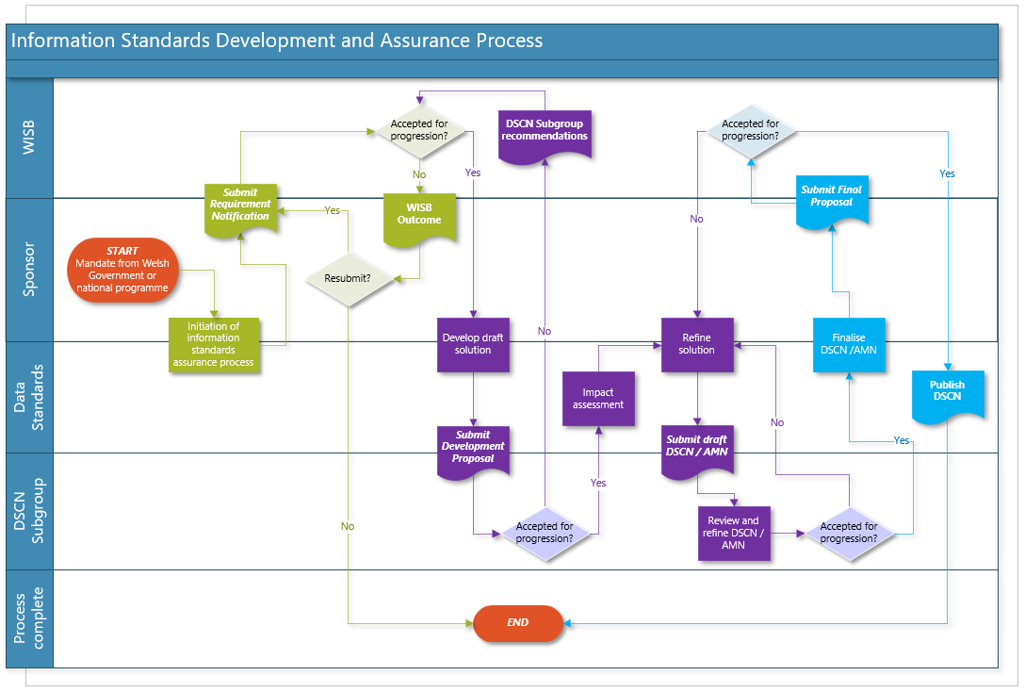

http://howis.wales.nhs.uk/doclib/WHC(2006)083.pdf (NHS Wales users only)
https://nhswales365.sharepoint.com/sites/wisb-DataStandardsDevelopmentandAssurance/Shared%20Documents/Forms/AllItems.aspx?FolderCTID=0x0120002B9E0AE3C8E9B7479AA372649D685767&id=%2Fsites%2Fwisb%2DDataStandardsDevelopmentandAssurance%2FShared%20Documents%2FData%20Standards%20Development%20and%20Assurance&viewid=e579ba29%2D779a%2D4dba%2D92eb%2D08b592cea97f
http://howis.wales.nhs.uk/sites3/home.cfm?orgid=1031 (NHS Wales users only)
http://www.wales.nhs.uk/sites3/home.cfm?orgid=742

