CYBER RESILIENCE UNIT
ANNUAL PLAN 2023/2024

Board Approval | Audit & Assurance Committee April 2023
Executive Sponsor | Claire Osmundsen-Little, Director of Finance & Business Assurance
Prepared By | Mike Prasad, Cyber Resilience Lead
Presented By | Paul Evans, Interim Head of Quality and Regulatory Compliance

Acronyms
Term | Definition
DHCW | Digital Health and Care Wales
NIS | Network and Information Systems
CRU | NHS Wales Cyber Resilience Unit- provides cyber resilience guidance and support throughout NHS Wales, and assesses OES against the NIS Regulations
Operator of Essential Service (OES) | Organisations that can significantly disrupt the delivery of essential services to the public e.g. health care
Cyber Assessment Framework (CAF) | Framework to assess organisations against the NIS standards
NCSC | National Cyber Security Centre - provides cyber security guidance and support throughout the UK
RDSP | Relevant Digital Service Providers

APPROVAL/SCRUTINY ROUTE:
Person/Committee/Group who have received or considered this paper prior to this meeting
COMMITTEE OR GROUP | DATE | OUTCOME

TABLE OF CONTENTS

1 Outline 5
2 Background 5
2.1 Delivering High Quality Digital Services 6
3 Vision & Objectives 6
3.1 Assessment Plan 8
3.2 Incident Reporting Function 9
3.3 Non-Compliance with the Regulations 9
3.4 Internal Audit Schedule to support Standards 10
4 Role of the Cyber Resilience Unit in NHS Wales 10
4.1 Competent Authorities 10
4.2 NHS Wales Cyber Resilience Unit 11
4.3 Operators of Essential Services (OES) 11
4.4 Governance Structure 12
4.5 Unit structure 14
4.6 Scope 15
5 Summary 16
6 Areas for Improvements 16
7 Objectives for Cyber Resilience Unit 2023/24 18
8 Business as Usual 23
8.1 Activities 23
9 Managing Outputs 25
10 Budget 26
11 Conclusion 27

Outline
The purpose of this document is to give an overview of the Annual Plan 2023/24 for the Cyber Resilience Unit function in Digital Health and Care Wales (DHCW), as a Delegated Authority to Welsh Government's (WG) Competent Authority. The background describes the legal requirements of the NIS Regulations and how the Unit will function to operationalise its requirements and provide assurance and reporting to WG on NHS Wales compliance. This paper defines the approach to Cyber Resilience through NIS assessment, priorities for 2023/24 including the scheduled audit cycle, governance arrangements, and finally highlights areas of risk and opportunities for consideration.

Background

The UK has implemented the requirements of the Network and Information Systems (NIS) Directive through the NIS Regulations 2018 which seek to ensure that 'essential services' have adequate data and cyber security measures in place.

The Directive states "A Competent Authority will have the ability to delegate some of these tasks or responsibilities to another organisation. However, unless there is existing legislation to provide for such a legal transfer of responsibility, ultimate responsibility will continue to remain with the Competent Authority." Under this approach, Welsh Government (WG) will be the Competent Authority, and Digital Health and Care Wales will be the Delegated Authority, specifically the Cyber Resilience Unit. This has been confirmed to the Chief Executives of NHS Wales in a letter from the Welsh Government Director –Technology, Digital & Transformation on 29 October 2020.

The NHS Wales Cyber Resilience Unit (CRU) was launched on 01 April 2021 to support Welsh Ministers in discharging their functions as Competent Authority for the NIS regulations within the health care setting in Wales. The Unit will provide a challenge, support, and assurance function, with delegated authority to operationalise the NIS Regulations on behalf of Welsh Ministers. It has oversight of NIS assessments, and the associated action plans to remediate any gaps which those assessments identify. The Unit is also responsible for reporting on the status of the NHS Wales cyber posture against the NIS Regulations to Welsh Ministers as Competent Authority.

Since its’ launch, the following has been delivered by the CRU:

- Engaged at Service Management Boards to discuss roles, responsibilities, and expectations under the NIS Regulations
- Regular communications on Baselining activity
- Developed and agreed schedules for baselining activity, including a pilot cohort for developing the assessment process and identifying / implementing Lessons Learnt
- Developed and utilised various performance monitoring tools to understand completion of baseline assessments
- Developed and utilise data interpretation dashboard to give a visual oversight of NIS compliance
- Implemented a cyber security distribution list for sharing of Communications
- Established a Task and Finish group to further refine the incident reporting process for the CRU and DHCW combined
- Published updated Critical System scoping guidance for use by OES on an ongoing basis
- Developed and agreed final Assurance Report format following baseline activity for each OES, which was then used for the overarching NHS Wales Posture Report
- Successfully recruited to key positions in the Unit
- Workshops with each OES in order to provide advice and guidance in completing the Cyber Assessment Framework (CAF)
- Baseline CAF assessments completed by each OES
- Cyber assurance reports to each OES based on their CAF submission
- An overall cyber baseline report submitted to Welsh Government
- Produced initial cyber risk registers for each OES based on their CAF submission.
- Held workshops with each OES to agree and finalise their cyber risk registers.
- An overall cyber risk report submitted to Welsh Government

The CRU has been established and the initial baselining of NHS Wales cyber resilience is complete. This year will build on last years’ activity and will continue to migrate compliance and regulatory activity into to business as usual. These activities relate directly to the following Strategic objective:

Delivering High Quality Digital Services

The establishment of the Cyber Resilience Unit for NHS Wales supports the above DHCW strategic priority and enabler objective. The Unit provides a governance function across the whole of NHS Wales to ensure compliance against the NIS Regulations through the CAF for Health assessments, whilst also providing leadership and direction through the creation of a community of practice. The Unit will also support skills development through shared best practice.

There is a statutory requirement for NIS compliance, and the opportunity to have the Unit operationalising the regulations based within DHCW by extending the concept of cyber resilience from simply an assessment exercise into a transformation in services and culture. This will be achieved through the following strategic approach.

Vision & Objectives
In development of the 2023-4 annual plan, the vision and strategic map of the CRU have been refined. The vision of the Unit is to "strengthen the Cyber Resilience posture for NHS Wales, and improve its safety for our critical services and service users" through compliance with the NIS Regulations. The objectives underpinning this aim can be broken down into three composite parts:
- Assess overall NHS Wales compliance against the NIS Regulations through undertaking assessments against the CAF for Health and implementing improvement plans in response to the outcomes
- Perform a reporting function for NHS Wales OES of incidents which breach the NIS regulations, through the maintenance of an incident register and triage/investigation process, which will be used to inform future planning and cyber strategies
- Support and develop an appropriate community of best practice, linking in with established forums to build a consistent approach to cyber security and improve the overall resilience posture

These aims have been developed into a Strategic Map with associated Vision, Mission and Core Values.

The Strategic Map outlines our plan to move from a Vision to Outputs and Outcomes through alignment of our Strategic Priorities to agreed objectives. The Outcomes of this Strategic Map can be built upon to develop longer term benefits to the cyber resilience posture of NHS Wales.

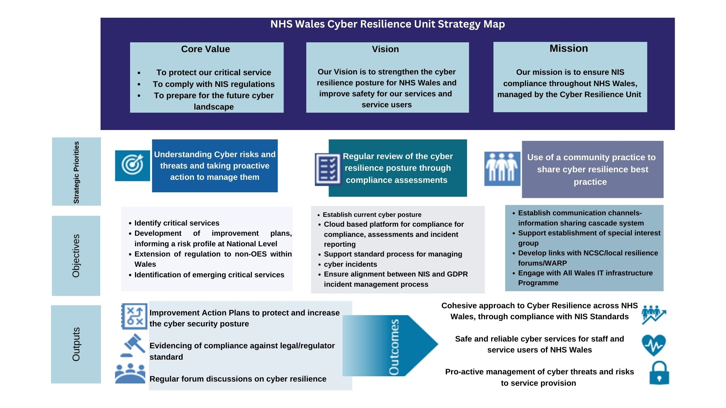

To implement this strategic plan, the below Target Operating Model outlines the function of the CRU. This will be further developed throughout 2023-24 as Standard Operating Operating Procedures are refined.

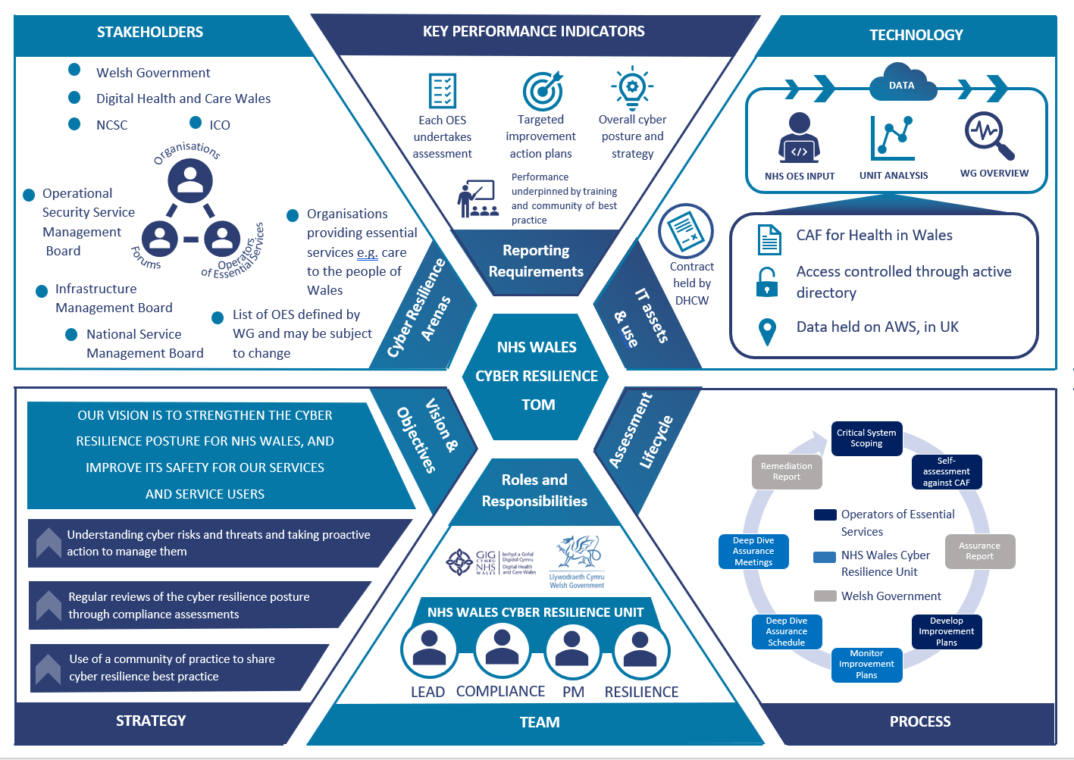

Assessment Plan
Compliance with the regulatory standards began during 2021/2022, continued, and followed the below process:
- Critical System Scoping – each OES is expected to identify their essential services and the critical systems they rely upon. Once the systems have been identified, these will be the systems which will need to comply with the NIS Regulations.
- Assessment against the CAF for health – Using the Cyber Assessment Framework (CAF), each OES will need to assess their systems against the Framework. This resulted in an overall baseline compliance against the regulations
- Compliance status – the Unit received the outcomes of the CAF from each OES and review overall compliance, providing a quality assurance process and identifying priority areas for improvement
- Risk management and implementation of mitigations – the Unit will support the OES to begin actions to mitigate and immediate areas for attention, and provide a central view to WG on any consistent issues raised on a national basis
- Review and Validation of mitigation – as part of the cycle; the Unit will liaise with each OES to understand any barriers of issues with the implementation of mitigating actions, providing leadership and support through a community of practice
- Final compliance report – a key requirement for the Unit is to provide WG as Competent Authority with an overall Compliance Status for NHS Wales against the NIS Regulations.

Following the assessment activities to establish the baseline NHS Wales compliance against the regulation at the end of March 2022, the Unit developed a cyber risk assessment programme which reported back to Welsh Government on the key cyber risks across NHS Wales. Following on from these key pieces of work, the CRU will establish a rolling assessment cycle based on Competent Authority requirements which will include surveillance audits of compliance against the NIS Regulations and deep dives into areas of concern and high risk.

Incident Reporting Function
The Unit also provides a cyber incident reporting function for NHS Wales. The Unit requires that any and all cyber incidents, regardless of impact score must be reported to the Unit for capture on the incident register. The purpose of this reporting function is to identify where any cyber incident could be classed as a breach against the NIS regulations, where an OES could have done more to ensure resilience of their systems and avoid an incident. The incident register will also be used to provide data and analysis of threats to the cyber resilience posture of NHS Wales and influence strategies for improvement.

As the Delegated Authority, the CRU will not have any responsibility to manage the incident directly, this will remain with the OES. Also, only the Competent Authority has the ability to implement any punitive actions such as fines for a NIS breach.

During 2023-24, the CRU will develop and refine its process for responding to NIS incidents and breaches.

Non-Compliance with the Regulations

The CRU will manage the regular assessment of OES to ensure they are fully compliant with the NIS Regulations, or at the very least, working towards compliance. This will take the form of deep dives into areas of concern in addition to reviews of remediation plans following CAF submissions. Relevant Digital Service Providers (RDSPs) will not be audited by the CRU as they fall outside the remit of this work, and the Competent Authority for RDSPs is the Information Commissioners Office (ICO).

In the UK, non-compliant organisations, or organisations subject to a breach of the NIS Regulations may be fined up to £17 million by the relevant Competent Authority. The largest fines will be imposed where an incident results in an immediate threat to life or significant adverse impact on the UK economy.

If an OES has an incident which also breaches GDPR and/or DPA 2018, the organisation could be liable to receive separate sanctions.

Internal Audit Schedule to support Standards
The activities of the CRU will be audited annually or after any significant event, the audit will be completed by the (DHCW) Internal Audit department. Due to the governance structure of the Unit, it will be based within the Finance and Business Assurance Directorate, with direct line of sight through the Head of Quality and Regulatory. Any outcomes from internal audit reports will be managed by the CRU, with compliance reported at the Audit and Assurance Committee.

Role of the Cyber Resilience Unit in NHS Wales

The NIS Directive states "A Competent Authority will have the ability to delegate some of these tasks or responsibilities to another organisation. However, unless there is existing legislation to provide for such a legal transfer of responsibility, ultimate responsibility will continue to remain with the Competent Authority." Under this approach, WG will be the Competent Authority, and the Cyber Resilience Unit within DHCW will be the Delegated Authority. This has been confirmed to the Chief Executives of NHS Wales in a letter from the Welsh Government Director of Technology, Digital & Transformation.

The following functions cannot be delegated by the Competent Authorities, and are therefore excluded from this project approach:
- Enforcement action where breaches of the Directive's provisions have been identified
- To issue binding instructions to Operators of Essential Services to address issues relating to the security of network and information systems
- Setting and enforcing fines
- Taking decisions on whether to make incidents public

Full details of roles and responsibilities related the NIS Regulations are outlined in WG's statutory guidance: The Network and Information Systems Regulations 2018: guidance to the health sector in Wales [HTML] | GOV.WALES

Competent Authorities
Welsh Ministers are Competent Authority on implementation of the UK's NIS Regulations in devolved health services in Wales (including hospitals, private clinics and online settings).
Competent Authorities are responsible for:
- reviewing the application of the NIS Regulations in their sector or region;
- preparing and publishing guidance to assist Operators of Essential Services (OESs) or Relevant Digital Service Providers (RDSPs) in meeting the requirements of the NIS Regulations;
- establishing the identification thresholds for the OESs in their sector or region;
- keeping a list of all OESs who are designated, including an indication of the importance of each operator; keeping a list of all revocations;
- consulting and cooperating with each other, the Computer Security Incident Response Team (CSIRT), national Single Point of Contact (SPOC) and Information Commissioner's Office (ICO);
- assessing the compliance of operators to the requirements of the NIS Directive;
- determining the thresholds for reportable incidents in their sectors or region;
- cooperating with other Competent Authorities to provide consistent advice and oversight to OESs or RDSPs;
- receiving incident reports;
- making sure that there are processes in place for non-cyber incidents and issuing guidance to support companies dealing with non-cyber incidents
- incident investigation; and
- enforcement, including issuing notices and penalties, of the requirements of the NIS Regulations.

NHS Wales Cyber Resilience Unit
Welsh Ministers have asked Digital Health and Care Wales (DHCW) to support the implementation of the NIS Regulations on its behalf, utilising their cyber security expertise.
The NHS Wales Cyber Resilience Unit has been established to provide this challenge, support and assurance function, hosted within DHCW with separated governance and reporting.
The Unit has delegated authority to operationalise the NIS Regulations on behalf of Welsh Ministers. It has oversight of NIS assessments, and the associated action plans to remediate any gaps which those assessments identify. The Unit will also provide operational support and advice for those completing the NIS reporting framework set out by Welsh Ministers and supporting operators of essential services in identifying and reporting a NIS incident. The Unit is responsible for reporting on the status of the NHS Wales cyber posture against the NIS Regulations to Welsh Ministers as Competent Authority.

Operators of Essential Services (OES)
The health sector is one of six economic sectors considered "essential" under the NIS Regulations. However, only organisations that can significantly disrupt the delivery of essential services are considered 'Operators of Essential Services' under the NIS Regulations.
A Local Health Board or NHS Trust as defined in the National Health Service (Wales) Act 2006 is automatically considered an 'Operator of Essential Services' for the health sector in Wales for the purposes of the NIS Regulations. These organisations are:
- Aneurin Bevan University Health Board
- Swansea Bay University Health Board
- Cardiff and Vale University Health Board
- Hywel Dda University Health Board
- Cwm Taf Morgannwg University Health Board
- Betsi Cadwaladr University Health Board
- Powys Teaching Health Board
- Welsh Ambulance Services NHS Trust
- Velindre University NHS Trust
- NHS Wales Shared Service Partnership
- Public Health Wales
In addition to the list above, the following organisations have been designated an OES by Welsh Ministers:
- Digital Health and Care Wales
The following organisations are required by Welsh Ministers to comply with the guidance as if they were OES:
- Health Education Improvement Wales
Welsh Ministers may, by exception, designate an organisation as an OES even if that organisation does not meet the threshold for designation if it provides essential services which would have significant disruptive effects, in accordance with NIS Regulation 8(1). Welsh Ministers may also remove an organisation's designation as an OES should the organisation no longer meet the criteria defined in the NIS Regulations for this designation.
This list of OES will be reviewed periodically, including when significant changes occur.
The NIS Regulations require organisations identified as Operators of Essential Services to take appropriate and proportionate measures to:
- manage risks posed to the security of the network and information systems on which their essential services rely
- prevent and minimise the impact of incidents on the delivery of essential services and
- report serious network and information incidents that impact on provision of the essential service.

Governance Structure
In addition to the statutory guidance on roles and responsibilities above, clear governance structures have been established within DHCW to ensure appropriate checks and balances for the professional accountability of the Unit, whilst also safeguarding the activity of the Unit and reporting requirements to Welsh Government.
The governance routes for the CRU will be:
- DHCW Internal Governance –the Unit is based in the Finance and Business Assurance Directorate, with the Head of Quality Assurance & Regulatory Compliance providing professional oversight to the Unit. This route will also provide updates to the Audit and Assurance Committee on the Unit's fulfillment of statutory obligations to Welsh Government, along with overall DHCW compliance against the Regulations.
- Welsh Government External Governance – the Unit has reporting obligations to Welsh Government on the NHS Wales Cyber Resilience posture and to provide updates on each OES's compliance against the Regulations. Reportable NIS breaches will be escalated to WG as the Competent Authority. This route will also provide updates to the Directors of Digital peer group to assure the function of the Unit is within scope, aligned to the strategy and fulfilling its duties.
- DHCW NIS Compliance – the Unit will be assessing DHCW in line with the process for any other OES, and therefore internal arrangements for compliance against the NIS Regulations needs separate governance through the Cyber Security Team as appropriate. This route will also provide assurance to the Digital Governance and Safety Committee on DHCW's compliance against the Regulations.

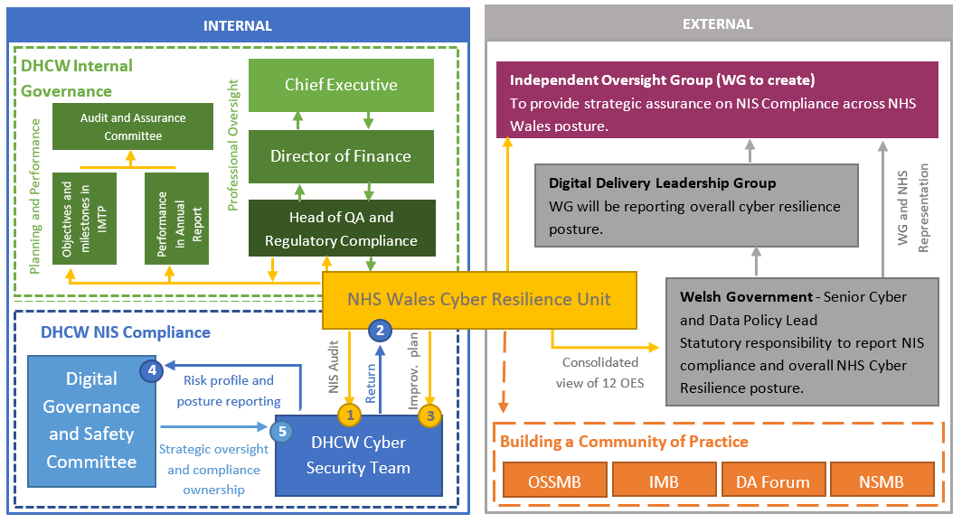

Unit structure
The structure of the Unit has been broken down into two main areas of focus; Leadership and Technical expertise. Each area of focus will be responsible for the following deliverables:

Leadership | Technical
Overall compliance reporting – Annual report drafting using data provided by technical | Technical Audit expertise – To ensure the assessments are appropriate, Collation of data for inclusion into reports
Planning and Performance – in line with annual plan milestones and overall strategy | Audit cycle – managing the overall audit cycle with OES for compliance against regulations
Engagement Representative - at Committees and Boards, conduit for information from the Unit and feedback from key stakeholders, managing the message | Cyber Knowledge – understanding of systems and controls across NHS Wales cyber landscape, keeping up to date with latest information.
Project and Programme management - input from technical management, oversight of programme of work for the cyber resilience posture of NHS Wales | Identifying areas for improvement – working with OES define improvement actions and build achievable targets. Risk & Remediation Planning
Trend analysis – using data provided by technical to analyse trends and use to create future strategies Presentation to Various Boards and committees | Risk and Issue reporting – Managing incident reporting process and providing advice as appropriate. Identifying risks to Unit deliverables. Upward escalation to Engagement and Governance Lead
Building community of practice – visual representative who builds relationships and links with appropriate forums | Platform management – Oversight and development of data capture platform for use across NHS Wales.

The structure would manage these areas of focus through the following approach:

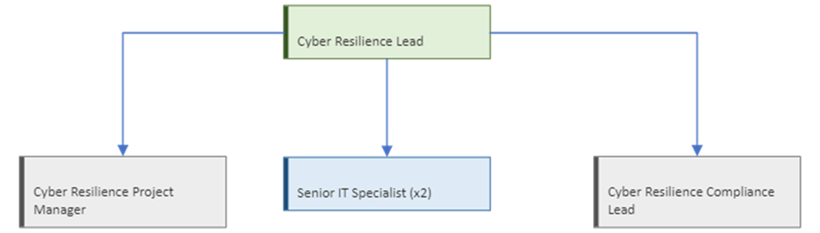

- Cyber Resilience Lead – Band 8b
Manage the strategic direction with Welsh Government for the deliverables of the Unit. Liaise with other Welsh or UK agencies to maintain a consistent approach and National level of assurance. To share and promote best practice through engagement with stakeholders. Provide oversight of reporting and compliance arrangements. This role combines responsibility and oversight of both Technical and Leadership deliverables.

- Cyber Resilience Compliance Lead – Band 8a
Deputise for the strategic role as necessary, provide an escalation point for the IT Specialists and be a subject matter expert in the required areas.

- Project Manager – Band 7
Responsible for data gathering, analysis, interpretation and presentation, including the planning of key activities and assessments. Engagement with key stakeholders to embed the Regulations and introduce new ways of working. Aid the development of the Unit through skills analysis and appropriate training.

- 2 x Senior IT specialist – Cyber Resilience – Band 6
Provide objective assessment of cyber assessment Framework (CAF) submissions, compliance monitoring of the Health Boards and Trusts, generate comprehensive reporting and support Health Boards with any resultant remediation plans.

Scope

The Unit will not:
- Hold ownership of local risk and improvement plans
- Undertake incident management, other than providing a reporting/NIS investigation function only
- Hold any responsibility for NIS compliance in private health care settings, or social care settings

Summary

The Cyber Resilience Unit was launched in NHS Wales on 01 April 2021, and with it came an increased priority across Health Boards and Trusts to ensure cyber resilience. The Unit's vision and objectives aim to ensure NHS Wales critical cyber systems are resilient and therefore safe for our service users. To achieve these aims, the Unit will manage the NIS assessment process, facilitate incident reporting, and build a community of practice to share learning and best practice across NHS Wales.

It will:
- Support the OES in completion of the NIS Cyber Assessment Framework
- Assist the OES in identification and remediation of risks to compliance
- Review and assess cyber incidents identified by the OES
- Prepare and schedule assessment activities
- Assist with identified risk remediation activities
- Prepare monthly CRU performance reports
- Prepare annual review reports on compliance for Welsh Gov
- Provide assistance and guidance to OES in relation to cyber resilience
- Strengthen and build upon engagement to date to raise the profile of cyber resilience in NHS Wales

Through undertaking the actions set out for this annual plan, in line with the structures agreed, the Unit aims to achieve its key objectives of:
- Understanding cyber risks and taking proactive action to manage them
- Regular reviews of the cyber resilience posture through compliance assessments, and;
- Using a community of practice to share cyber resilience learning and best practice.

Areas for Improvements

The following are areas identified during the development of the plan and feedback received from health boards following the initial CAF self-assessments which identify these areas for improvement:
- Reliance on external consultants –
Since its inception, the CRU has been supported by external consultants. They have brought extensive expertise to the team in NIS assessments and cyber risk assessments. While the the first CAF cycle is still ongoing, there will be a need to keep the consultants engaged but there will need to be a planned, phased knowledge transfer from the consultants to the permanent members of staff in the CRU. This will allow strengthening the structure of the Unit to achieve its deliverables. This knowledge transfer will be built into by the deep dive and assurance activities scheduled for 2023-4.
- Information Management Policies and Procedures –
A documentation review is currently underway as part of the planned migration to iPassport. This includes the development and updating of CRU policies, procedures, strategy and target operating model. This will help to clarify the role of the CRU across DHCW and other NHS Wales organisations.
- Improved usability of the CAF form –
The CAF form currently issued to be OES by the CRU is an Excel spreadsheet. The CRU has received feedback and acknowledges that this is not user friendly, nor is it efficient from a data management perspective.
- Improved information sharing –
Ensure that correct information regarding CRU activities is shared with OES personnel involved in CAF completion, workshops and assurance activities as early and comprehensively as possible.

Objectives for Cyber Resilience Unit 2023/24

The Cyber Resilience Unit statement of requirements for 2023/24 key objectives:

ID | Description | Date
001 | Understanding cyber risks and threats and taking proactive  action to manage them | Q4 23/24
002 | Regular reviews of the cyber resilience posture  through compliance assessments | Q4 23/24
003 | Use of a community of practice to share  cyber resilience best practice | Q2 23/24

Objectives will be delivered by the Cyber Resilience Unit supported by consultants, with planned scheduled knowledge transfer from the consultants to the permanent members of staff in the CRU. This will be facilitated by shadowing, workshops, and peer reviews.
Summary activities required to deliver objectives and estimated quarter of delivery:
Strategic Priorities | Objective | Deliverables | Action Plans | Timelines | Monitor
Understanding cyber risk and threats and taking proactive action to manage them | Review and develop policies and procedures | Continued monitoring and reporting against NIS regulatory compliance with associated and defined post-effectiveness processes | - Refine the process for the management of NIS Breaches and/or Cyber Incidents  - Develop a CRU strategy and assurance strategy  - Develop a Communication and Information Strategy  - Knowledge transfer from external consultants, undertaken by presentations, shadowing, per-reviews and feedback meetings.  - Investigate and implement options for improving the usability of the CAF submission form, engaging with the M365 COE. | Q1  Q1  Q1  Q2  Q2 | Cyber Resilience Lead through regular progress meetings with the team
 | Validation and review of OES improvement plans |  | - Improvement Action Plans (IAP)  - Assurance meetings and workshops | Q2
 | Identification of emerging critical services |  | - Identification of emerging critical services through project management activities  - Ensure CAF completion of new critical services | Q4
 | Horizon scanning on the emerging and relevant regulatory changes |  | - Review and communicate regulation and CAF changes | Q4
Regular review of the cyber resilience posture through compliance assessments | Ongoing compliance activities against NIS regulations | Compliance and Audit  Assess overall NHS Wales compliance against the NIS Regulations | - Review and validate remediation plans provided by OES  - Commence deep-dive assurance cycle with OES  - Develop a process for the management of NIS Breaches and/or Cyber Incidents  - Undertake CAF audits to ensure compliance with the NIS Regulations | Q2  Q4  Q2  Q4 | Cyber Resilience Lead through regular progress meetings with the team
 | Design and develop a cyber health dashboard | NIS Dashboard | - Define KPI and KRIs  - Development of reports and dashboards  - Automation of dashboard production  - Devlop metrics and KPIs to improve define and improve the efficiency of the CRU. | Q1  Q2  Q3  Q1 | Cyber Resilience Lead and Cyber Resilience Project Manager
Use of a community of practice to share cyber resilience best practice | Support establishment of special interest group | Support and Engagement  Produce guidance and provide specialist support to operators of essential services and Welsh Ministers | - Establish Terms of Reference for NIS Improvement Group  - Establish NIS Improvement Group | Q1  Q1 | Cyber Resilience Lead
 | Support establishment of special interest group | Capacity and skills planning | - Engagement with other NIS regulatory organisations to learn and share best practice  - Build an develop the skills of the CRU staff by a series of knowledge transfer sessions, shadowing and peer-to-peer reviews  - Upskilling of the team through training, seminars and conferences. | Q3  Q4  Q4 | Cyber Resilience Lead

Business as Usual

The Unit operationalises the regulations by extending the concept of cyber resilience from simply an assessment exercise into a transformation in services and culture throughout NHS Wales.

Activities

Engagement
- Consultancy against the NIS Framework
- NIS regulations Guidance, Education and Support to each OES
- NIS assessments against National Projects
- Stakeholder meetings with WG, NSMB and OSSMB

Assurance and Compliance
- Completion of Cyber Assessments Framework (CAF) by each OES
- Completion of Critical System Scoping by each OES
- Management and escalation of NIS Incidents to WG
- Creation and management of Improvement Action Plan (IAP) by each OES supported by the Unit
- Regular Audits activities against each OES to provide Cyber Assurance to WG (period to be determined)

Data analysis
- CAF Metrics compiled against each OES to support NIS Cyber posture reporting
- Identification of CAF common themes to drive improvement across NHS Wales
- Evaluation of CAF submissions to identify critical areas of Cyber Risk
- OES Training Gap Analysis for support personnel

Reporting
- Daily Scrum to track progress against unit activities
- Monthly Progress Report against unit activities, shared with WG and NSMB
- Production of NIS dashboard

Training
- OES Certified training courses (skills development through co-ordination)
- Training plan for Unit staff

Managing Outputs

Welsh Ministers are the Competent Authority for Health in Wales and are responsible for overseeing the operation of the Network and Information Systems (NIS) Regulations. To support Welsh Ministers in this, the NHS Wales Cyber Resilience Unit provides the assurance framework for compliance against the NIS regulations.

To support the governance of the plan, a project plan is in place. This is monitored by the CRU Project Manager in conjunction with the Cyber Resilience Lead. This is supported by weekly meetings with the Competent Authority, and monthly meetings with the DHCW Head of Quality and Regulatory Compliance.

The National Cyber Security Centre (NCSC) is the UK technical authority under the NIS Regulations. It is responsible for supporting operators of essential services and the competent authorities by publishing guidance and acting as a source of technical expertise.

To establish a community of shared best practice throughout NHS Wales, the Unit has a representative attend NHS Wales boards (see below) where they have the opportunity to provide leadership, direction and education to highlight NHS Wales responsibilities under the NIS regulations.

Operational Security Service Management Board (OSSMB)
Infrastructure Management Board (IMB)
National Service Management Board (NSMB)
4 Nations health Forum
Cyber Regulators Forum

The Unit acquires NCSC guidance and technical expertise whilst also gathering knowledge from UK Government, Information Commissioners Office (ICO), consultancy services and other health care settings across the UK, e.g., NHS England.

NHS Wales Health Boards and NHS Trusts are automatically considered an 'Operator of Essential Services'; loss of system/service would significantly disrupt the delivery of essential services for the health sector in Wales.

The NIS Regulations require organisations identified as Operators of Essential Services to take appropriate and proportionate measures to:
- manage risks posed to the security of the network and information systems on which their essential services rely
- prevent and minimise the impact of incidents on the delivery of essential services and
- report serious network and information incidents that impact on the provision of the essential service.

To ensure NHS Wales' cyber resilience posture is robust and prepared for new and emerging threats, Operators of Essential Services must support and implement risk remediation (People, Process and Technology) to protect NHS Wales.

Budget

The overall Unit budget for 2022-23 was £422,943. Of this, £100,000 was reverted to Welsh Government for extension of the contract with the consultants.
The proposed budget for 2023-24 is £412,369, based on 2.5% efficiency savings.

This is comprised of
Staffing: 1 x 8b, 1 x 8a,1 x Band 7, 2 x Band 6 | £289,854
Staff Training | £32,189
Monitors/Docking Stations/Keyboards | £2,425
Laptops | £4,850
Travel and expenses: | £1,400
Welsh Language Translation | £4,850
Other (Staff Consultancy & Support / GRC Tooling) | £76,801

Conclusion

The plan will be overseen by Head of Quality & Regulatory and Executive Director of Finance & Business Assurance. Progress will be reported monthly to Management Board through the Quality section and quarterly to Audit & Assurance Committee

